THE EASTER BUNNY
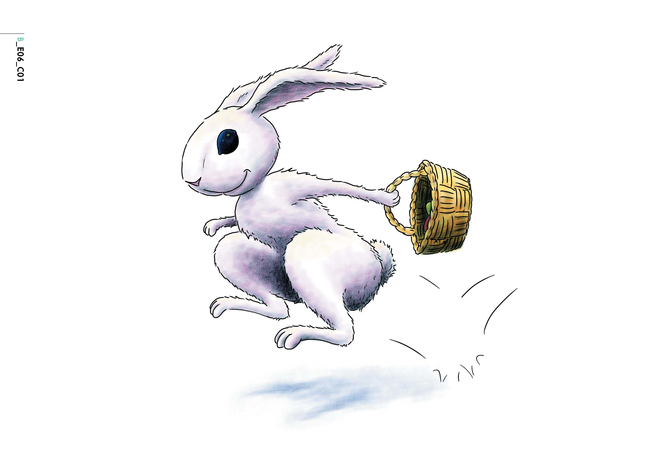
Bunny is an Easter Bunny. He is nice and he likes children.

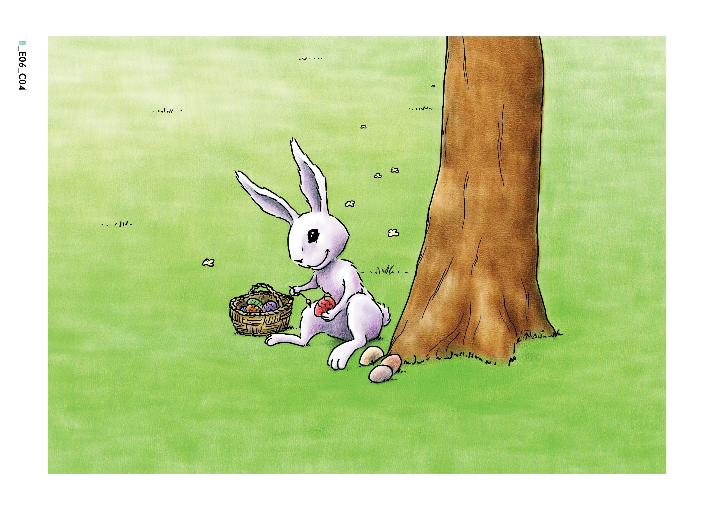

Bunny is painting some eggs under a tree.

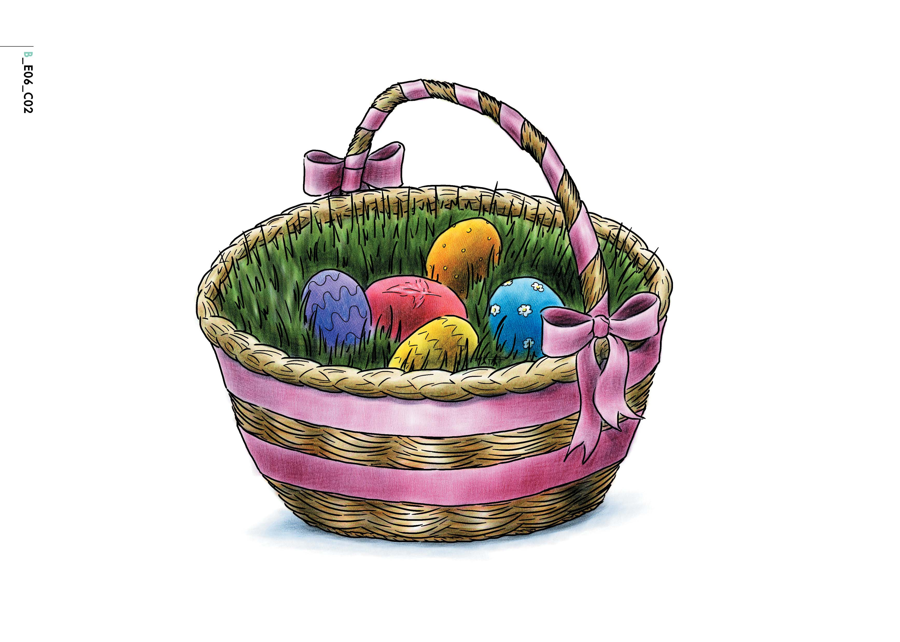
The eggs are beautiful. They are red and blue and green and purple and orange.

Then Bunny thinks, “Let’s play a game!” And he hides the eggs in the garden: in the trees, behind the flowers, near the fence, everywhere in the garden.
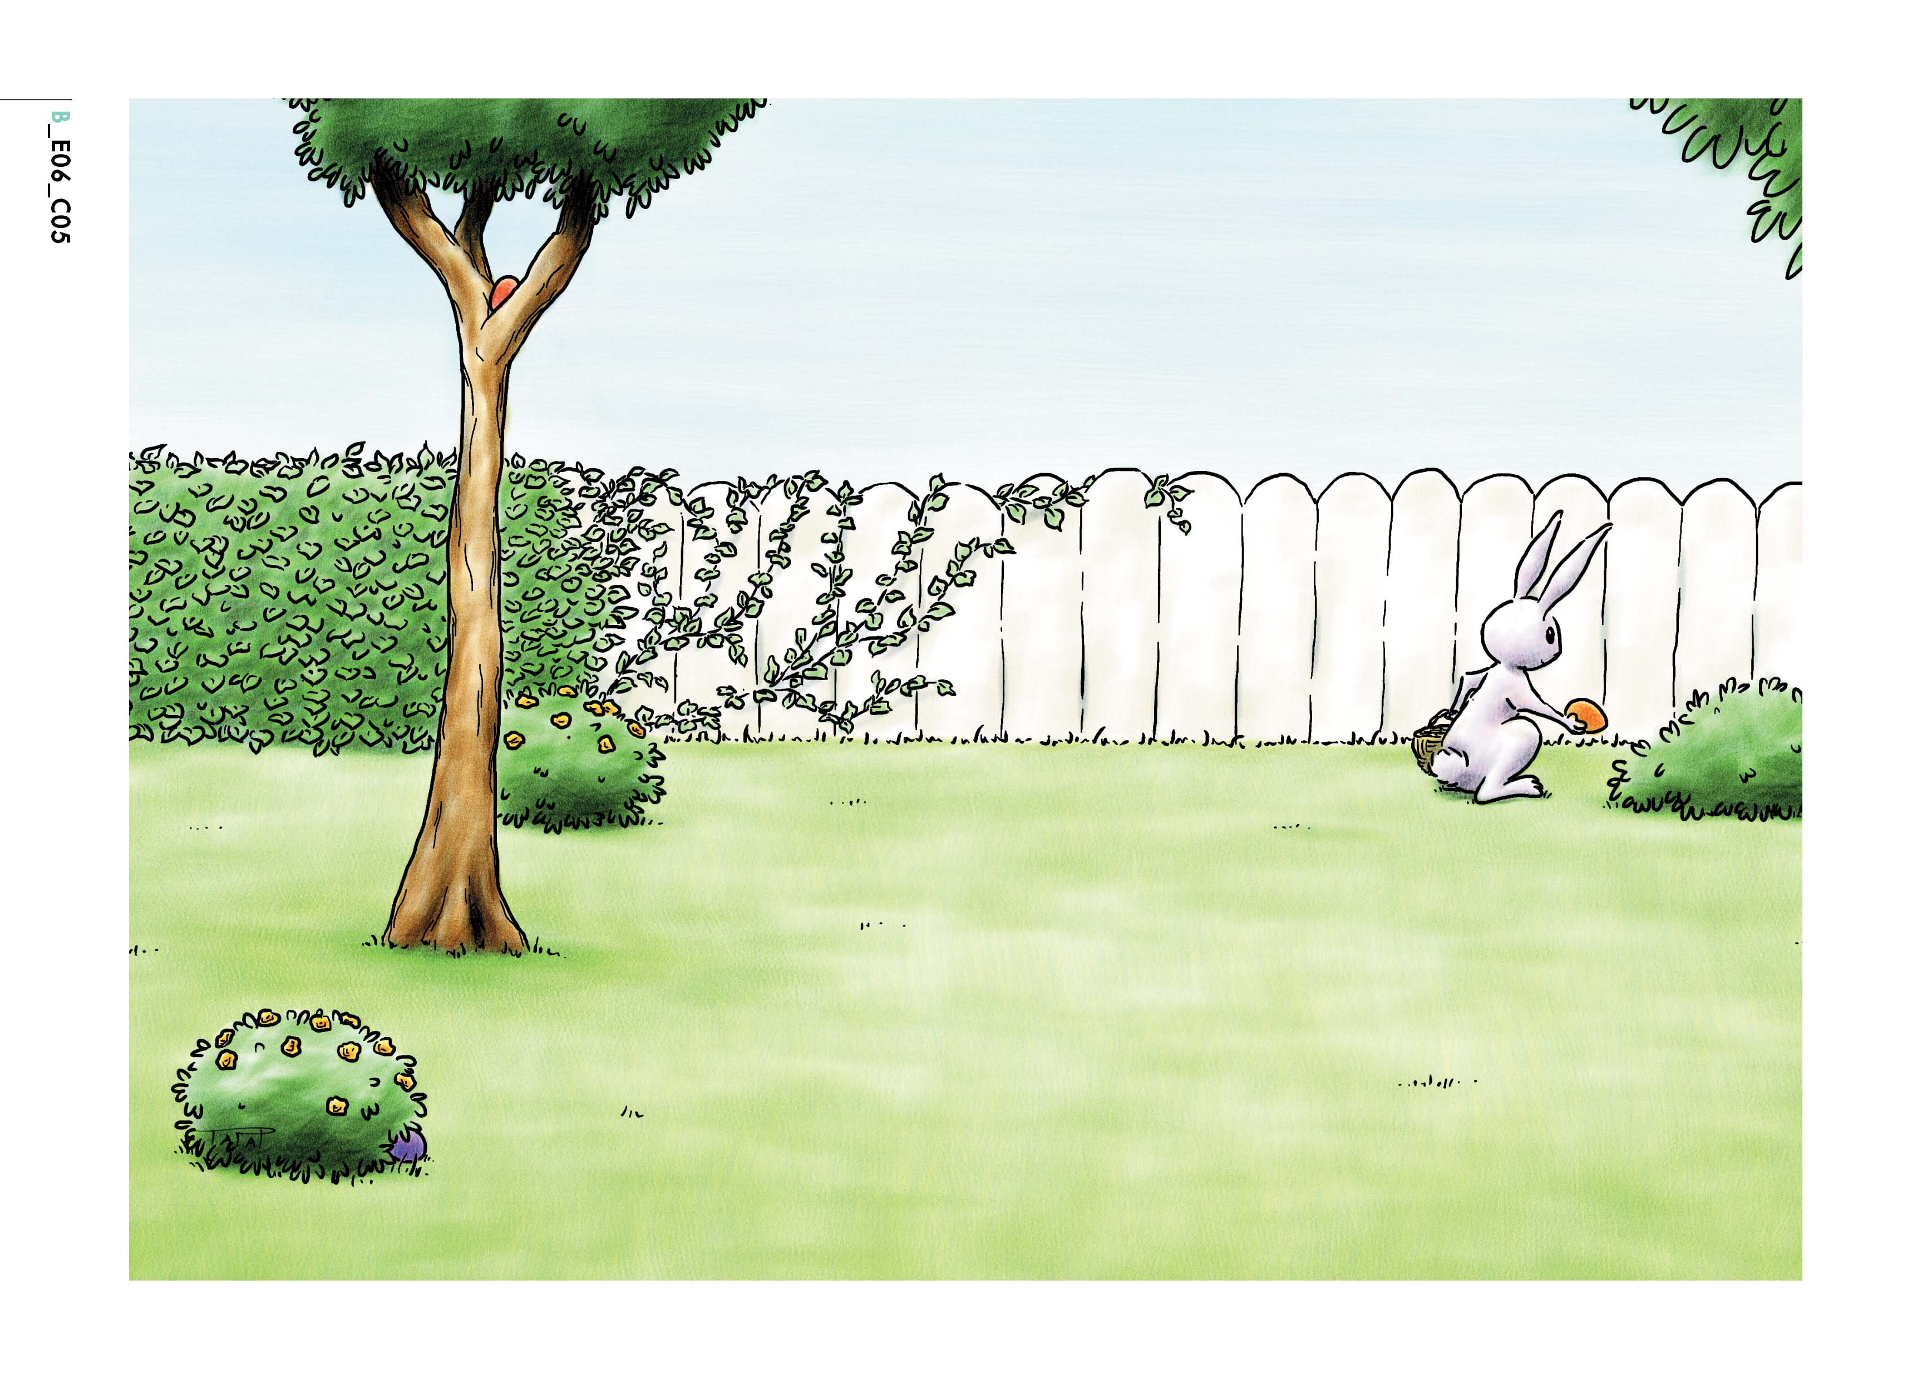

On Easter Day the children come into the garden and look for the beautiful Easter eggs.

“Where are the eggs?” they say.

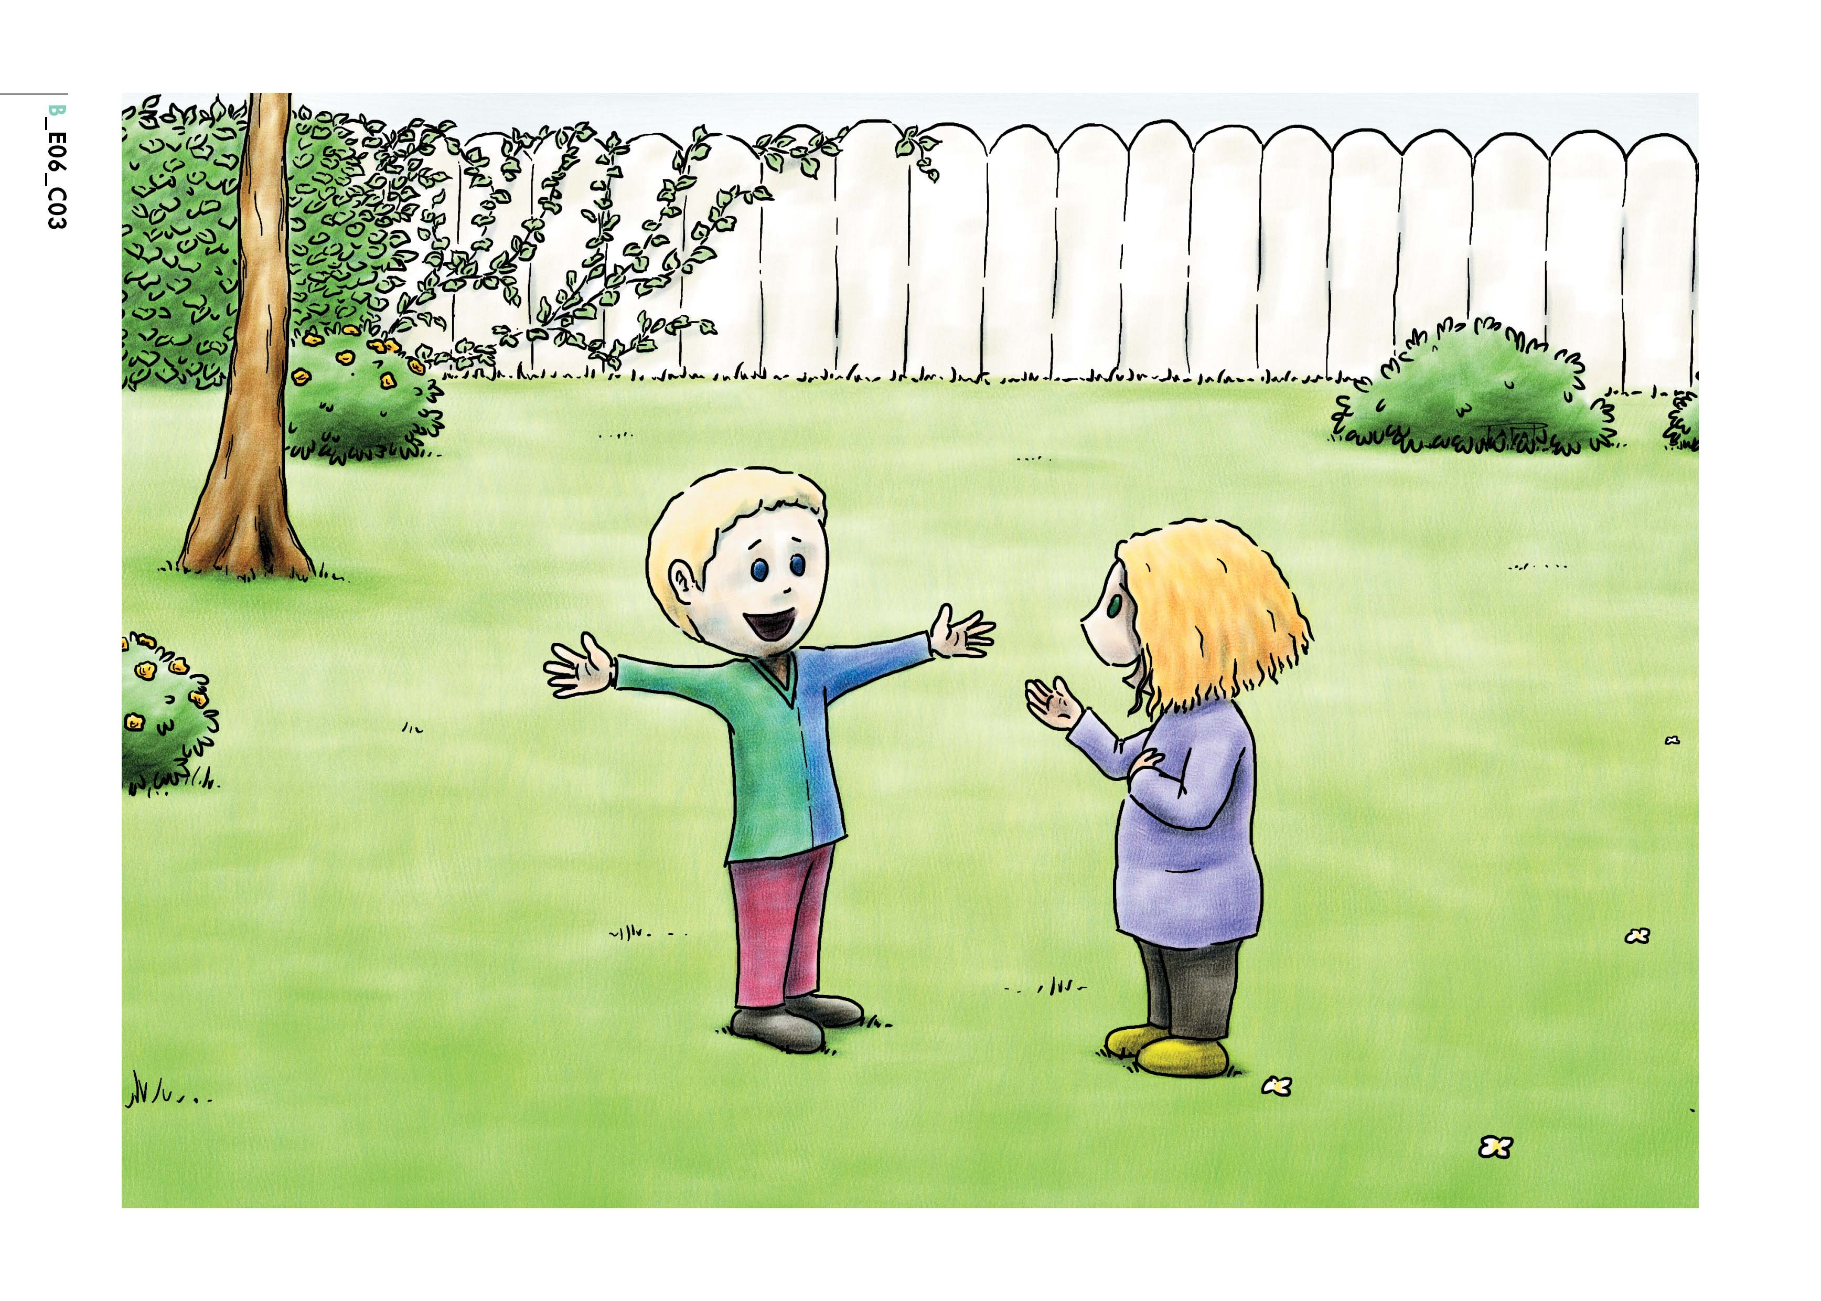

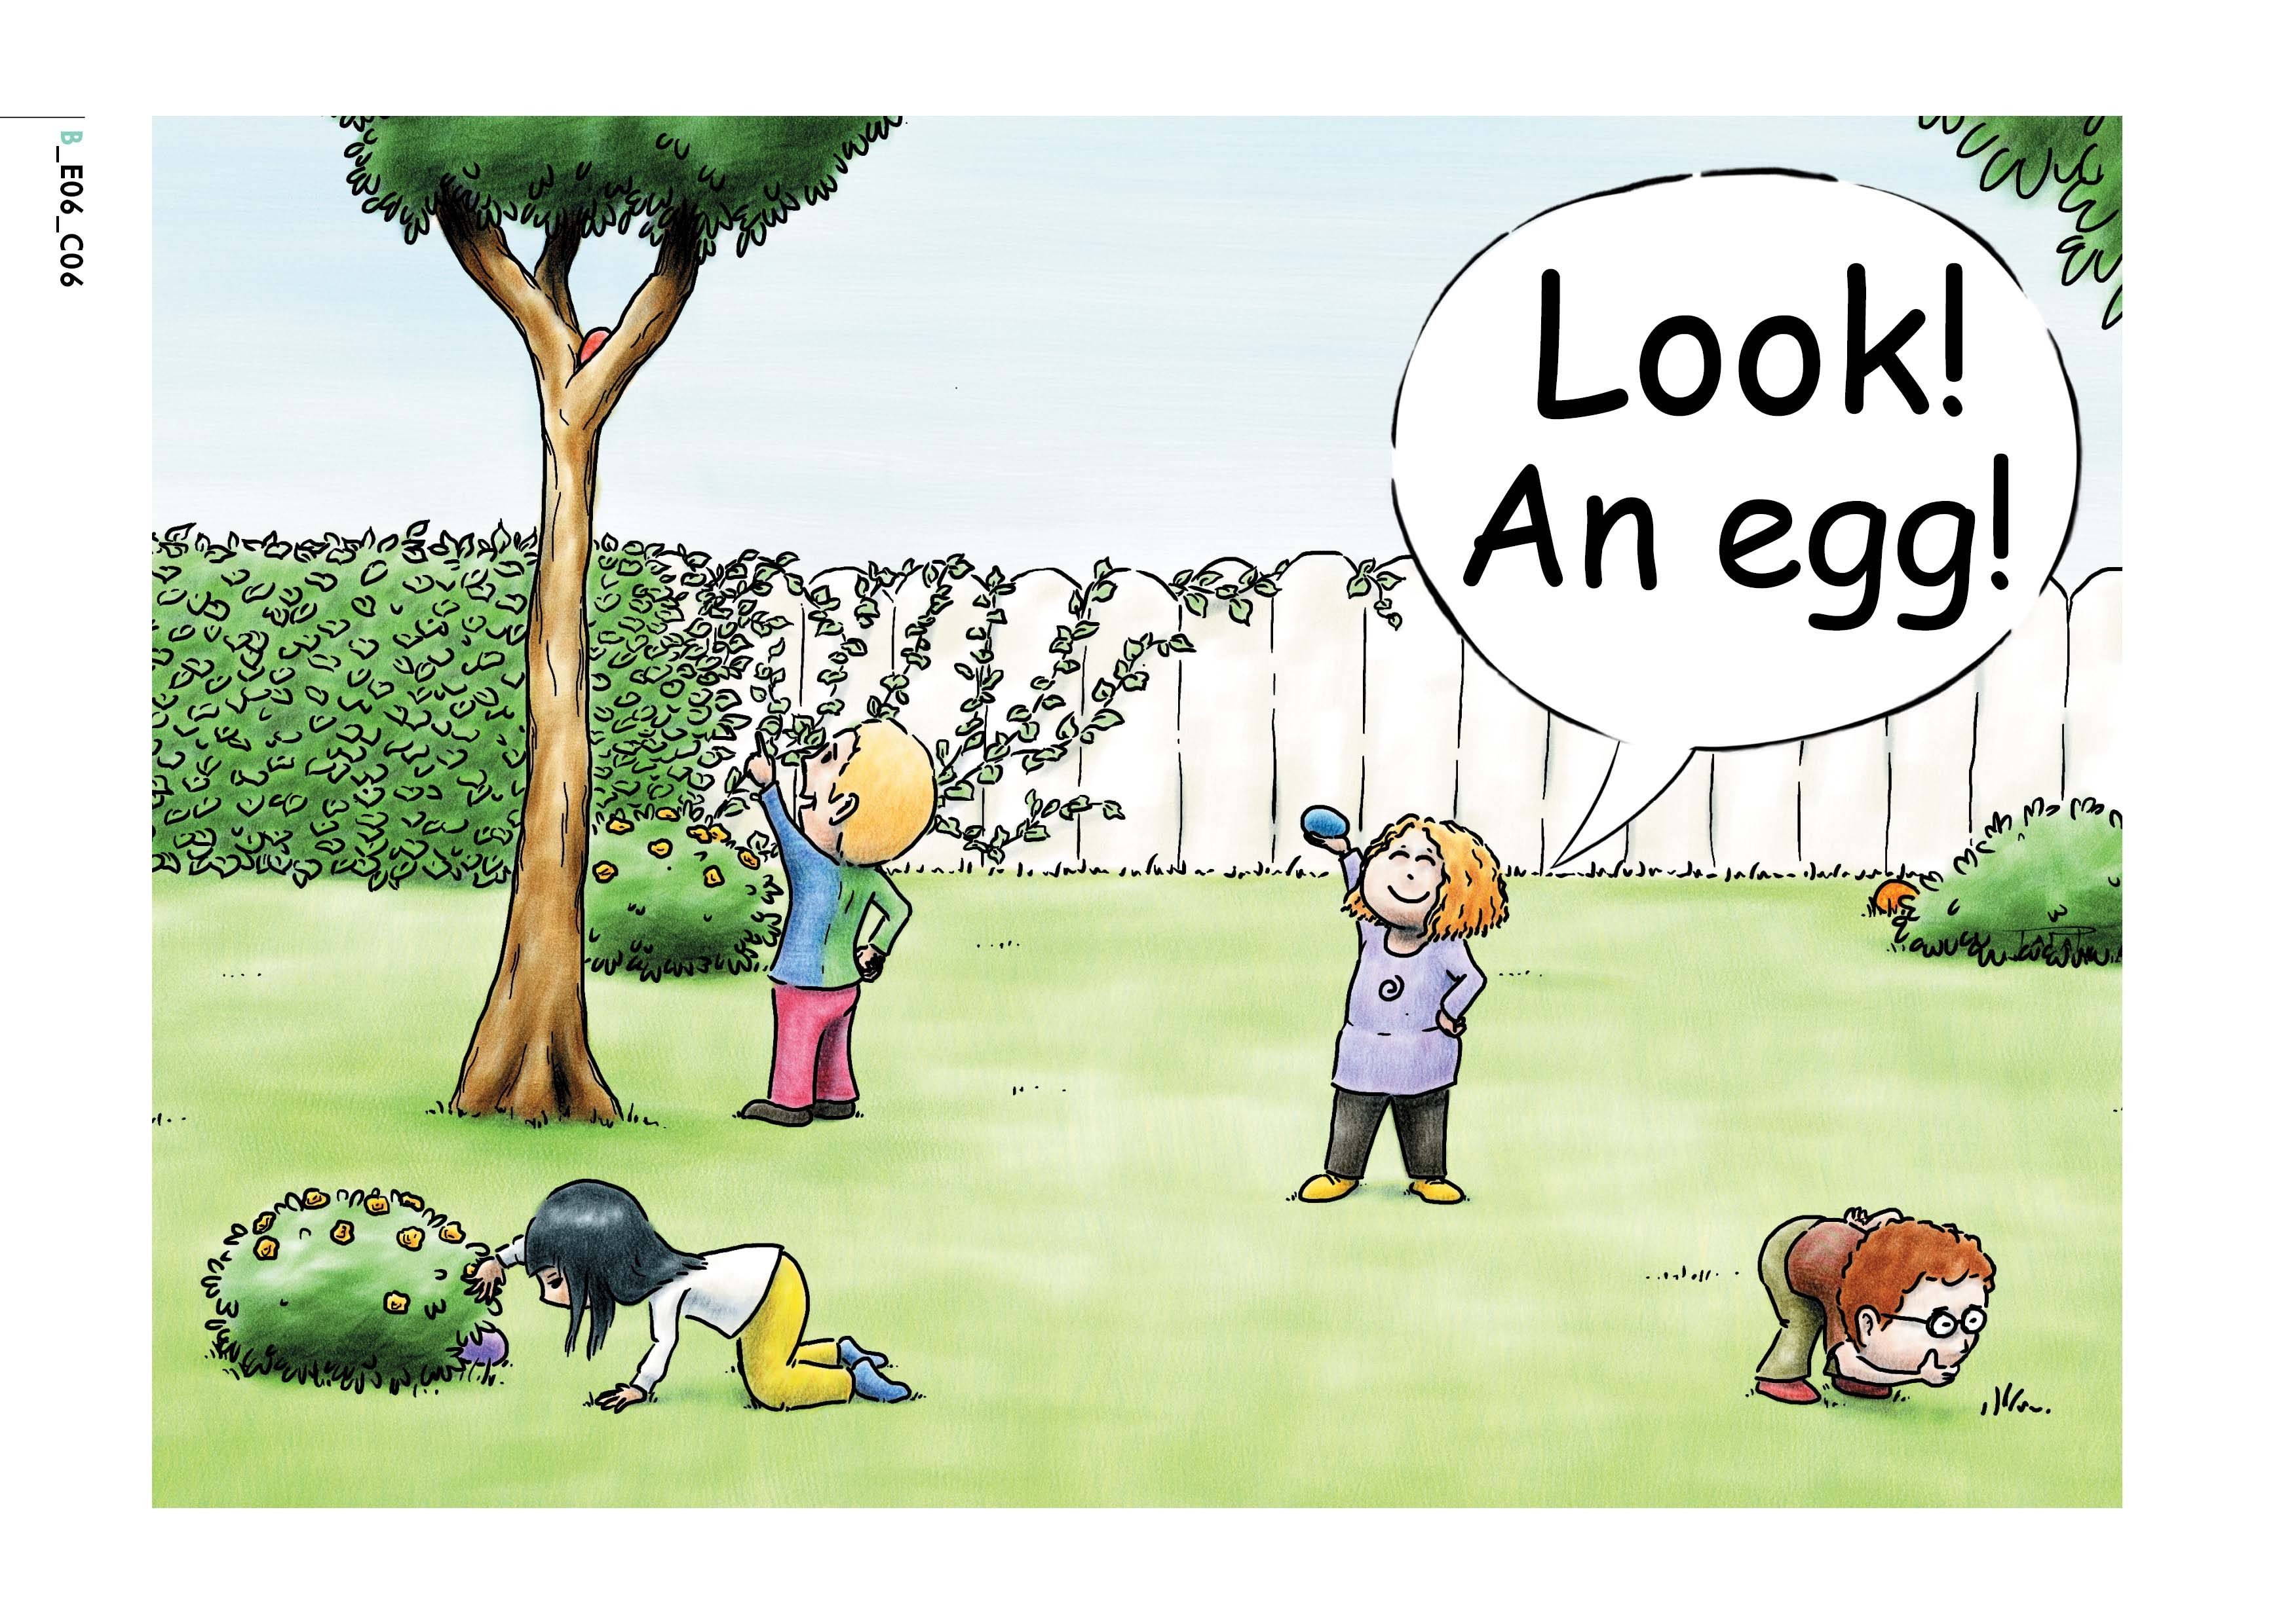
“There’s one in the tree”, says George.

“There’s one behind the flowers!” says Anne.

The children find all the eggs.

George, Anne, Mary and Tom are happy. They smile and say:

“Thank you Easter Bunny! Happy Easter!”

