Getting to know England
England is the biggest of the four countries in the United Kingdom. Together with Scotland and Wales, these three countries are the island of Great Britain. The English Channel is in the south between England and France. People travel to France by ferry across the English Channel or by train through the Channel Tunnel which goes under the sea.
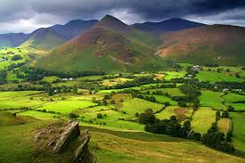

Over 50 million people live in England and that’s around 80 per cent of the total UK population. It is a multicultural country where more than 250 languages are spoken in the capital city, London.
Other large cities in England are Birmingham, Manchester, Liverpool, Leeds and Bristol. Outside cities, England is a very green country and has many rural areas of natural beauty such as the Lake District, an area with lots of lakes in the north, and the New Forest, a big area of forest in the south of the country. Language
The official language of England is English, which is spoken today by millions of people all over the world. Many students go to England from other countries to study the language and learn about the culture.

Music
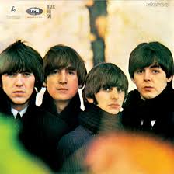

English people love music. In the summer you can go to music festivals all over the country like those at Glastonbury, Leeds or Reading. Glastonbury is a five-day festival of music, dance, comedy, theatre and circus and around 175,000 people go. Many people stay at the festivals for a few days and camp in tents. People listen to all types of music, especially pop and rock. England has produced many international groups and singers like the Beatles, Amy Winehouse, Coldplay, Ed Sheeran and Adele.

Sport
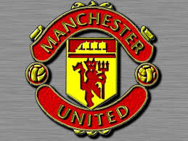

The most popular sports in England are football, rugby and cricket and most towns have a sports ground where teams can play. English football teams like Manchester United, Chelsea and Liverpool are world-famous and English football players include David Beckham, Wayne Rooney and Harry Kane. Women’s football is also popular and teams play in competitions all over the country. Cricket is a traditional sport played with a bat and ball which began in England and is now played all over the world. People like to watch all these sports on television, as well as other sports like horse racing, tennis, snooker (a type of billiards) and motor racing.Food
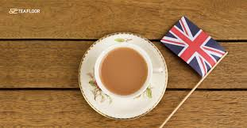

England is a very multicultural country and this has a big influence on the food people eat. Indian, Chinese and Italian cuisines are popular alternatives to traditional English food like fish and chips, roast beef or sausage and mash (mashed potatoes). Many English people drink several cups of tea every day, usually with milk. However, coffee and herbal teas are also popular. Symbols
The national flag of England is white with a red cross. It is called the St George’s Cross and Saint George is the patron saint of England. St George’s Day is on 23 April, but it’s not a public holiday. The rose is the national flower of England and the lion is the national animal. The lion is a symbol of many English sports teams.
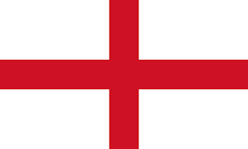

Vocabulary
Channel tunnel = το τούνελ κάτω από τη θάλασσα της Μάγχης (ενώνει Αγγλία και Γαλλία)
multicultural = πολυπολιτιστικό
rural = αγροτικό
official = επίσημο
produce = παράγω
international = διεθνής
popular = δημοφιλής
traditional = παραδοσιακό
alternative = εναλλακτική λύση
herbal teas = ροφήματα με βότανα
patron saint = φύλακας άγιος
such as = όπως για παράδειγμα
area = περιοχή

