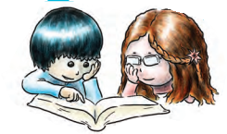

**Class C - Unit 2**

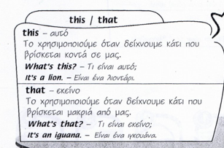 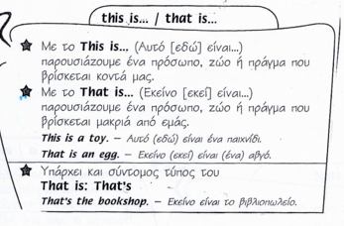

**A**. Write ***What’s this*** or ***What’s that***.

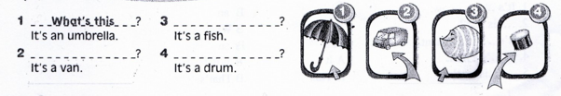

**B**. Write ***This is*** or ***That is***.

**1 2 3 4 5 6 7 8**

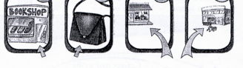. 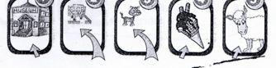

1. *This is*… a bookshop. 5. ………… a museum.

2. …………. a bag. 6. ………… a school.

3. ………… a toy shop. 7. ……….. a cat.

4. …………a supermarket. 8. ………… a sheep.

**C**. Put the words in the correct order.

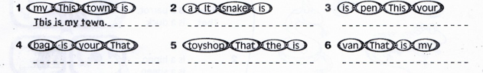

**Possessive Adjective's (Κτητικά Επίθετα)**

**My** (μου)                                                                          This is **my** book

**Your** (σου)                                                                      Is this **your** bike?

**His** (του = για έναν άντρα/αγόρι)                              This is Jim's bike. It is **his** bike.

**Her** (της = για μία γυναίκα/ένα κορίτσι)                    That is Tina's kite. It is **her** kite.

**Its**  (του = για ένα ζώο ή πράγμα)                                This is the rabbit's carrot. It is **its** carrot.

**Our** (μας)                                                                          This is my family and this is **our** house.

**Your** (σας)                                                                         These are **your** schoolbags.

**Their** (τους = για πολλά πρόσωπα, ζώα, πράγματα) They are footballers. This is **their** ball.

**D.** Fill in ***my, your, his, her, its, our*** or t***heir***.

1. I’ve got a car. This is …*my*... car.

2. That is Billy and that’s …………… bike.

3. She’s got a video camera. It’s ……… video camera.

4. They’ve got sunglasses. They’re …………… sunglasses.

5. You’ve got a computer. It’s …………. computer.

6. We’ve got shorts. They’re ………….. shorts.

7. The rat has got a tail. It’s …….. tail.

8. Mary and Tom have got white T-shirts. They’re …………….. T-shirts.

9. This is Mary and this is …………. dog.

10. He’s got a black jacket. It’s ……… jacket.