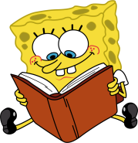 **Class C’**

**UNIT 2 – Captain Cook**

**LESSON 1: The magic map**

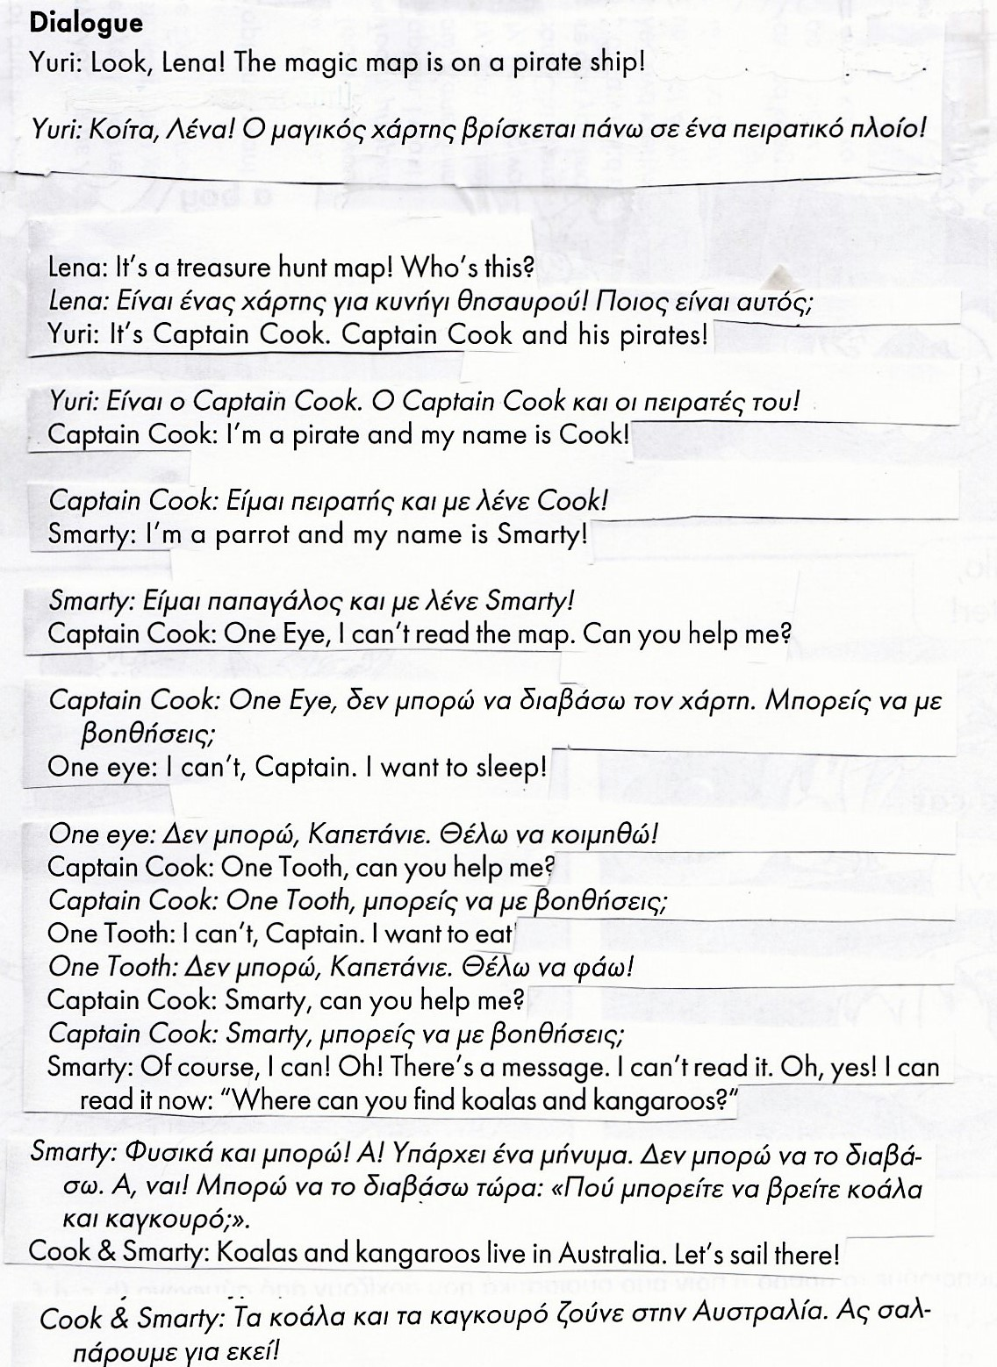

**LESSON 2: On the big island**

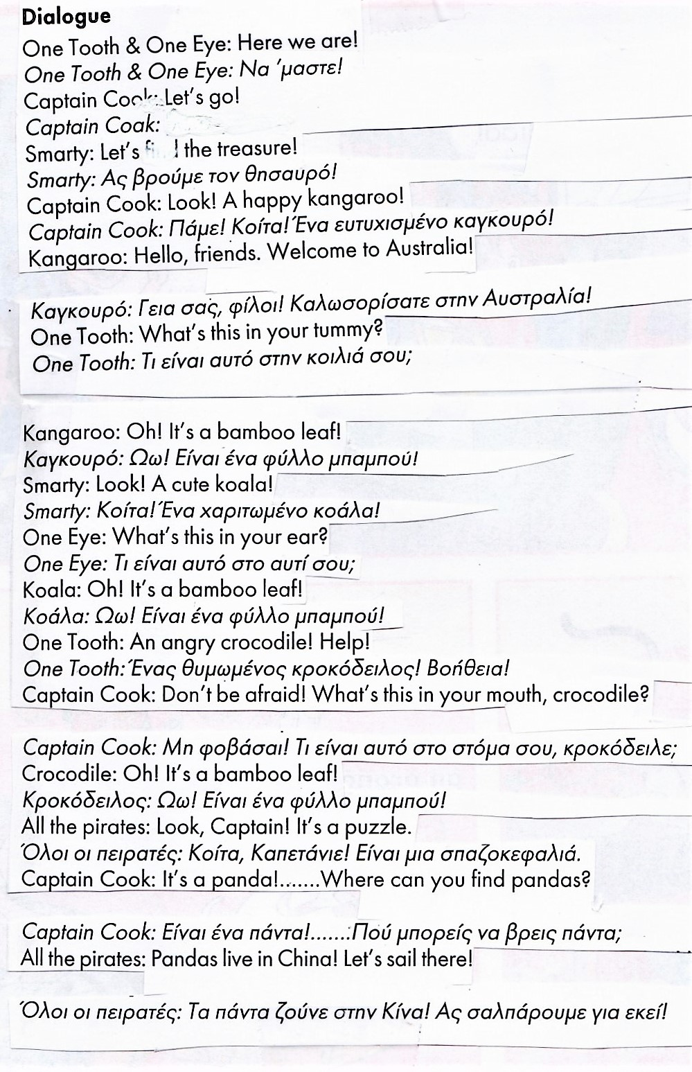

**LESSON 3: The dragon’s house**

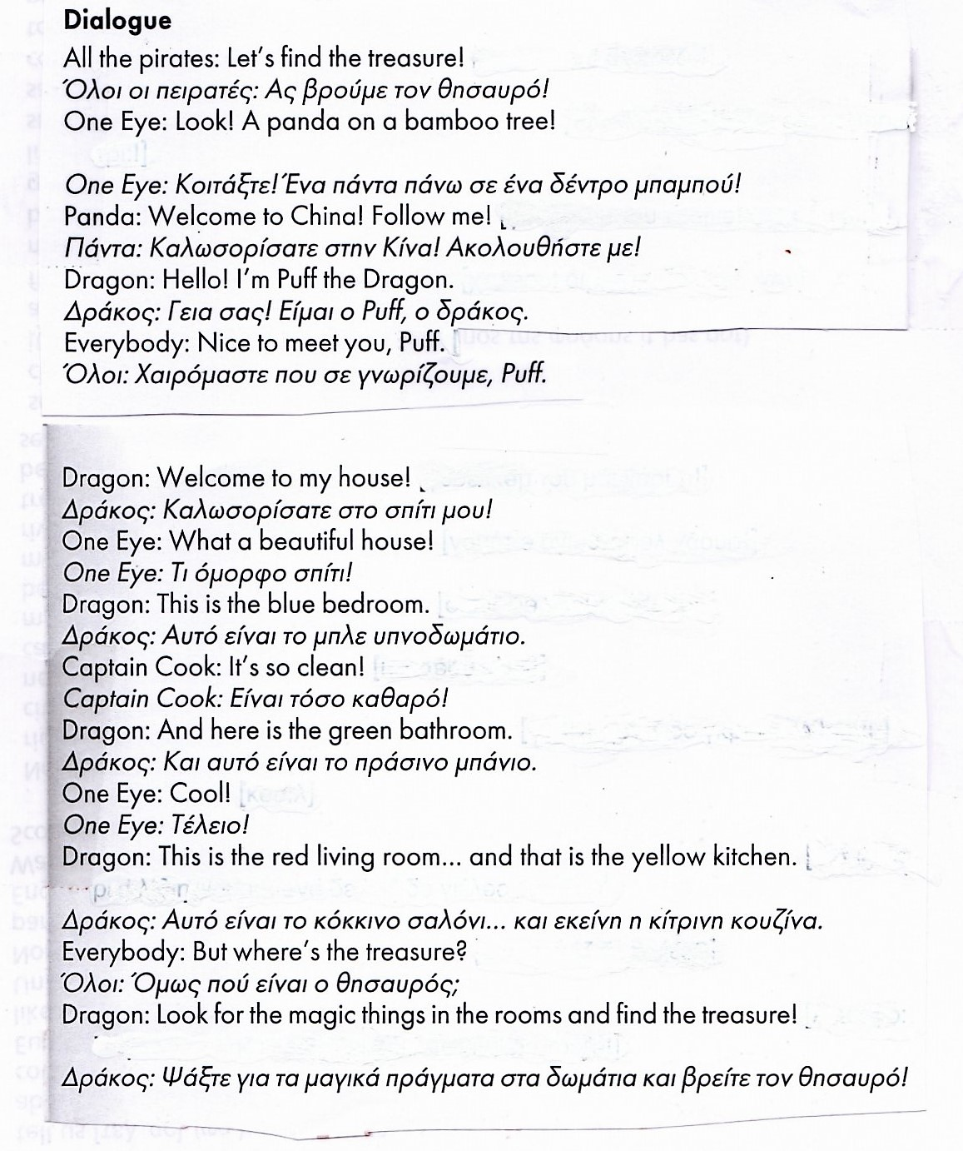



**Be: He / She / It is… - He / She / It is not… - Is he /she / it…?**

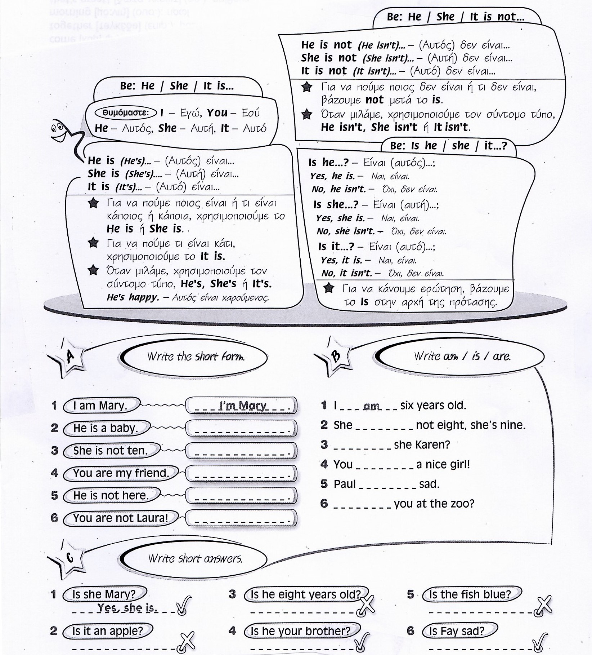

**Be: We / You / They are… - We / You / They are not… - Are we /you / they…?**

