 **Class C’**

**UNIT 4 – The Weasel and the Mole**

**LESSON 1: In the cellar**

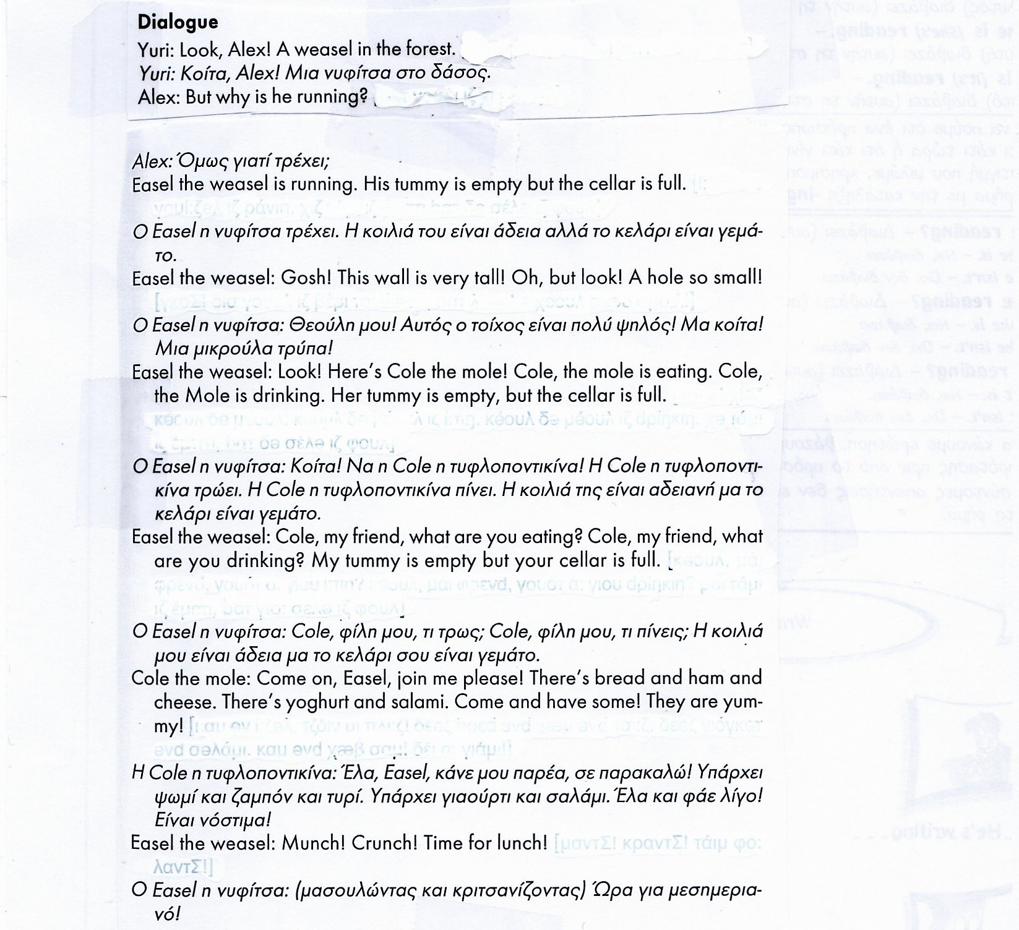

**LESSON 2: Time for lunch**

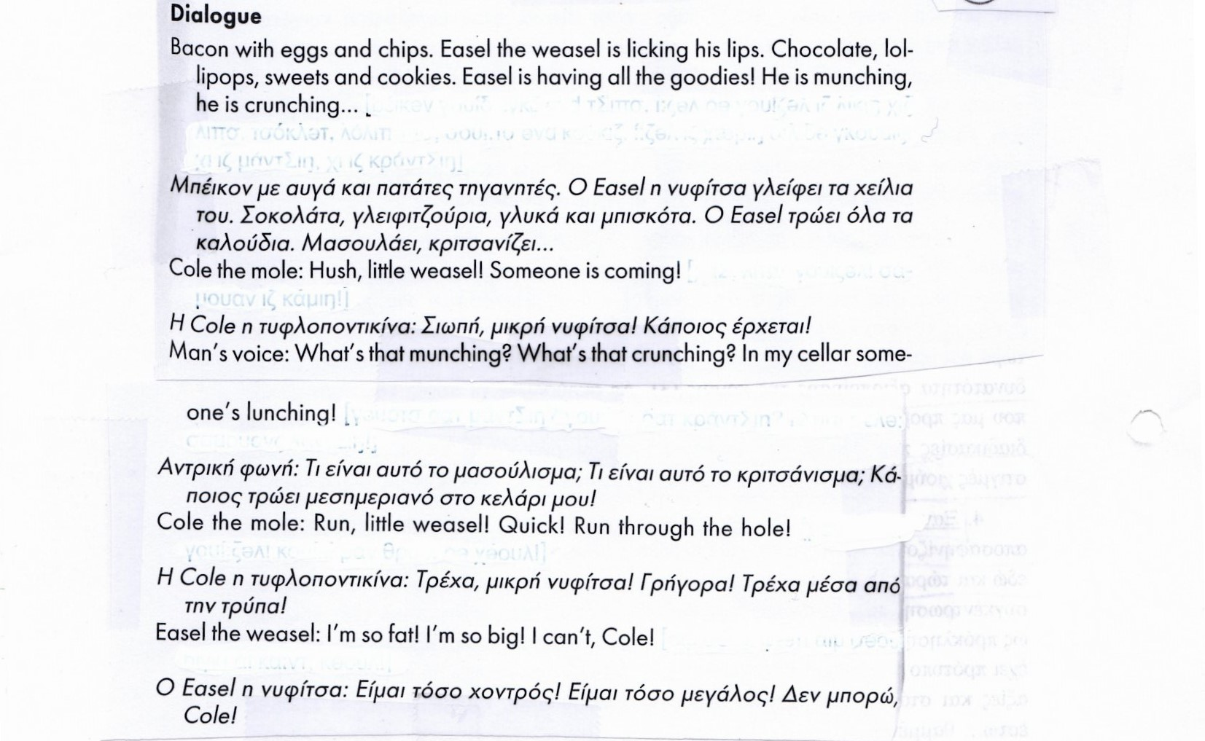

**LESSON 3: The right kind of food**

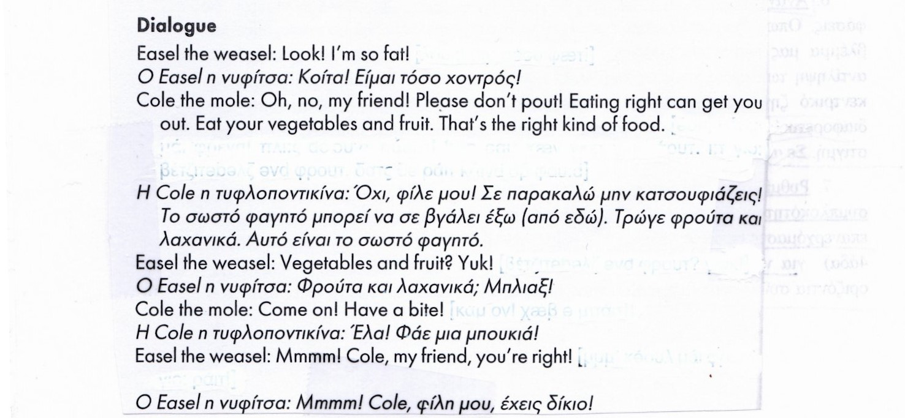

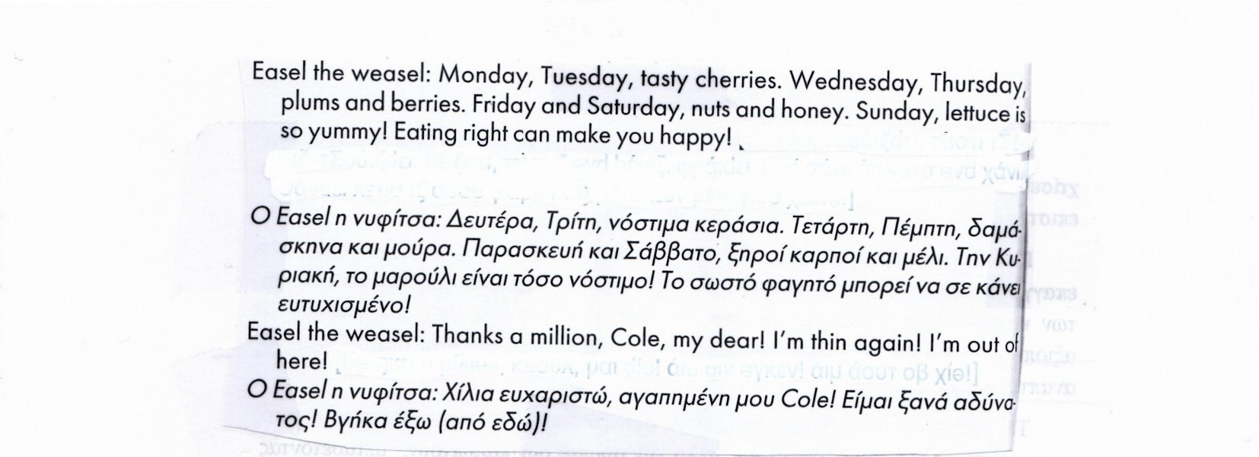



**There is – There are**

Με το **There is** μπορούμε να περιγράψουμε τι **υπάρχει** σε κάποιον χώρο π.χ.

There is a bookcase in the classroom.

Ενώ το **There are** χρησιμοποιείται στον πληθυντικό και σημαίνει **υπάρχουν** π.χ.

There are some pencils in my pencil case.

**Ερώτηση – Άρνηση**:

Is there a dog in the house? Yes, there is / No, there isn’t.

Are there books in the bookcase? Yes, there are / No, there aren’t.

Μελετήστε τον παρακάτω πίνακα για να δείτε τους τύπους του **There is – There are**:

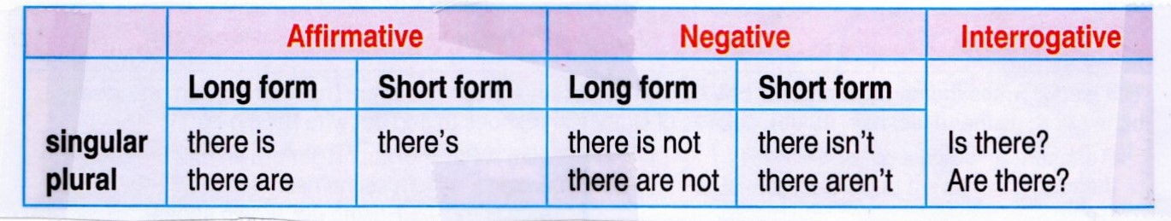



**A.** Write **There is - there isn’t / There are – there aren’t**.

0. …There is … a table in the kitchen.

1. ………………. three boys in the garden.

2. ………………. a lion at the zoo? - Yes, ……………

3. Is there a pond in your garden? - No, …………….

4. ………………. ten rooms in your house? - No, ……………

5. ………………….. a lamp on my desk.

6. ……….. a desk in your bedroom? - Yes, ……………

7. ………………. five eggs in the nest.

8. …………. six chairs in the dining room? - Yes, ……………

9. ……………..four photos on the wall.

10. ……………. a bed in the kitchen? - No, …………….



**B.** Write the answers.

