 **Class C’**

**UNIT 5 – The Animal School**

**LESSON 1: School is fun**



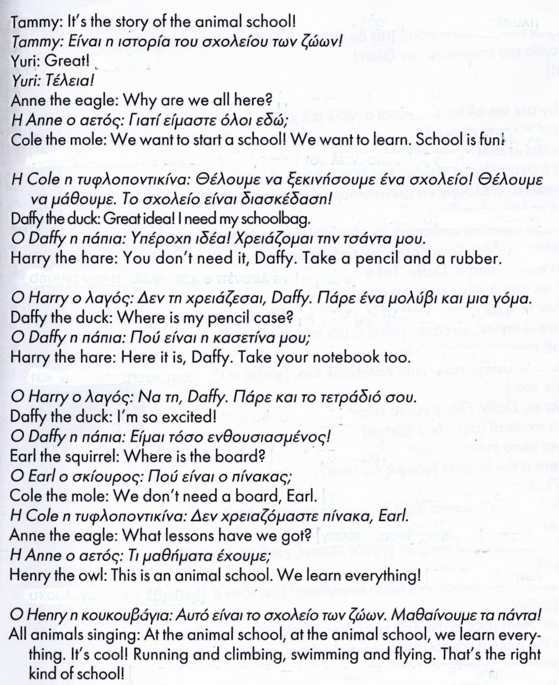



**LESSON 2: Lessons at the animal school**

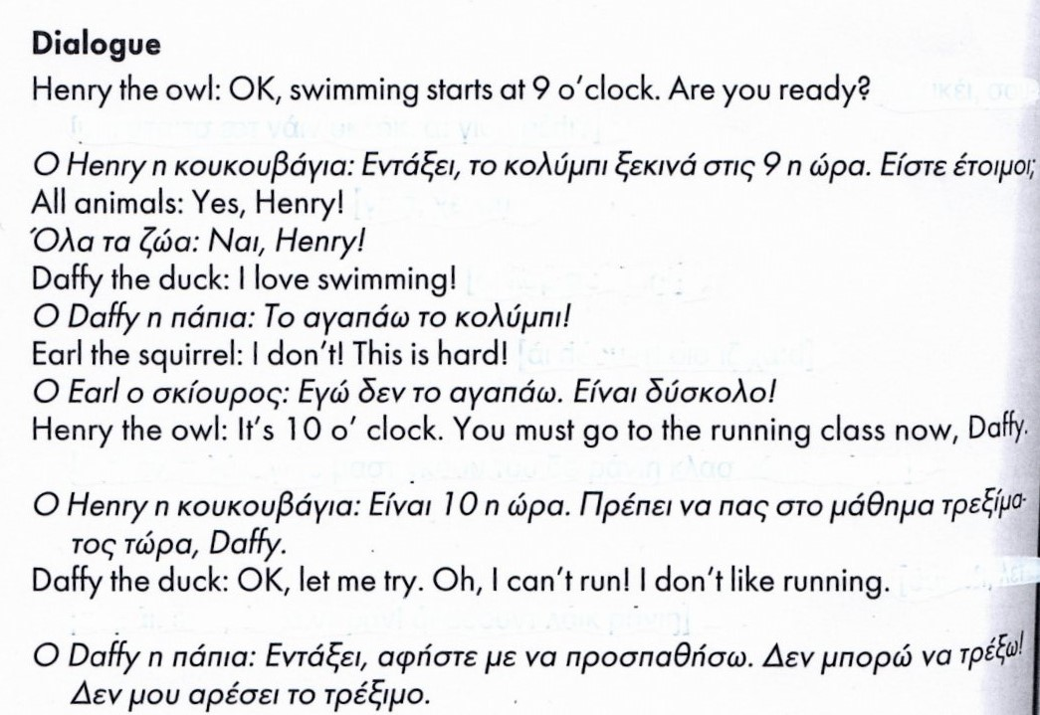

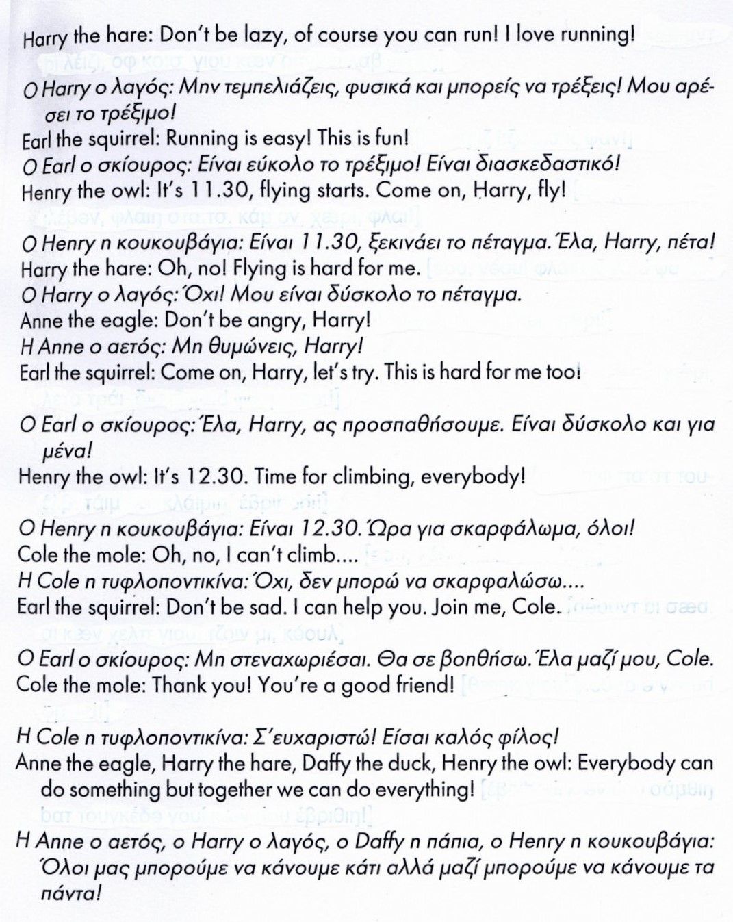

**LESSON 3: A bright world**

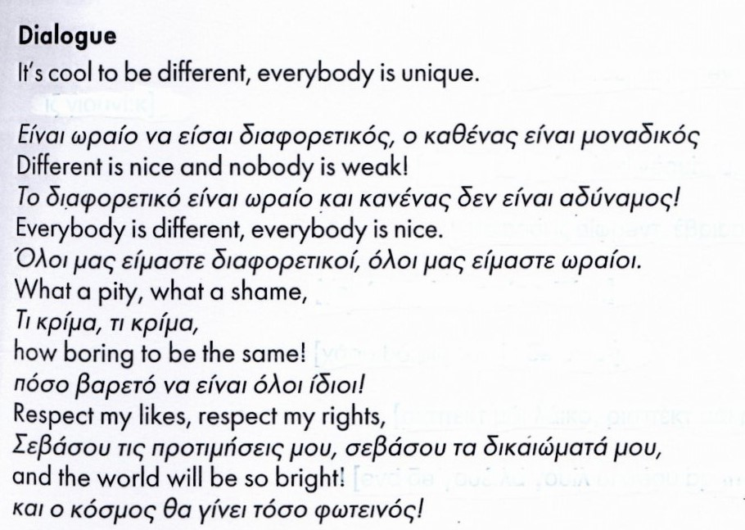

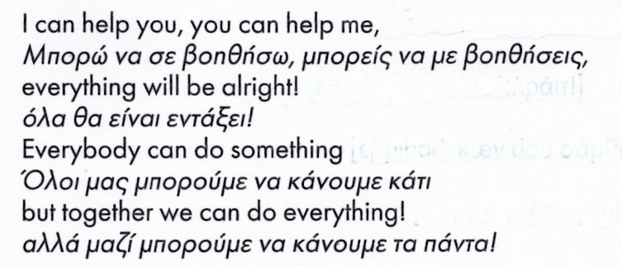



**Telling the time**

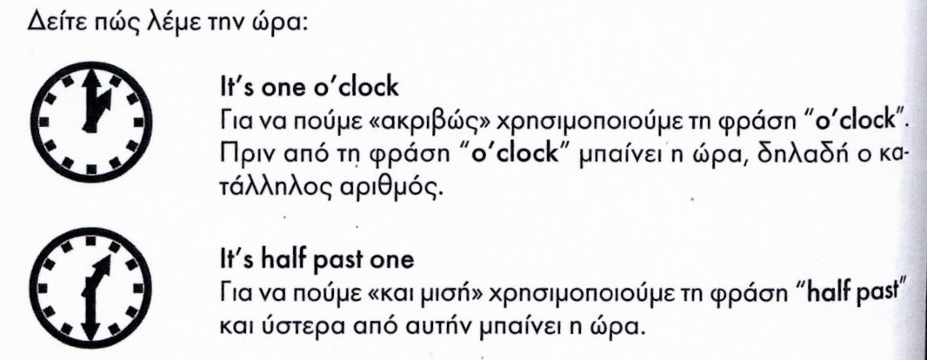

**Can / Cannot / Can’t (Μπορώ / Δεν μπορώ)**

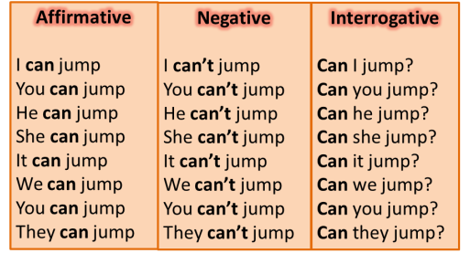

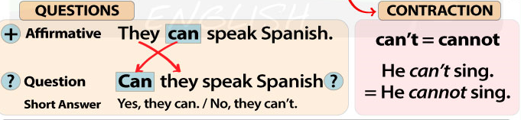



**Α. What’s the time? -** Κοίτα τα ρολόγια και γράψε την ώρα.

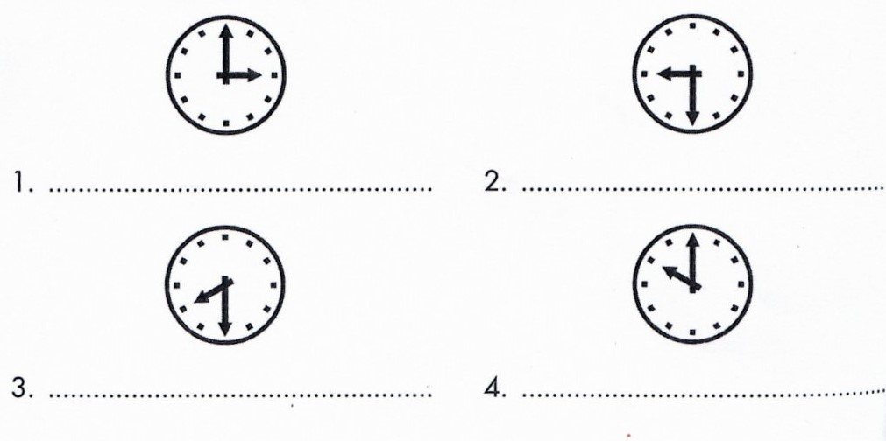



**B.** Ταίριαξε τα αντίθετα.

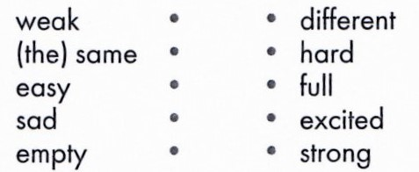



**C.** Ταίριαξε τις ερωτήσεις με τις απαντήσεις.

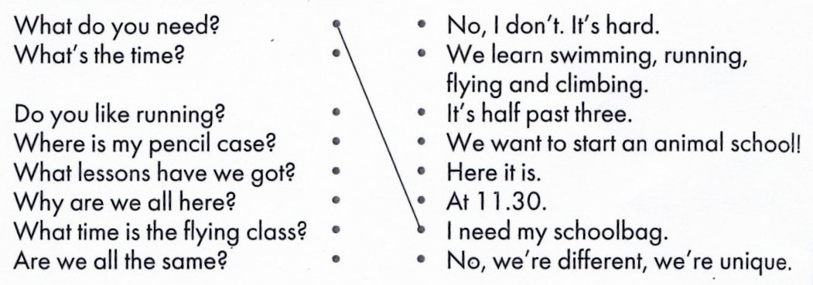

**D.** Κοίταξε τον πίνακα και συμπλήρωσε τις προτάσεις με **can** ή **can’t** .

|  |  |  |  |  |  |  |
| --- | --- | --- | --- | --- | --- | --- |
|  | **Imagem3** | **Imagem4** | **Imagem5** | **j0349109[1]** | **j0397446[1]** | **j0365702[1]** |
| **Ann** | **×** | **✓** | **✓** | **✓** | **×** | **✓** |
| **Mike** | **✓** | **×** | **×** | **×** | **✓** | **✓** |
| **Tim and Samantha** | **×** | **✓** | **×** | **✓** | **✓** | **×** |
| **Cathy** | **✓** | **×** | **✓** | **×** | **✓** | **✓** |
| **John and Paul** | **✓** | **×** | **✓** | **×** | **✓** | **×** |

1. Mike can dance **but** Ann ___________.
2. Cathy _______ swim **but** she ___________ cook.
3. Tim and Samantha ______________ ride a bike.
4. John and Paul __________ play the guitar **but** they __________ sing.
5. Mike ________play the guitar **but** Cathy __________.
6. Mike ________ ride a bike **but** he ________ cook.
7. Tim and Samantha ________ swim **but** they _________ sing.