 **Class C’**

**UNIT 6 – The Emperor’s New Clothes**

**LESSON 1: Nothing looks right**

**Dialogue**

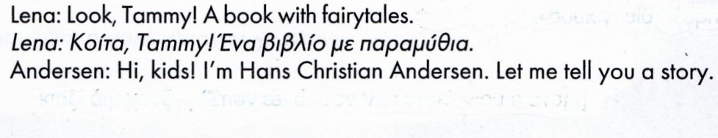

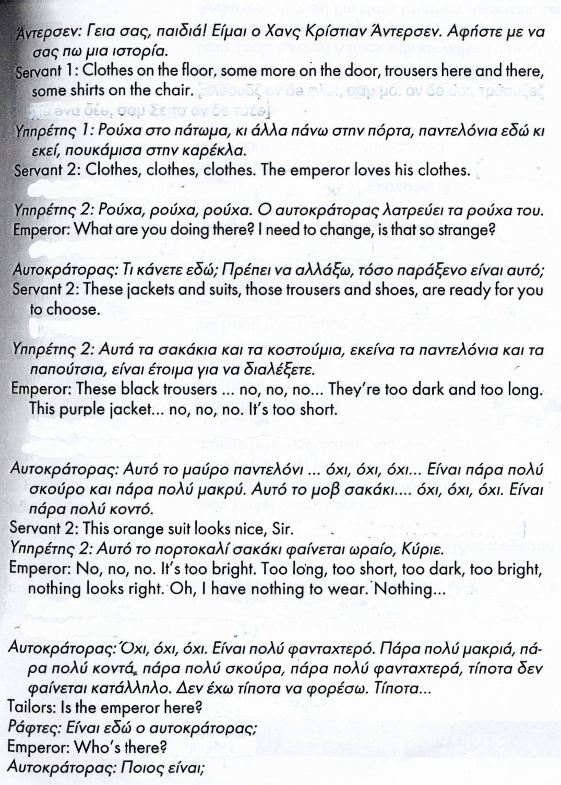



**LESSON 2: The emperor’s special suit**

**Dialogue**

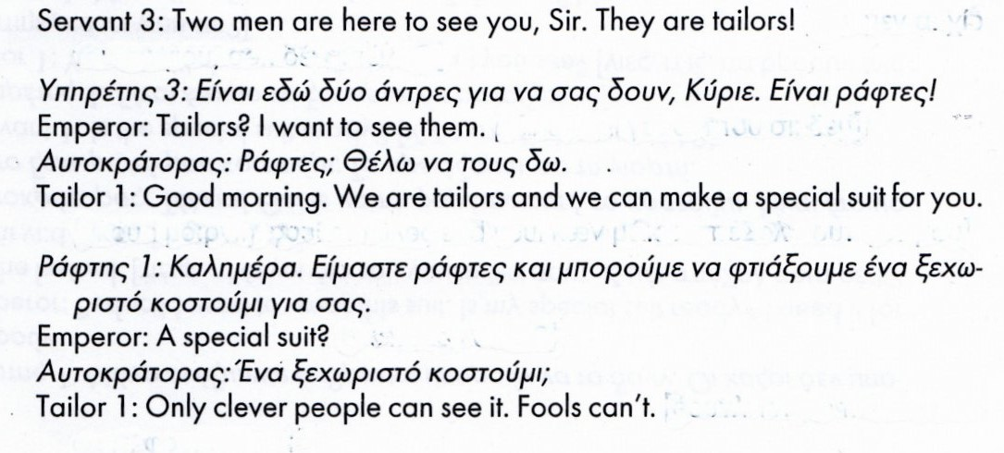

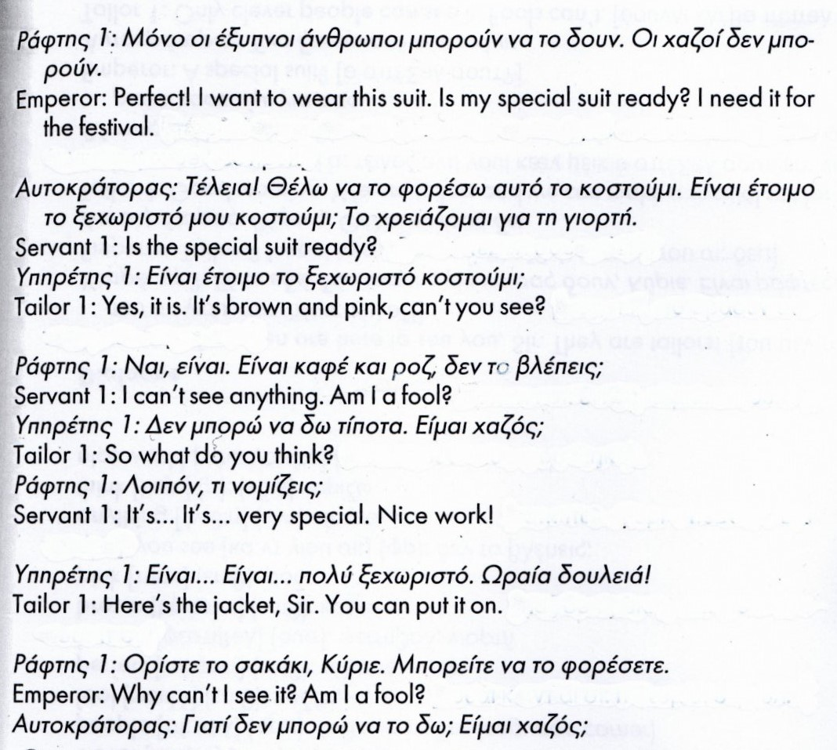

**LESSON 3: At the festival**

**Dialogue**

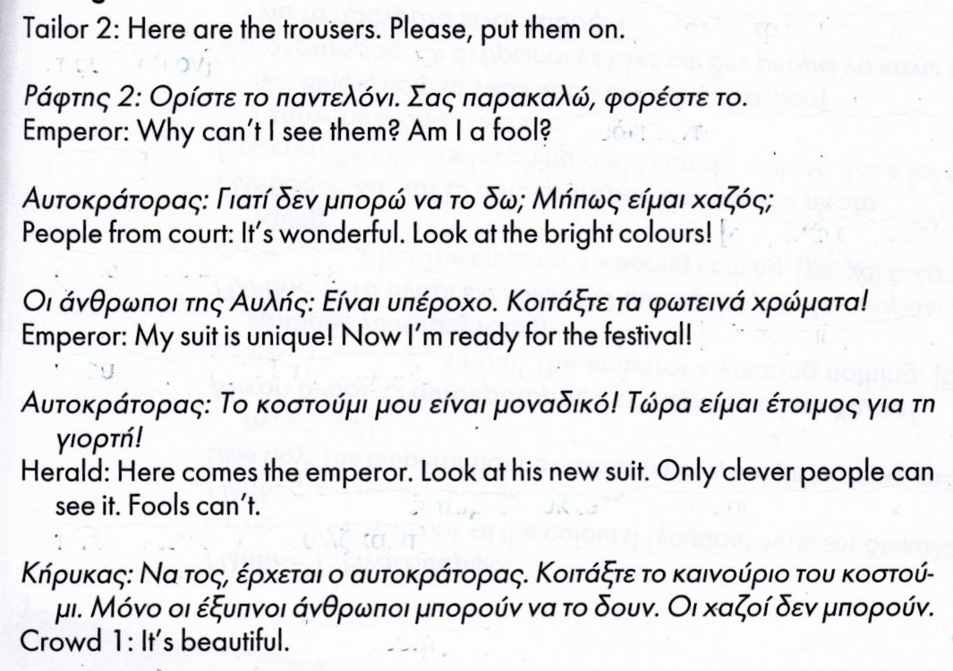



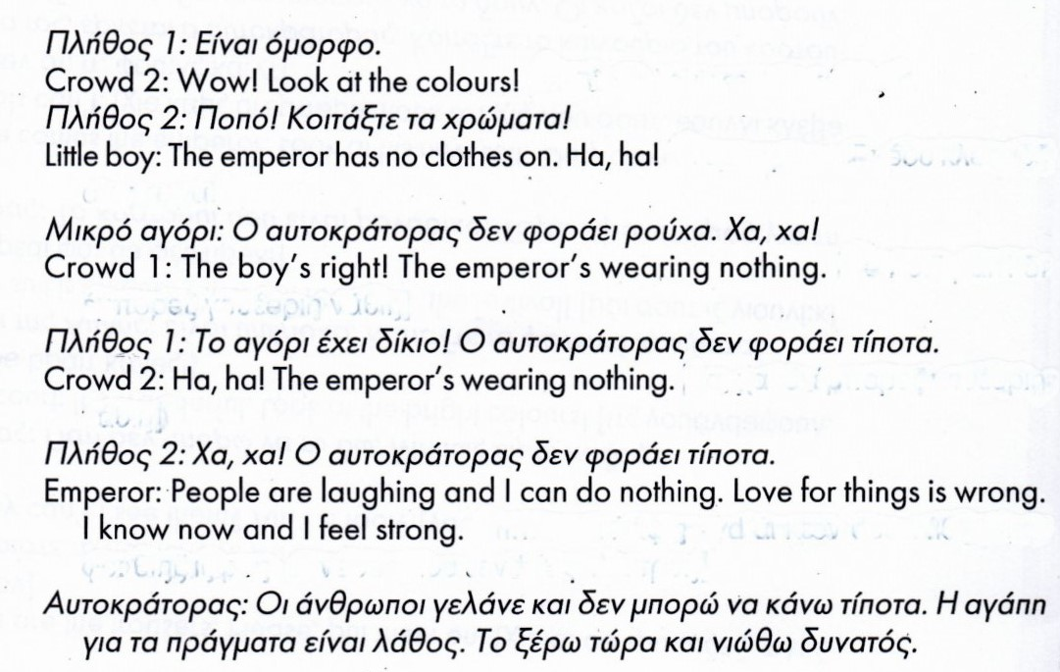



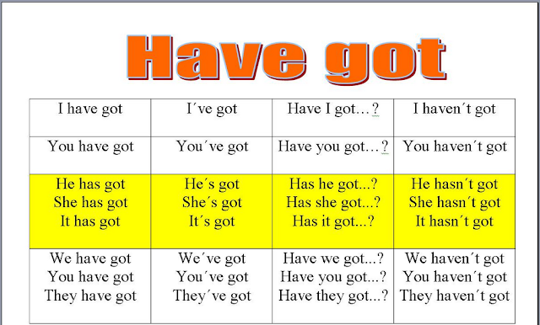



1. **Complete the sentences with have got and has got.**
2. She ………………………...a red pencil.
3. They ………………………. a big book.
4. We ………………………….two cats.
5. He …………………………..a red car.
6. You …………………………a bike.
7. My phone …………………………………a camera.
8. Sue and Tom ………………………..a nice teacher.
9. The children ………………………………computers.
10. We ……………………………..a big dog.
11. She …………………………..a goldfish.
12. **Choose the correct option.**
13. George **hasn’t/ haven’t** got short red hair.
14. Isabel **hasn’t/ haven’t** got brown eyes.
15. Tom and Max **hasn’t/ haven’t** got blue eyes.
16. Carla **hasn’t/ haven’t** got dark hair.
17. Milly and Louise **hasn’t/ haven’t** got blue eyes.
18. I **hasn’t/ haven’t** got a good phone.
19. Kate and Jamie **hasn’t/ haven’t** got a television.
20. We **hasn’t/ haven’t** got a bike.
21. He **hasn’t/ haven’t** got a piano.



1. **Make questions.**
2. Tom and Max have got blue eyes.

*Have Tom and Max got blue eyes?*

1. Carla has got dark hair.

___________________________________________

3. Ted has got an umbrella.

___________________________________________

4. They have got two cats and a dog.

___________________________________________

5. Ben has got a lot of books.

___________________________________________

6. My parents have got a big bedroom.

___________________________________________

7. Your dad has got a motorbike

___________________________________________

8. My friends have got pets.

___________________________________________

**REMEMBER!**

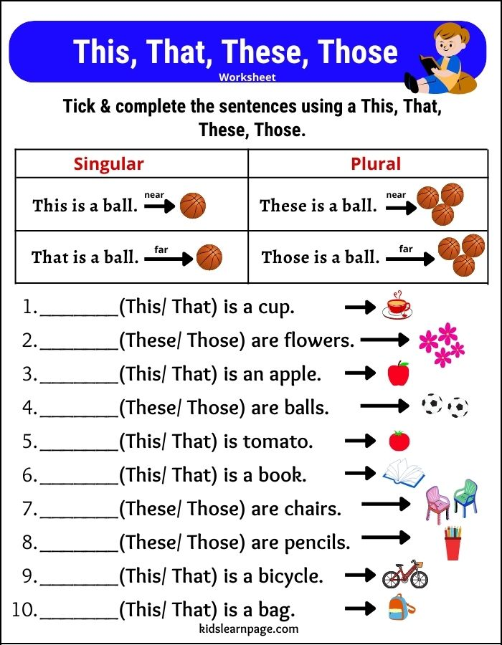

**REMEMBER!**

