Name______________________
Nº ___ Class ___ Date ___/__/__

 | 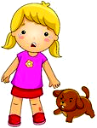  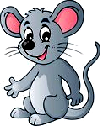  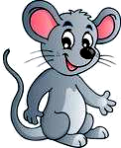 |  | 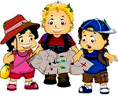  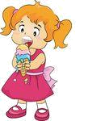 | 
1. This cat is so cute! ______ tail is long! | 2. This is Susan. ____  dog is brown. | 3. These mice are so pretty! ______hair is grey. | 4. I am eating _____  favourite ice cream. | 5. They are looking for _____ hidden treasure.
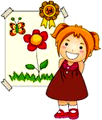   |  |  | 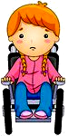 | 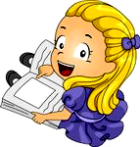
6. Julia won the first prize.  _____ mother likes  _____ drawings. | 7. I’m Peter. Look at _____ house. | 8. This is a sunflower. _____  shape reminds us of the Sun. | 9. I had an accident.  ____ wheelchair is comfortable. | 10. Don’t forget to do ____ homework.
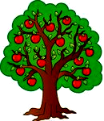  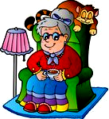 | 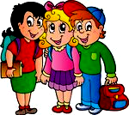 |  | 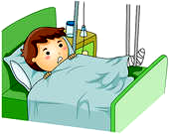 | 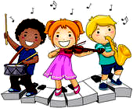
11. They own an orchard.  ________apple trees are full of apples. | 12. Grandma has a pet.  ______favourite animal is the cat. | 13. We are going to school. The bus stop is near ____ house. | 14. I am in hospital. I’m waiting for ____  friends. | 15. He plays at school with _____ friends. ___  band is great!
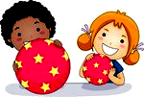 |  | 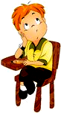 | 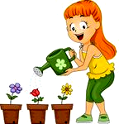 | 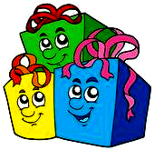
16. We are playing with  ____ balls. | 17. Mary is a cheerleader. ____ team is fantastic. | 18.He is trying to do _____ best. | 19. I am watering ____ mother’s plants. | 20. You received these gifts. They are _____  gifts.

Key:

1. Its
2. Her
3. Their
4. my
5. their
6. Her / her
7. my
8. Its
9. My
10. your
11. Their
12. Her
13. our
14. my
15.his / Their
16. our
17. Her
18. his
19. my
20. your

