
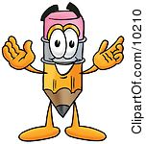

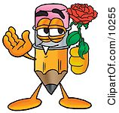
I
You
He
He
She
It

Make questions :
Jake/ tall ?____________________________________________
They / happy? ________________________________________
My dog/ small? _______________________________________
You / Spanish? ________________________________________
Students /good?_______________________________________
Linda/ pretty?_________________________________________
Your mother/ a teacher?_________________________________
We/friends?___________________________________________
Justin/ famous?________________________________________
Spain/ in Europe?______________________________________

WRITE THE CORRECT PRONOUN
Jenny ___________
A cat ___________
Students ___________
My mother ___________
My friends ___________
Jack ___________
Books ___________

FILL IN WITH AM, IS , ARE
That flower ___________ very pretty
Mike _________a very nice boy
They ________ always late
Linda ________very tall
Those chairs _______very expensive
My dog __________small
Your mother ________a teacher

Now write short answers
Yes, _______________________
Yes, _______________________
No, _______________________
Yes, _______________________
No, _______________________
Yes, ______________________
No,_______________________
Yes, ______________________
Yes, ______________________
Yes, ______________________

Fill in the blanks with the correct form of the verb to be:
Hello, my name _____James. I_______13 years old. I _________ a student. My father_________Michael. He ________40 years old and my mother _________Lara. She _________38. They __________doctors. Mitch _____ my older brother. He ______ 15 and Matt ________ my younger brother. He ______ 10.They ________ also students. We _________ also footballers. We play in a football team. My best friends _________ Tom and Peter. They ________ students too. Tom _________ 12 and Peter___________14.
THE VERB TO BE
We
They

