**CLASS D**

**UNIT 1 - Lesson 1**

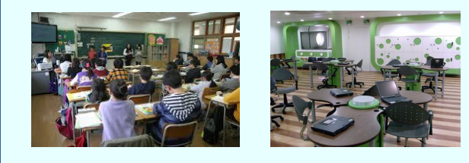

* These are the pictures of two classrooms. Can you describe them?
* Which classroom do you prefer and why?
* Look at the pictures of the two classrooms again. How do you think the students work in each classroom? Which way do you prefer? Why?
* Now look around you. What is your classroom like? Can you describe it? What changes would you suggest and why?