 **Class: D**

**Unit 3 – This is where I live!**

**Lesson 1: My country (Page 34)**

1. Country = χώρα e.g. My country is Greece!

2. Capital city = πρωτεύουσα

3. Europe - European = Ευρώπη – Ευρωπαϊκός

4. Where? = Πού;

5. Part = μέρος, κομμάτι

6. North = Βορράς e.g. Veria is in the North of Greece.

7. South = Νότος

8. East = Ανατολή

9. West = Δύση

10. City = πόλη

11. Near = κοντά

12. More = περισσότερο, πιο πολύ e.g. Tell me more about your favourite place!

13. Mountain = βουνό

14. River = ποτάμι

15. Beach = παραλία

16. Sea = θάλασσα

**Pages 35 - 37**

**NATIONALITIES = Εθνικότητες**

1. Italy – Italian = Ιταλία - Ιταλός

2. England – English = Αγγλία - Άγγλος

3. The United Kingdom – British = Μεγάλη Βρετανία - Βρετανός

4. Egypt – Egyptian = Αίγυπτος – Αιγύπτιος

5. China – Chinese = Κίνα – Κινέζος e.g. He is from China. He is Chinese.

6. Greece – Greek = Ελλάδα – Έλληνας

7. Albania – Albanian = Αλβανία -Αλβανός

8. Where are you from? = Από πού είσαι?

9. Flag = σημαία e.g. Our flag is white and blue.

10. Guess = μαντεύω

11. Remember = θυμάμαι e.g. I never remember my password!

**Lesson 2: My city! (Pages 38 - 39)**

1. building = κτίριο

2. village = χωριό e.g. My friend lives in a small village.

3. town = κωμόπολη

4. city = πόλη, μεγαλούπολη

5. post office = ταχυδρομείο

6. theatre = θέατρο e.g. I love going to the theatre.

7. museum = μουσείο

8. shopping centre = εμπορικό κέντρο

9. block of flats = πολυκατοικία

10. sports centre =αθλητικό κέντρο

11. church = εκκλησία

12. bank =τράπεζα e.g. People put their money in banks.

13. clean ≠ dirty = καθαρός ≠ βρόμικος

14. garden = κήπος

15. same ≠ different = ίδιος ≠ διαφορετικός

16. together = μαζί

17. next to = δίπλα σε

18. between = ανάμεσα e.g. The bank is between the supermarket and the café.

19. on the corner of = στη γωνία e.g. The gym is on the corner of Pefkon street and

Aretis street.

20. a lot of= πολύς (πολλή, πολύ, πολλοί, πολλές, πολλά)

21. but = There aren’t many blocks of flats but there are a lot of houses with gardens.

**Lesson 3: Let’s talk about Greece (Page 42)**

1. area = περιοχή

2. information = πληροφορίες

3. lake = λίμνη

4. large = big = μεγάλος

5. important = σημαντικός e.g. It is important to do your homework!

6. sights = αξιοθέατα

7. famous products = φημισμένα προϊόντα

8. festival = φεστιβάλ, γιορτή

9. rare = σπάνιος e.g. There are rare birds in this forest!

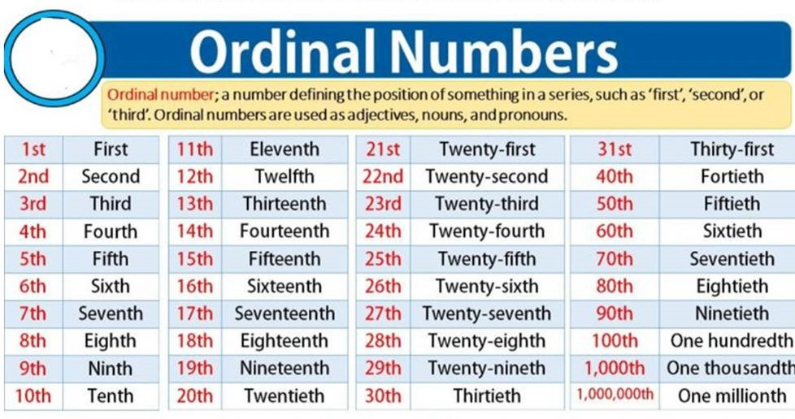



**Where are you from?**

Με την ερώτηση “Where are you from?” ρωτάμε από πού είναι κάποιος. Μπορούμε να χρησιμοποιήσουμε όλα τα πρόσωπα π.χ. Where are you from? I am from Greece. I am Greek – Where is John from? He is from Great Britain. He is British. Where are Maria and Claudia from? They are from Italy. They are Italian.

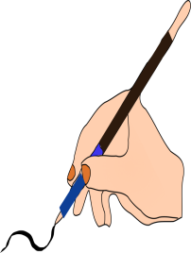 Use the information in the table below to complete the questions and answers.

|  |  |  |
| --- | --- | --- |
| **Name** | **Country** | **Nationality** |
| Tom | America | American |
| Nefeli | Greece | Greek |
| Claudio | Italy | Italian |
| Jennifer | Great Britain | British |
| Amelia | France | French |
| Yuri | China | Chinese |
| Omar | Egypt | Egyptian |

0. Where …is… Tom…from…………………………………………………………………?

He is from America. He’s American………………………………………………

1. Where ……………Nefeli……………………………………………………………………?

She …….………………………. She……………………………………………………….

2. Where ……………Claudio…………………………………………………………………?

He …….…………………………. He………………………………………………………

3. Where ……………Jennifer………………………………………………………………..?

She …….…………………………. She……………………………………………………

4. Where ……………Amelia………………………………………………………………….?

She …….…………………………. She……………………………………………………

5. Where ……………Yuri……………………………………………………………………..?

He …….…………………………. He………………………………………………………

6. Where ……………Omar……………………………………………………………………?

He …….…………………………. He………………………………………………………