 **Class: D**

**Unit 5 Habits and Customs**

**Lesson 1: It’s only a dream! (Page 58)**

1. Dream = όνειρο

2. Live = ζω, μένω e.g. Margaret **lives** in London.

3. Life = ζωή

4. Island = νησί e.g. Peter Pan lives **on an island**.

5. Wake up = ξυπνάω

6. Do my homework = κάνω τα μαθήματά μου

7. Fly = πετάω

8. Ship = πλοίο

9. War = πόλεμος

10. Funny = αστείος

11. Explore = εξερευνώ e.g. I like **exploring** caves!

12. Cave = σπηλιά

13. Late ≠ early = αργά ≠ νωρίς e.g. I always wake up **early** in the morning.

14. Realize = συνειδητοποιώ

15. Only = μόνο

16. Always = πάντα

17. Often = συχνά

18. Sometimes = μερικές φορές

19. Never = ποτέ

**Page 59**

1. Take a bath = κάνω μπάνιο

2. Take exercise = κάνω γυμναστική e.g. He **takes exercise** three times a week.

3. Get up early = σηκώνομαι νωρίς (το πρωί)

4. Go to bed late = πάω για ύπνο αργά e.g. I never **go to bed late.**

5. Clean up my room = καθαρίζω το δωμάτιό μου

6. Wash my hands = πλένω τα χέρια μου

7. Brush my teeth = βουρτσίζω τα δόντια μου

8. Make my bed = φτιάχνω το κρεβάτι μου

**Lesson 2: British customs (Page 62)**

**CHRISTMAS**

1. Most popular = ο πιο δημοφιλής

2. Holiday = γιορτή

3. People = άνθρωποι

4. Decorate = στολίζω

5. Send a card = στέλνω μια κάρτα

6. Each other = ο ένας στον άλλο

7. Carols = κάλαντα

8. Stocking = κάλτσα

9. Fried potatoes = τηγανητές πατάτες

10. Dessert = επιδόρπιο

11. Have dinner = δειπνώ

12. Riddle = γρίφος

13. Britain = Βρετανία - British = Βρετανικός

14. Roast turkey = ψητή γαλοπούλα

15. Beef = μοσχάρι

16. Dinner = δείπνο

17. Plate = πιάτο

**HALLOWEEN**

18. Pumpkin = κολοκύθα

19. Candy = καραμέλα

20. Ghost = φάντασμα

21. Witch = μάγισσα

22. Dress up = ντύνομαι μασκαράς

23. Fancy costume = αποκριάτικο κοστούμι

24. Trick or treat = φάρσα ή κέρασμα

25. From door to door = από πόρτα σε πόρτα

26. Give goodies = δίνω καλούδια

27. Spooky = στοιχειωμένος



**Present Simple – Απλός Ενεστώτας**

Ο **Present Simple** εκφράζει κάτι μόνιμο, μια γενική αλήθεια ή μια συνήθεια (εθνική συνήθεια – έθιμο ή προσωπική). Όταν εκφράζει συνήθεια ή έθιμο πολλές φορές συνοδεύεται από λέξεις που δείχνουν πόσο συχνά (How often…?) γίνεται κάτι. Αυτές οι λέξεις ή φράσεις λέγονται Επιρρήματα συχνότητας – Adverbs of frequency. Τα πιο βασικά από αυτά είναι: **always (πάντα), usually (συνήθως), often (συχνά), sometimes (μερικές φορές), never (ποτέ).** Στην πρόταση τα Επιρρήματα Συχνότητας πάνε πάντα ακριβώς πριν από το κύριο ρήμα π.χ. She always comes home early –

He doesn’t often watch TV on weekdays.

Ο Present Simple κλείνεται όπως στον παρακάτω πίνακα:

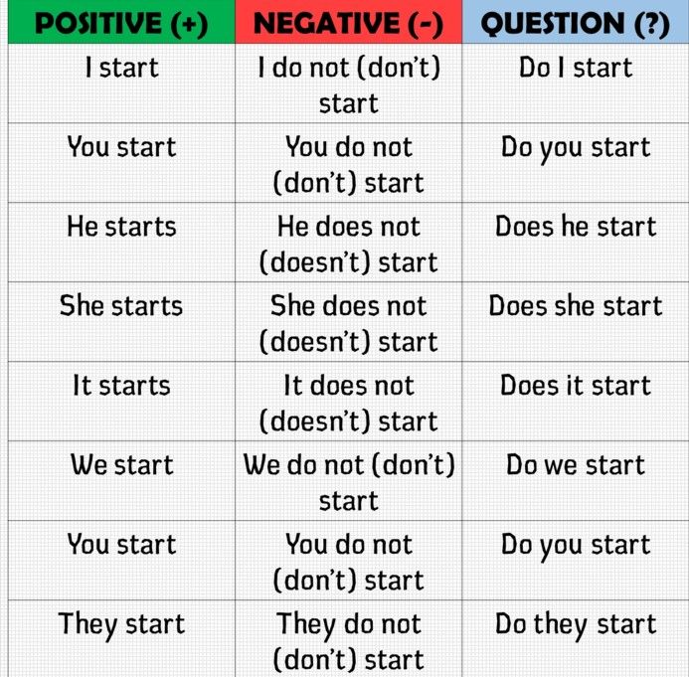

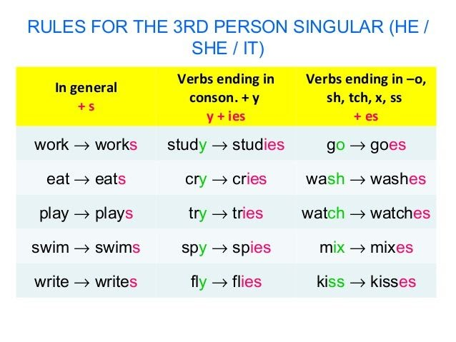

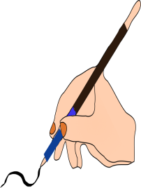**A.** Use the notes to write full sentences about the children’s habits as in the example.

0. Sam / always / brush / teeth. He / never / make / bed.

Sam *always brushes his teeth. He never makes his bed*.

1. Sam / sometimes / clean up / room. He / often / take exercise.

Sam …………………………………………………………………………………………….

2. Ken / always / brush / teeth. He / often / make / bed.

Ken ……………………………………………………………………………………………..

3. Ken / usually / clean up / room. He / never / take exercise.

Ken ……………………………………………………………………………………………..

4. Mary / sometimes / brush / teeth. She / usually / make / bed.

Mary …………………………………………………………………………………………….

5. Mary / always / clean up / room. She / often / take exercise.

Mary …………………………………………………………………………………………….

6. Helen / usually / brush / teeth. She / sometimes / make / bed.

Helen …………………………………………………………………………………………...

7. Helen / often / clean up / room. She / always / take exercise.

Helen …………………………………………………………………………………………...

**B.** Put the Adverbs of Frequency in the correct place

0. I drink a glass of milk in the morning. (always)

………….*I always drink a glass of milk in the morning*…………………………………

1. Kate goes to bed late at night. (never)

………………………………………………………………………………………………………

2. In Spring you can see clouds in the sky. (sometimes)

………………………………………………………………………………………………………

3. Joanne doesn’t get up early at the weekends. (usually)

………………………………………………………………………………………………………

4. They don’t go to the cinema in the summer. (often)

………………………………………………………………………………………………………

**C.** Write questions and negations as in the example.

0. Simon likes coffee.

….*Does Simon like coffee?* ...............................................................................................

….*Simon doesn’t like coffee* ……………………………………………………………………

1. They often play basketball on Saturdays.

………………………………………………………………………………………………………

………………………………………………………………………………………………………

2. Tom drives to work every day.

………………………………………………………………………………………………………

………………………………………………………………………………………………………

3. Our cat likes biscuits.

………………………………………………………………………………………………………

………………………………………………………………………………………………………

4. They study in Britain.

………………………………………………………………………………………………………

………………………………………………………………………………………………………

5. Samantha works in a supermarket.

………………………………………………………………………………………………………

………………………………………………………………………………………………………

6. Jim and Paul often go to the gym in their free time.

………………………………………………………………………………………………………

………………………………………………………………………………………………………

7. My mother always gets up at 7:30.

………………………………………………………………………………………………………

………………………………………………………………………………………………………

8. Miss Smith teaches Art.

………………………………………………………………………………………………………

………………………………………………………………………………………………………

9. Sue and Kelly usually wear jeans at school.

………………………………………………………………………………………………………

………………………………………………………………………………………………………

10. Susan washes her hair every day.

………………………………………………………………………………………………………

………………………………………………………………………………………………………