 **Class: D**

**Unit 7 – What are you doing?**

**Lesson 1: Helping around the house (Page 82)**

1. Kitchen = κουζίνα e.g. Grandma is cooking in the **kitchen**.

2. Just a minute = μια στιγμη, ένα λεπτό

3. Finish = τελειώνω

4. Maths = Μαθηματικά(Η λέξη Maths είναι Ενικού Αριθμού) e.g. Mary thinks that

**Maths is** difficult.

5. Exercise = άσκηση

6. I’ll only be a minute = θα κάνω μόνο μια στιγμή

7. Need = χρειάζομαι e.g. Mum, I **need** your help with this exercise.

8. Beat = χτυπώ (ένα μίγμα)

9. By the way = μια που το’φερε η κουβέντα

10. Take out = βγάζω

11. Clothes = ρούχα (μόνο πληθ.) e.g. Your new **clothes** are beautiful!

12. Washing machine = πλυντήριο ρούχων

13. It seems = φαίνεται e.g. **It seems** that this animal is dangerous.

14. Everybody = όλοι

15. Around the house = στο σπίτι

**Page 83 Housework – Δουλειές του σπιτιού**

1. Sweep = σκουπίζω e.g. Look at Sue! She is **sweeping!**

2. Make the beds = στρώνω τα κρεβάτια

3. Washing up = πλύσιμο πιάτων e.g. I don’t like **washing up**.

4. Set the table = στρώνω το τραπέζι e.g. I never **set the table.**

5. Cook = μαγειρεύω

6. Wash the floor = σφουγγαρίζω

7. Iron = σιδερώνω e.g. My mum always **irons** my clothes.

8. Water the plants = ποτίζω τα φυτά

**Lesson 2: What do you do?**

**Pages 86 - 87**

1. Jobs = επαγγέλματα

2. Doctor = γιατρός

3. Reporter = δημοσιογράφος

4. Teacher = δάσκαλος, -α

5. Farmer = αγρότης

6. Architect = αρχιτέκτονας

7. Footballer = ποδοσφαιριστής

8. Singer = τραγουδιστής, -στρια

9. Actor = ο ηθοποιός / Actress = η ηθοποιός

10. Pilot = πιλότος

11. Policeman = ο αστυνομικός / policewoman= η αστυνομικίνα

/ police officer= ο/η αστυνομικός

12. Shop assistant = υπάλληλος σε κατάστημα

13. Firefighter = πυροσβέσης

14. Waiter = ο σερβιτόρος / waitress = η σερβιτόρα

15. Bank clerk = υπάλληλος σε τράπεζα

16. Hairdresser = κομμώτρια, -ής

17. Taxi driver = οδηγός ταξί

18. Bus driver = οδηγός λεωφορείου

19. Cleaning lady = καθαρίστρια

20. Builder = οικοδόμος

21. Baker = φούρναρης

22.Work = εργάζομαι

23. Hospital = νοσοκομείο

24. Picture = εικόνα e.g. In this **picture** Adam is laughing!

25. Examine = εξετάζω

26. Patient = ασθενής

27. Correct = διορθώνω / σωστός

28. Pupil = μαθητής, -τρια e.g. There are 26 **pupils** in the classroom.

29. Around the city = στην πόλη

30. Beauty salon = ινστιτούτο ομορφιάς

31. Cut = κόβω

32. Hair = μαλλιά (μόνο ενικός) e.g. Anna’s **hair is** very long!

33. Customer = πελάτης

34. Medicine = φάρμακο (μονο ενικός) e.g. When I’m sick I always take **medicine.**

35. Serve = σερβίρω

36. Interview = συνέντευξη

37. Take an interview from sb = παίρνω συνέντευξη από κάποιον



**Present Continuous**

Χρησιμοποιούμε τον **Present Continuous** όταν θέλουμε να μιλήσουμε για κάτι που γίνεται τώρα, τη στιγμή που μιλάμε ή προσωρινά. Σχηματίζεται :

Υποκείμενο (**I, You, He, She, It, We, They**) + **am, is, are** + Ρήμα **–ing**

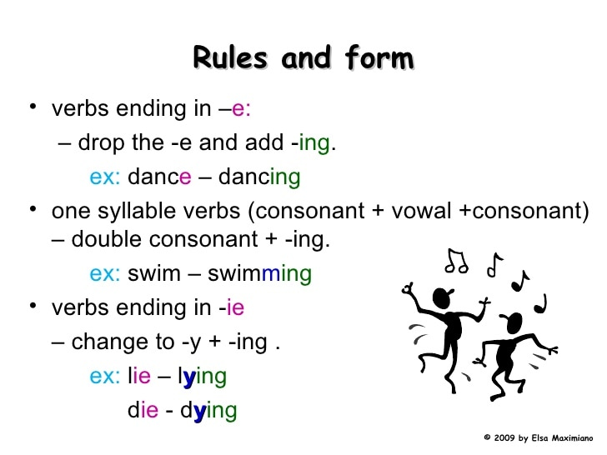

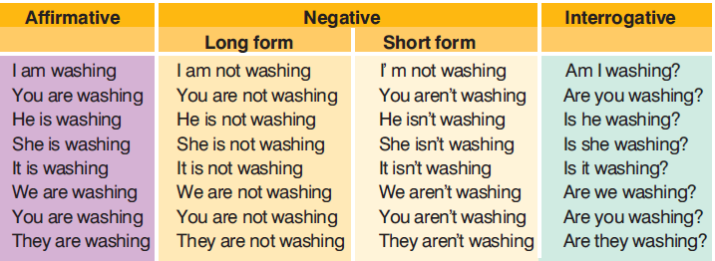

**Present Simple vs. Present Continuous**

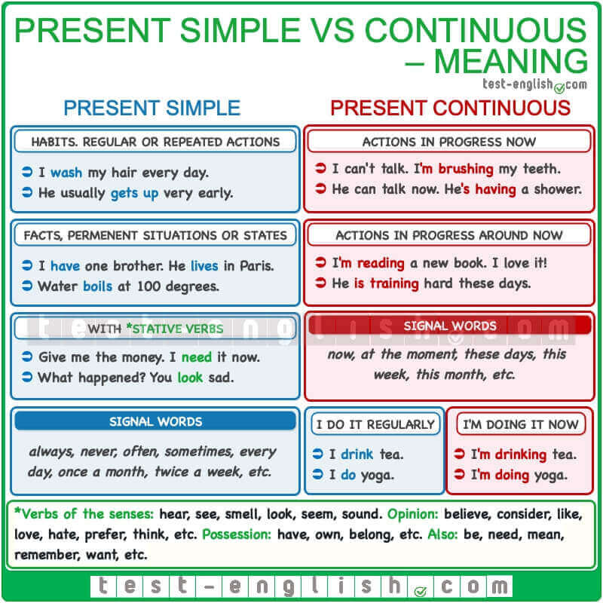

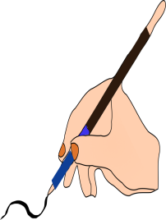

**A.** Guess what the people in Andrew’s family are doing and write sentences as in the example:

0. Andrew is in his parents’ bedroom. He is standing near their bed. What is he doing?

………He’s making their bed……………………………………………………………..

1. Amy is in the kitchen. There is an egg near her. What is she doing?

…………………………………………………………………………………………………….

2. Mum is in the garden. There is water near her. What is she doing?

……………………………………………………………………………………………………

3. Dad is in the kitchen. There is water and soap on his hands. What is he doing?

……………………………………………………………………………………………………



**B.** Add **–ing** to the following verbs.

Read – reading Stop - ………………….. Live - ………………………….

Sit - ………………… Wash - ………………… Travel - ………………………..

Walk - ……………… Cook - ………………… Lie - …………………………



**C.** Complete these sentences with either the **Present Simple** or the **Present**

**Continuous** form of the verbs in brackets.

0. This week Andrew’s father __is making___ (make) the beds.

1. David never ____________ (clean) up his mess.

2. Deborah ____________ (prepare) dinner at the moment.

3. I ____________ (talk) with my friend now.

4. We ____________ (have) a meeting every Monday morning.

5. ____________ (he / play) basketball now?

6. Look! Our cat ____________ (sleep).

7. ____________ (you/ like) going to fancy dress parties?

8. What time ____________ (the bank / open)?

9. ____________ (you / kid) me now?

10. Everyone ____________ (work) on the new project now.

11. We usually ______________ (spend) our holidays in Rome, but this year we 12. __

________________________ (go) to Venice.

13. The police officer ____________ (wear) her uniform today.

14. I know that Sam usually ____________ (water) the plants, but today he 15. ______

__________________ (play) with his friends in the park.

16. She ____________ (live) in Poland, but this week she 17. ____________ (visit) her

grandparents in Sicily.

18. What ____________ (you / do) this weekend?

19. David ____________ (not / drink) coffee, he 20. ____________ (not / like) it.