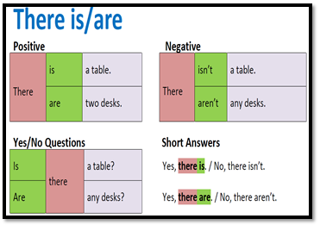

Source:

<https://www.blendspace.com/lessons/sopzGjbxBJIxyw/there-is-there-are>