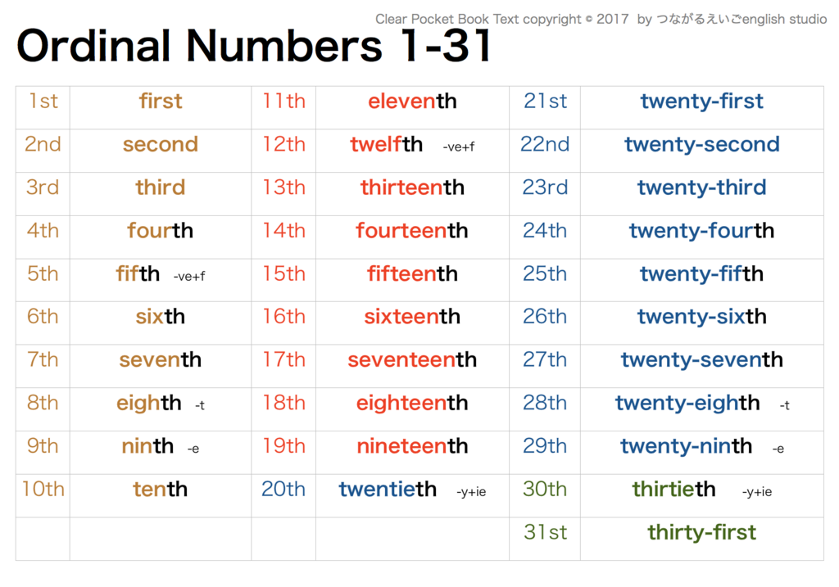

Source: <https://quizlet.com/jp/302337041/ordinal-numbers-1-31-diagram/>