PREPOSITIONS OF PLACE

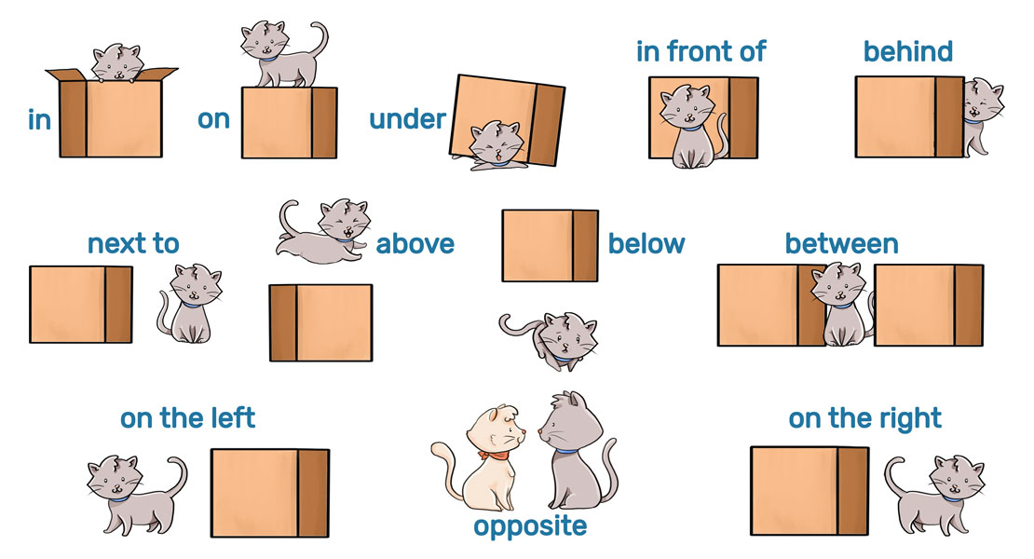

Source: <https://portalacademico.cch.unam.mx/ingles1/describing-house-belongings/prepositions-place>