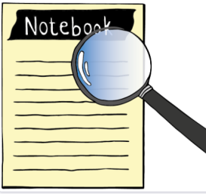

**DETECTIVE NOTES**

**Crime details**

On 5th July during a fancy dress party organized by Mrs. White for her 40th birthday one of the guests, the mayor of Rivertown, was murdered. Most of the guests had left the party early. Only a few remained and they are all suspects.

|  |  |  |
| --- | --- | --- |
| **Suspects** | **General Comments** | **Investigation Notes** |
| **1. The Colonel** | A rather surly figure |  |
| **2. The Professor** | Looks rather smart |  |
| **3. The Minister** | Very popular, loved by most people |  |
| **4. Mrs. White** | Honest, a woman of her word |  |
| **5. Rose** | Mrs. White’s daughter; known for her beauty |  |
| **6. Miss Blue** | A bit older, classy woman |  |

|  |  |
| --- | --- |
| **Rooms of the house** | **Investigation Notes** |
| **1. The living room** |  |
| **2. The kitchen** |  |
| **3. The study** |  |
| **4. The swimming pool** |  |
| **5. The bathroom** |  |
| **6. The bedroom** |  |
| **7. The conservatory** |  |

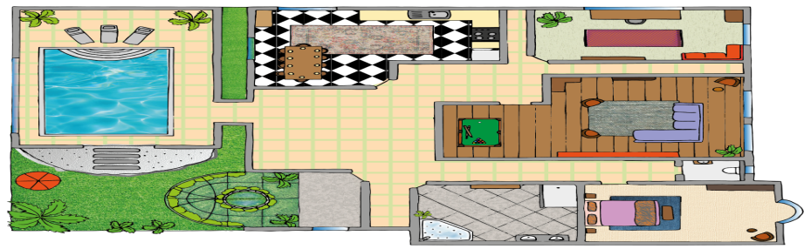Mrs. White’s Villa – The Floor Plan

|  |  |
| --- | --- |
| **Potential Murder Weapons** | **Investigation Notes** |
| **1. The Kitchen knife** |  |
| **2. The lead pipe** |  |
| **3. The revolver** |  |
| **4. The rope** |  |
| **5. The candlestick** |  |
| **6. Poison** |  |

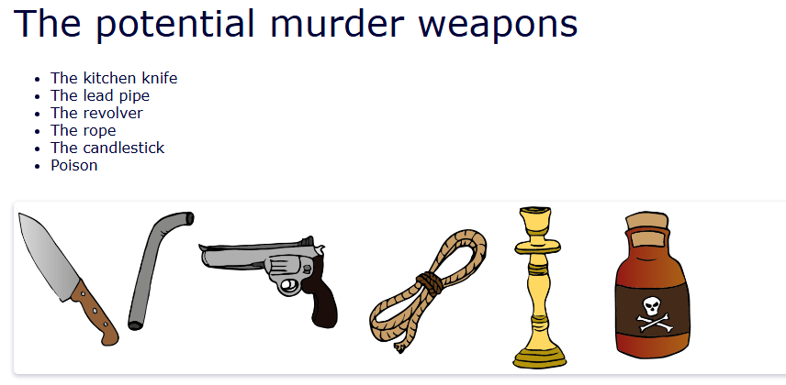

**Conclusions**



