 **Class E**

**Unit 1 – INTERNET FRIENDS AROUND EUROPE**

**Lesson 1: Do you like computers? (Pages 13-15)**

1. Various parts = διάφορα μέρη e.g. There are **various parts** in a computer.

2. Screen= οθόνη

3. Speaker = ηχείο

4. Keyboard = πληκτρολόγιο

5. Scanner = σαρωτής, σκάνερ

6. Tower = πύργος, κεντρική μονάδα

7. Printer = εκτυπωτής

8. Headphones = ακουστικά

9. Useful = χρήσιμος

10. Whether = If = Εάν, αν

11. Hour = ώρα e.g. How many **hours** are there in a day?

12. Say hello = χαιρετώ, λέω γεια

13. Send an e-mail = στέλνω ηλεκτρονικό μήνυμα

14. Answer an e-mail = απαντώ σε ένα ηλεκτρονικό μήνυμα

15. Find information on the Internet = βρίσκω πληροφορίες στο διαδίκτυο

16. Especially = ειδικά e.g. This is **especially** for you!

**Pages 16-17**

1. Draw = ζωγραφίζω, σχεδιάζω

2. Do the housework = κάνω τις δουλειές του σπιτιού

3. Do my homework = κάνω τα μαθήματά μου

4. Share with =μοιράζομαι με e.g. I will **share** my cake with you!

5. Common interests = κοινά ενδιαφέροντα

6. Enjoy = διασκεδάζω e.g. He **enjoys** listening to music.

7. Prefer = προτιμώ

8. Preference = προτίμηση

9. Majority ≠ Minority = Πλειοψηφία ≠ Μειοψηφία

10. I like ≠ I dislike = Μου αρέσει ≠ Δεν μου αρέσει

11. Play chess = Παίζω σκάκι e.g. He can **play chess** very well!

12. Same= ίδιο

13. Have sth (something) in common with sb (somebody) = Έχω κάτι κοινό με

κάποιον

**Lesson2: Internet friends (Pages 18-21)**

1. Primary School = Δημοτικό σχολείο

2. I see = I understand = Κατάλαβα

3. North = Βορράς

4. South = Νότος e.g. Greece is in the **south** of Europe.

5. West = Δύση

6. East = Ανατολή

7. That’s like… = Είναι σαν…

8. It sounds difficult = Ακούγεται δύσκολο

9. I like + verb+ ing = (n) = Μου αρέσει να… e.g. I like listen**ing** to music

10. I don’t really mind + verb + ing == Δεν με πειράζει να…e.g. I don’t really mind

wak**ing** up early

11. Spend time/money on sth = ξοδεύω χρόνο/χρήμα σε κάτι…

12. Expert = ειδικός e.g. Tom is an **expert** on computers.

13. Hear the bell = Ακούω το κουδούνι/καμπάνα

**COUNTRIES AND NATIONALITIES = ΧΩΡΕΣ ΚΑΙ ΕΘΝΙΚΟΤΗΤΕΣ**

Great Britain – Briti**sh** = Βρετανός

England – Engl**ish** = Άγγλος

Finland – Finn**ish** = Φινλανδός

Denmark – Dan**ish** = Δανός

Spain – Span**ish** = Ισπανός

Poland – Pol**ish** = Πολωνός

China – Chin**ese** = Κινέζος

Portugal - Portugu**ese** = Πορτογάλος

Russia – Russ**ian** = Ρώσος

Italy – Ital**ian** = Ιταλός

Albania – Alban**ian** = Αλβανός

Holland – Dutch = Ολλανδός

Germany – German = Γερμανός

Switzerland – Swiss = Ελβετός

Greece – Greek = Έλληνας

France – French = Γάλλος

**Lesson 3: The United Kingdom (Page 22)**

1. The United Kingdom = Το Ηνωμένο Βασίλειο

2. Isle= νήσος

3. Island= Νησί e.g. Crete is the biggest **island** in Greece.

4. Great Britain = Μεγάλη Βρετανία

5. England = Αγγλία

6. Scotland = Σκωτία

7. Wales = Ουαλία

8. Northern Ireland = Βόρεια Ιρλανδία

9. Capital city = πρωτεύουσα e.g.The **capital city** of Greece is Athens.

10. Population = πληθυσμός

11. Nationality = εθνικότητα

12. To be situated= βρίσκομαι/βρίσκεται

13. To include=περιλαμβάνω/ει

14. Twice the size of…= δύο φορές το μέγεθός του

15. One third= το ένα τρίτο

16. National= εθνικός-ή-ό

17. To be made of= αποτελούμαι/αποτελείται από…



**Likes – Dislikes & Preferences**

* We use **enjoy, prefer, like, love, don’t like/doesn’t like, dislike, hate** (always in the Present Simple tense) **+ -ing (gerund)** **/ noun** to express likes, dislikes or preferences e.g. Mark loves study**ing** (gerund)**,** but he hates **tests** (noun) - I enjoy danc**ing** (gerund).
* We use **prefer + -ing/noun** to show preference e.g. I **prefer** liv**ing** in the city **to** livi**ng** in the country - He prefers chocolate **to** strawberry ice cream.

**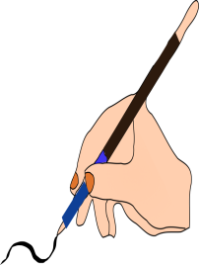 A.** Write sentences to say what they like / don’t like /enjoy/hate/prefer. Remember to add **–s/-es/-ies** where it is needed,

|  |
| --- |
| C:\Users\Dimitra\AppData\Local\Microsoft\Windows\INetCache\IE\N13C86DB\Not_facebook_not_like_thumbs_down[1].pngdislike C:\Users\Dimitra\AppData\Local\Microsoft\Windows\INetCache\IE\3NO4PF5J\like_PNG47[1].png like C:\Users\Dimitra\AppData\Local\Microsoft\Windows\INetCache\IE\DNVCEVW6\no-hate-e1402466791399[1].jpghate C:\Users\Dimitra\AppData\Local\Microsoft\Windows\INetCache\IE\N13C86DB\love-2519688_640[1].png enjoy C:\Users\Dimitra\AppData\Local\Microsoft\Windows\INetCache\IE\3NO4PF5J\13534467011766[1].pngprefer |

|  |  |  |  |  |
| --- | --- | --- | --- | --- |
|  | **listen to music** | **drink milk** | **watch TV** | **sleep** |
| **Maria** | **C:\Users\Dimitra\AppData\Local\Microsoft\Windows\INetCache\IE\3NO4PF5J\like_PNG47[1].png** | **C:\Users\Dimitra\AppData\Local\Microsoft\Windows\INetCache\IE\3NO4PF5J\like_PNG47[1].png** | **C:\Users\Dimitra\AppData\Local\Microsoft\Windows\INetCache\IE\N13C86DB\Not_facebook_not_like_thumbs_down[1].png** | **C:\Users\Dimitra\AppData\Local\Microsoft\Windows\INetCache\IE\N13C86DB\Not_facebook_not_like_thumbs_down[1].png** |
| **Connor & Jane** | **C:\Users\Dimitra\AppData\Local\Microsoft\Windows\INetCache\IE\N13C86DB\love-2519688_640[1].png** | **C:\Users\Dimitra\AppData\Local\Microsoft\Windows\INetCache\IE\DNVCEVW6\no-hate-e1402466791399[1].jpg** | **C:\Users\Dimitra\AppData\Local\Microsoft\Windows\INetCache\IE\N13C86DB\love-2519688_640[1].png** | **C:\Users\Dimitra\AppData\Local\Microsoft\Windows\INetCache\IE\3NO4PF5J\13534467011766[1].png** |
| **The cat** | **C:\Users\Dimitra\AppData\Local\Microsoft\Windows\INetCache\IE\DNVCEVW6\no-hate-e1402466791399[1].jpg** | **C:\Users\Dimitra\AppData\Local\Microsoft\Windows\INetCache\IE\3NO4PF5J\like_PNG47[1].png** | **C:\Users\Dimitra\AppData\Local\Microsoft\Windows\INetCache\IE\3NO4PF5J\13534467011766[1].png** | **C:\Users\Dimitra\AppData\Local\Microsoft\Windows\INetCache\IE\3NO4PF5J\13534467011766[1].png** |
| **You** |  |  |  |  |

0. Jenny likes listening to music and dancing, but she doesn’t like watching TV.

1. Maria\_\_\_\_\_\_\_\_\_\_\_\_\_\_\_\_\_\_\_\_\_\_\_\_\_\_\_\_\_\_\_\_\_\_\_\_\_\_\_\_\_\_\_\_\_\_\_\_\_\_\_\_\_\_\_\_\_\_\_\_\_\_\_

2. Connor & Jane \_\_\_\_\_\_\_\_\_\_\_\_\_\_\_\_\_\_\_\_\_\_\_\_\_\_\_\_\_\_\_\_\_\_\_\_\_\_\_\_\_\_\_\_\_\_\_\_\_\_\_\_\_\_\_

3. The cat \_\_\_\_\_\_\_\_\_\_\_\_\_\_\_\_\_\_\_\_\_\_\_\_\_\_\_\_\_\_\_\_\_\_\_\_\_\_\_\_\_\_\_\_\_\_\_\_\_\_\_\_\_\_\_\_\_\_\_\_

4. I \_\_\_\_\_\_\_\_\_\_\_\_\_\_\_\_\_\_\_\_\_\_\_\_\_\_\_\_\_\_\_\_\_\_\_\_\_\_\_\_\_\_\_\_\_\_\_\_\_\_\_\_\_\_\_\_\_\_\_\_\_\_\_\_\_\_

**Simple Present Tense**

* Use: We use the Present Simple Tense to talk about habits, routines, general truths, states, timetables and programmes.

e.g. He always does his homework in the afternoon.

The sun sets in the west.

The film starts at 7:45 pm tonight.

What time does the flight arrive?

* Key Words: Every day/month/week/year/Monday/summer etc, always (πάντα), usually (συνήθως), often (συχνά), sometimes (μερικές φορές), rarely & seldom (σπάνια), never (ποτέ), at the weekends, on weekdays etc.

**Be Careful!!!!**

The Adverbs of Frequency come *before* the main verb of the sentence

e.g. She always comes home early – He doesn’t often listen to music at night

BUT

They come after the verb to be

e.g. They are always polite to their teacher.

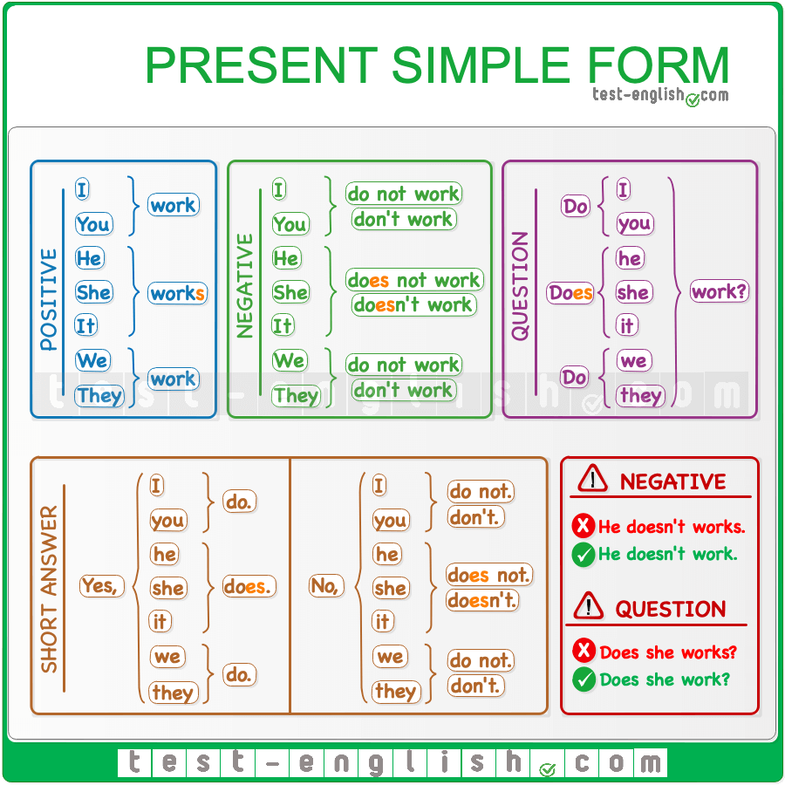

* **Spelling Rules**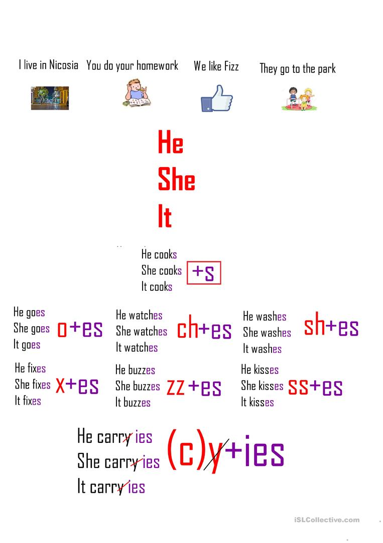

 **A**. Rewrite the sentence using the Adverb of Frequency in the correct position.

1. He listens to the radio. (often) \_\_\_\_\_\_\_\_\_\_\_\_\_\_\_\_\_\_\_\_\_\_\_\_\_\_\_\_\_\_\_\_\_\_\_\_\_

2. They read a book. (sometimes) \_\_\_\_\_\_\_\_\_\_\_\_\_\_\_\_\_\_\_\_\_\_\_\_\_\_\_\_\_\_\_\_\_\_\_\_

3. Tom is very friendly (usually) \_\_\_\_\_\_\_\_\_\_\_\_\_\_\_\_\_\_\_\_\_\_\_\_\_\_\_\_\_\_\_\_\_\_\_\_\_\_

4. My grandmother doesn’t go for a walk in the evening. (always)

\_\_\_\_\_\_\_\_\_\_\_\_\_\_\_\_\_\_\_\_\_\_\_\_\_\_\_\_\_\_\_\_\_\_\_\_\_\_\_\_\_\_\_\_\_\_\_\_\_\_\_\_\_\_\_\_\_\_\_\_\_\_\_\_

5. They watch TV in the afternoon, (never) \_\_\_\_\_\_\_\_\_\_\_\_\_\_\_\_\_\_\_\_\_\_\_\_\_\_\_\_\_\_

 **B.**  Put the verbs below in the third (3rd) person singular and write them in the correct column.

|  |
| --- |
| *write, study, wash, eat, fish, stay, walk, pay, carry, finish, do, dance,*  *miss, dry, try* |

|  |  |  |
| --- | --- | --- |
| -s  writes | -es  washes | -ies  studies |
|  |  |  |
|  |  |  |
|  |  |  |
|  |  |  |
|  |  |  |

 **C**. Complete the paragraph by putting the verbs in brackets into the Simple Present tense.

My family likes travelling a lot. Every time there 1 (be) \_\_\_\_\_\_\_\_\_\_ a holiday my dad

2 (ask) \_\_\_\_\_\_\_\_ my mum to start preparing for a journey. My mum always

3 (prepare) \_\_\_\_\_\_\_\_\_\_\_the food and the clothes we 4 (need) \_\_\_\_\_\_\_\_\_\_ to take with us. My sister 5 (finish) \_\_\_\_\_\_\_\_\_\_\_ her homework and then 6 (pack) \_\_\_\_\_\_\_

her things in her rucksack. Our dog, Fluff, 7 (not/stay) \_\_\_\_\_\_\_\_\_\_ back. My sister usually 8 (carry) \_\_\_\_\_\_\_\_\_\_\_ him with us because he 9 (enjoy) \_\_\_\_\_\_\_\_\_\_ the journey tremendously. Finally, I 10 (help) \_\_\_\_\_\_\_\_\_\_\_ my parents to carry the things in the car and start the trip. What about you? Do you like travelling?