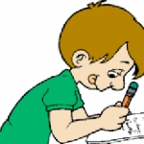 **Class E**

**Unit 2 – SCHOOL LIFE AND THE WORLD AROUND US**

**Lesson 1: Do you like computers? (Pages 26-27)**

1. Invite= προσκαλώ – invitation= πρόσκληση

2. Below ≠ above= κάτω από ≠ πάνω από

3. Text= κείμενο

4. Find out = βρίσκω, ανακαλύπτω

5. I am bored ≠ I am excited = βαριέμαι ≠ είμαι ενθουσιασμένος

6. Boring ≠ exciting, interesting= βαρετό ≠ συναρπαστικό, ενδιαφέρον

7. Straight to = απευθείας σε

8. Amusement park = λούνα παρκ

9. Ill = άρρωστος

10. Sad ≠ happy = λυπημένος ≠ χαρούμενος

11. Bring = φέρνω

12. Headmaster – headmistress = διευθυντής – διευθύντρια / headteacher = διευθυντής / διευθύντρια

13. Soft drink = αναψυκτικό

14. Offer = προσφέρω

15. Rehearsal = πρόβα

16. Angry = θυμωμένος

17. Same ≠ different = ίδιος ≠ διαφορετικός

18. Postcard = ταχυδρομική κάρτα

19. Juice = χυμός

20. Chemistry lab = εργαστήριο χημείας

21. Library = (αίθουσα / κτήριο) βιβλιοθήκη

22. Dining room = τραπεζαρία

23. Schoolyard = προαύλιο σχολείου

24. School trip = σχολική εκδρομή

**Pages 28-29**

1. Canteen menu = μενού κυλικείου

2. Apple pie = μηλόπιτα

3. Croissant = κρουασάν

4. Doughnut = λουκουμάς

5. Here’s your change. = Ορίστε τα ρέστα σας.

6. **On** Christmas Eve = Παραμονή Χριστουγέννων

7. **On** weekdays = τις καθημερινές

8. **At** the weekend = το Σαββατοκύριακο

9. **At** midnight = τα μεσάνυχτα

10. **At** noon = το μεσημέρι

11. Fizzy drink = ανθρακούχο ποτό, αναψυκτικό

12. Pizza flavoured = με άρωμα (γεύση) πίτσα

13. Crisps, chips = πατατάκια

14. Health = υγεία

15. Healthy ≠ unhealthy = υγιεινός ≠ ανθυγιεινός

16. Here you are = ορίστε

**Lesson 2: Talking about school life and habits (Pages 30-31)**

1. Interview = συνέντευξη

2. Erase = σβήνω

3. Famous = διάσημος

4. Become = γίνομαι

5. Practice - practise = εξάσκηση - εξασκούμαι

6. Important = σημαντικός

7. Professional = επαγγελματικός

8. Success ≠ failure = επιτυχία ≠ αποτυχία

9. Successful career = επιτυχημένη καριέρα

10. Miss = χάνω, μου λείπει

11. Recommend = συστήνω

12. Level = επίπεδο

13. Train hard = γυμνάζομαι σκληρά

14. Passion = πάθος

15. Passionate = παθιασμένος

16. Talent = ταλέντο

17. Talented = ταλαντούχος

18. As well = επίσης

19. It is a pleasure … = είναι χαρά …

20. Habit = συνήθεια

**Pages 32-33**

|  |
| --- |
| **Adverbs of Frequency**  1. always = πάντα (100%) 4. sometimes = μερικές φορές (50%)  2. usually = συνήθως (80%) 5. rarely – seldom = σπάνια (20%)  3. often = συχνά (70%) 6. never = ποτέ (0%) |

6. Advice = συμβουλή

7. To look sth up = αναζητώ στοιχεία σε λεξικό, εγκυκλοπαίδεια κλπ

8. Dictionary = λεξικό

9. To let = αφήνω

10. Instead of… = αντί για

**Lesson 3: Customs around the world (Page 34)**

1. Custom = έθιμο

2. Leave ≠ stay = φεύγω ≠ μένω

3. Even if = ακόμα κι αν



**Prepositions of Time: At – On – In**

Seven o’clock **(Time)**

Christmas, Easter

the weekend

noon, night, midnight

**At**

October **(Months)**

2021 **(Years),** 20th century

the winter **(Seasons)**

the morning, the afternoon,

the evening

**In**

Monday **(Days)**

November 14th **(Dates)**

weekdays

Christmas Eve / Day, May Day, Easter Sunday

My birthday **(Specific days)**

**On**

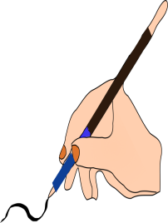 **A.** Complete the sentences using **at, on** or **in**.

1. Goodbye! See you ____ Friday.
2. Where were you ____ 28 February?
3. I got up ____ 7 o’clock this morning.
4. I like getting up early ___ the morning.
5. My sister got married ____ May.
6. Diane and I first met ____ 1979.
7. Did you go out ____ Tuesday?
8. Did you go out ____ Tuesday evening?
9. Do you often go out ____ the afternoon?
10. Let’s meet ____ 7.30 tomorrow evening.
11. I often go away ____ the weekend.
12. We often go to the beach ____ summer.
13. Georgia isn’t herself ____ the moment.
14. Julia’s birthday is ____ January.
15. Do you work ____ Saturdays?
16. The company started ____ 1969.
17. I like to look at the stars ____ night.
18. George usually goes to his hometown _____ Easter.
19. I’m visiting my parents ____ New Year’s Eve.



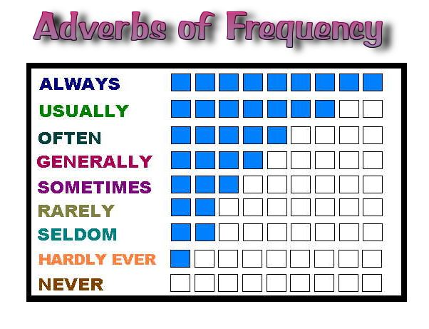

We use the Adverbs of Frequency with the Present Simple Tense to say How often we do something e.g. John sometimes forget his homework – They rarely eat junk food.

**Be careful!**

We put the Adverbs of Frequency before the main verb, but after the verb ‘to be’

e.g. We usually drink milk in the morning

It doesn’t often snow in November

Do you always eat ice cream for dessert?

BUT He is never late for school

 **B.** Put the adverbs in the right place.

1. She goes jogging(seldom) __________________________________________
2. Mr. Smith cooks for the family. (often) ________________________________
3. Does Tim study for the tests? (always) ________________________________
4. They aren´t at home at weekends.(often) _____________________________
5. Their children don’t eat fast food.(usually) _____________________________
6. We go to school on foot.( never) _____________________________________
7. Is Tina late for work?(sometimes) ____________________________________
8. The students change rooms. (rarely) __________________________________

