 **Class E**

**Unit 5 – READY FOR ACTION**

**Lesson 1: An Ambitious Class Project (Pages 61-64)**

1. action = δράση

2. environment = περιβάλλον

3. neighbourhood = γειτονιά

4. reduce = μειώνω

5. waste = απόβλητα

6. waste = σπαταλάω - σπατάλη

7. recycle = ανακυκλώνω – recycling = ανακύκλωση

8. do my best = βάζω τα δυνατά μου

9. survive = επιβιώνω – survival = επιβίωση

10. ambitious = φιλόδοξος

11. do everything I can = κάνω ό,τι μπορώ

12. rubbish = garbage = σκουπίδια

13. save = σώζω

14. to organize = οργανώνω

15. hand out = μοιράζω

16. from now on = από τώρα και στο εξής

17. to litter =ρυπαίνω, πετάω σκουπίδια

18. recyclable = ανακυκλώσιμο

19. to reduce = μειώνω

20. to survive = επιβιώνω

21. environment = περιβάλλον - environmental = περιβαλλοντικός (-η,-ο)

22. to protect = προστατεύω

23. leaflet = φυλλάδιο

24. brochure = φυλλάδιο, μπροσούρα

25. to hold an exhibition = οργανώνω μια έκθεση

26. to persuade = πείθω

27. information = πληροφορίες

28. use = χρησιμοποιώ – reuse = ξαναχρησιμοποιώ

29. to try out = δοκιμάζω (π.χ. να κάνω κάτι)

30. to encourage = ενθαρρύνω

31 rechargeable = επαναφορτιζόμενες

32. refreshment = αναψυκτικό

33. package = συσκευασία, περιτύλιγμα

34. environmentally friendly = φιλικό προς το περιβάλλον

35. to take something seriously = παίρνω κάτι στα σοβαρά

36. to collect = συλλέγω, μαζεύω

37. campaign = καμπάνια, εκστρατεία

38. to succeed = επιτυγχάνω, καταφέρνω

39. terrific = υπέροχος –η-ο

40. landfill =χωματερή

41 to protest = διαμαρτύρομαι

**Lesson 2: LET’S DO IT!!! (Pages 65-69)**

1. survey = έρευνα

2. attitude = στάση (απόψη)

3. questionnaire = ερωτηματολόγιο

4. planet Earth = πλανήτης Γη

5. honest = ειλικρινής

6. turn on the light = ανάβω το φως

7. turn off the light = σβήνω το φως

8. rubbish bin – litter bin = κάδος σκουπιδιών

9. expedition = αποστολή

10. once, twice, three times etc = μία φορά, δύο φορές, τρεις φορές

11. encourage ≠ discourage = ενθαρρύνω ≠ αποθαρρύνω

12. belong to = ανήκω σε

13. take part in = συμμετέχω

14. reduce = μειώνω ≠ increase = αυξάνω

15. positive= θετικός ≠ negative = αρνητικός

16. ability = ικανότητα

17. obligation = υποχρέωση

18. advice = συμβουλή

19. protect = προστατεύω – protection = προστασία

20. the Mediterranean = η Μεσόγειος

21. is situated = βρίσκεται

22. continent = ήπειρος

23. biodiversity = βιοποικιλία

24. feature = χαρακτηριστικό

25. It is under threat = απειλείται

26. cause = προξενώ, προκαλώ

27. decade = 10 years = δεκαετία

28. climate = κλίμα

29. drought = ξηρασία

30. flooding = πλημμύρα

31. development = ανάπτυξη

32. atmospheric pollution = ατμοσφαιρική ρύπανση

33. lumbering = υλοτομία, ξύλευση

34. ton = τόνος

35.to cut down = κόβω τελείως / από τη ρίζα

36. magazine = περιοδικό

37. violence = βία

38. destroy = καταστρέφω



**Talking about intentions**

In English we can use three different ways to talk about **the future**:

**A**. **Simple future - will**

**B.** **be going to**

**C.** **Present continuous (with future meaning)**

**A. Simple future - will**

* We use **will** when we decide to do something at the time of speaking e.g. Ok. I’ll come with you. / Will you get me some eggs from the super market?
* When we make general predictions about the future based on our opinion mostly (NOT on evidence). We may also use words like:  *I think, I believe, I hope, I’m sure, probably* e.g. They will probably come later - I think things will get better soon.
* Time expressions: We can use these time expressions with the simple future: *tomorrow, next week/month/year, soon, later.*

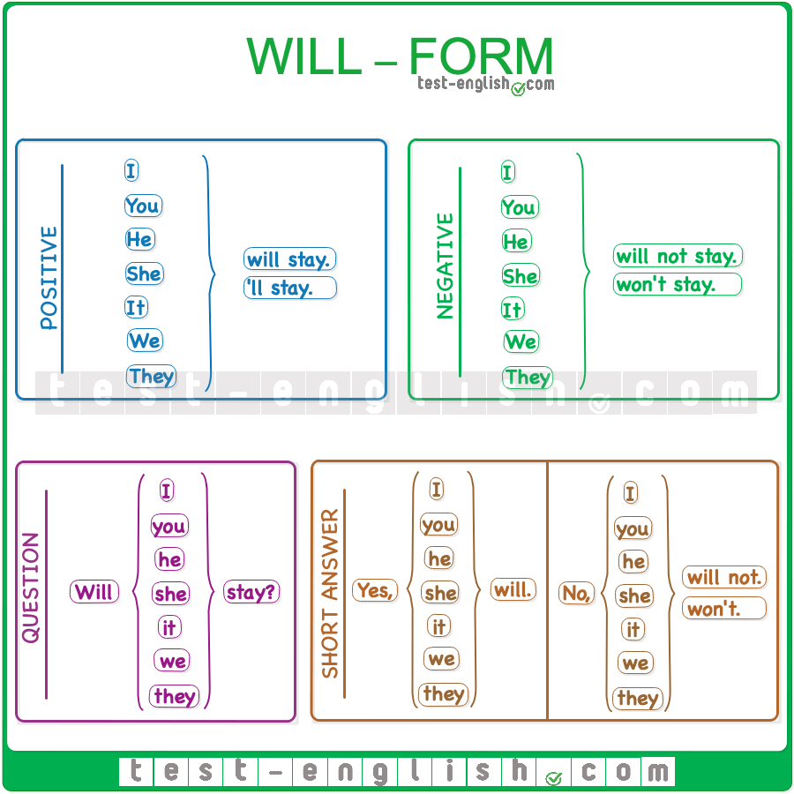

**B.** **be going to**

We use **be going to**

- to talk about what we plan or intend to do in the near future,

- to make a prediction based on what we can see or what we know

e.g. I am going to play football tomorrow. - He is going to study Medicine when he

grows up. - What are you going to do to save animals in danger? – Look at the clouds!

It’s going to rain.

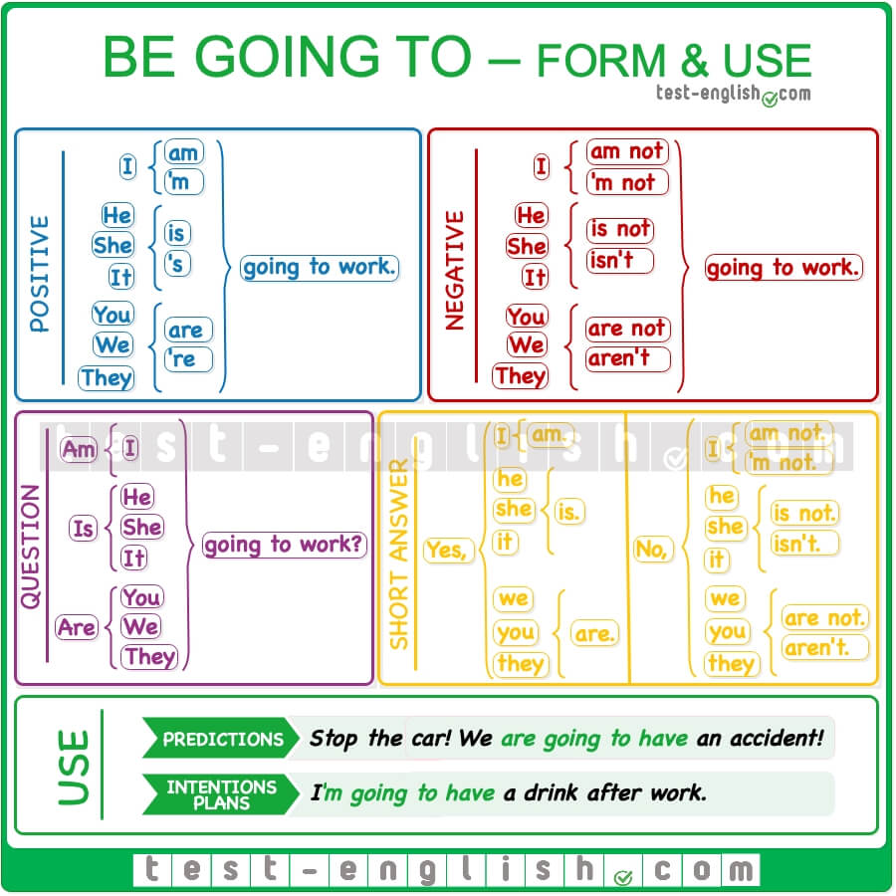

**C.** **Present continuous (with future meaning)**

We can use the **Present continuous** tense to talk about plans or arrangements we’ve made for the near future e.g. We’re visiting our grandmother tomorrow. – We’re handing out leaflets and brochures next week.

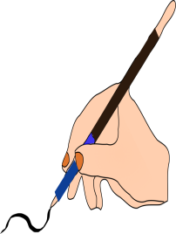

**A.** Complete the sentences with the correct form of the verb in brackets (Future Simple, be going to or Present Continuous).

1. The teacher asked the pupils revise Unit 1 over the weekend. They …………………...

(have) a test next week.

2. It’s very cold today. I think I ……………………… (need) to put on my coat.

3. “I’m sorry, but I cannot see you tonight. I….………………. (see) my doctor tonight at

7:30.

4. Look at all these dark clouds in the sky. It ……………………… (rain).

5. I strongly believe that things ……………… (change) in the world if we all try to save

our environment.

6. It’s so hot in here. I ……………… (take off) my sweater,

7. Tom …………………….. (fly) to New York on Saturday. He’s already bought his

ticket.

8. I’m sure Kate ……………. (not / let) him drive her new car.

9. I can’t go to the cinema on Saturday. I ………………………… (go) shopping with

my mother.

10. I think it …………………. (snow) on Christmas Day this year.



**Abilities, obligations, advice (Ικανότητες – Υποχρεώσεις – Συμβουλές)**

In English we use verbs like **can, must, should** to talk about abilities (can) and obligations (must) or to give advice (should). These verbs are called modal verbs and they go before other main verbs. They are always followed by the base form of these verbs: **can, must, should + Base Form**

e.g. He can’t come with us because he doesn’t feel very well.

**• Abilities: Can / Can’t**

We use **can** to talk about ability in the present and the future e.g. Mary can swim very well, but her brother can’t. He’s afraid of water.

**• Obligations: Must / Mustn’t**

We use **must** to talk about obligation in the present and the future. We use **mustn’t** to talk about things we are not allowed to do in the present and the future e.g. We must follow the rules. – Drivers mustn’t drive through a red traffic light.

**• Advice: Should / Shouldn’t**

We use **should** to give advice to people. We may also use “think” with should e.g. What do you think I should do? – I think you should study harder - It’s a nice play. You should go and see it.

**NOTE: Must** is stronger than **should.**



**B.** Complete the sentences using the correct modal verb (can / can’t, must /

mustn’t, should / shouldn’t).

1. Remember you …………… pick flowers in the park. There is a sign “Do not pick

flowers”.

2. I think you ……………….. be very careful while riding your bike in the park because

there are little children playing around.

3. “I’m afraid I ……………. read this sign. It’s not very clear”

4. “The sign says that people ……………….. walk on the grass. There’s a fine for that.

5. Mum says that people …………….. always follow the rules in a park.