 **Class E**

**Unit 6 – GOOD, BETTER, THE BEST!**

**Lesson 1: Choose what is better (Pages 74-75)**

1. choose = επιλέγω, διαλέγω

2. choice = επιλογή

3. be interested in = ενδιαφέρομαι για

4. exactly = ακριβώς

5. modern ≠ old-fashioned = μοντέρνος ≠ παλιομοδίτικος

6. entertaining = διασκεδαστικός

7. according to = σύμφωνα με

8. compare = συγκρίνω

9. comparison = σύγκριση

10. prize = βραβείο

11. all expenses paid = όλα τα έξοδα πληρωμένα

12. exchange = ανταλλάσσω

13. holiday destination = προορισμός διακοπών

14. prefer = προτιμώ

15. preference = προτίμηση

16. radio-controlled = τηλεκατευθυνόμενος

17. price = τιμή

18. exciting = συναρπαστικός

19. fast = γρήγορος

20. easy = εύκολος ≠ difficult = δύσκολος

**Pages 76 – 77: Living in the city or in the countryside?**

1. countryside = ύπαιθρος, εξοχή

2. I live **ON** a farm = ζω σε φάρμα

3. be better off = (είμαι) καλύτερα….

4. safe = ασφαλής

5. breathe = αναπνέω

6. breath = αναπνοή

7. traffic = κυκλοφορία (στους δρόμους)

8. polluted = μολυσμένος – pollution = μόλυνση

9. offer = προσφέρω, προσφορά

10. teenager = έφηβος

11. be cut off = είμαι αποκομμένος

12. population = πληθυσμός

13. average = μέσος, μέσος όρος

14. temperature = θερμοκρασία

15. metro – tube = μετρό, υπόγειος

16. airport = αεροδρόμιο

17. exclude = αποκλείω ≠ include = συμπεριλαμβάνω

18. size = μέγεθος

19. mountain = βουνό

20. boring = βαρετός

21. fresh air = καθαρός αέρας

22. urban = αστικός

23. area = περιοχή

24. monthly = μηνιαίος

25. daily = καθημερινός

26. busy = απασχολημένος

27. destination = προορισμός

**Lesson 2: World Records (Pages 78-81)**

1. circus = τσίρκο

2. pull = τραβάω ≠ push = σπρώχνω

3. to weigh = ζυγίζω

4. weight = βάρος

5. distance = απόσταση

6. retire from = αποσύρομαι από

7. currently = τώρα, πρόσφατα

8. to own = έχω, κατέχω

9. relations = σχέσεις

10. public relations = δημόσιες σχέσεις

11. (to be) based = έχω σαν βάση, εδρεύω

12. palace = παλάτι

13. residence = κατοικία

14. it belongs to = ανήκει σε

15. heavy ≠ light = βαρύς ≠ ελαφρύς

16. balance = ισορροπία – to balance = ισορροπώ

17. gigantic = γιγάντιος

18. guy = άνθρωπος, τύπος

19. venom = δηλητήριο

20. venomous = δηλητηριώδες

21. to reach = φτάνω

22. long = μακρύς – length = μήκος

23. amount = ποσό, ποσότητα

24. poison = δηλητήριο

25. to swallow = καταπίνω

26. prey = λεία

27. whole = ολόκληρος

28. aircraft = αεροσκάφος

29. to run = διευθύνω

**Lesson 3: Knowledge Quiz (Page 82)**

1. knowledge = γνώση

2. high = ψηλά ≠ low = χαμηλά

3. deep = βαθύς

4. ocean = ωκεανός

5. I am jealous of = ζηλεύω

6. imagine = φαντάζομαι

7. conversation = συζήτηση

8. fashionable = μοντέρνος

9. pronunciation = προφορά

10. healthy ≠ unhealthy = υγιεινός ≠ ανθυγιεινός

11. whale = φάλαινα

12. tidy ≠ untidy = τακτοποιημένος ≠ ακατάστατος

13. opinion = γνώμη, άποψη

14. even though … = ακόμη κι αν, παρόλο που

15. leader = αρχηγός, ηγέτης

16. Earth = η Γη

17. shark = καρχαρίας



**Comparison of Adjectives (Comparative – Superlative)**

**Comparatives**

We use **Comparatives** to compare two people, animals or things. We often use the word **than** after the comparative form e.g. Bob is tall**er than** Mark.

• Short adjectives: We add **–er** to short adjectives to make the comparative form e.g.

strong – strong**er**.

• Long adjectives: With long adjectives we use the word **more** before the adjective

to make the comparative form e.g*.* beautiful - **more** beautiful

**Superlatives**

We use **Superlatives** to compare one person or thing to several others e.g. John is the young**est** pupil in our class.

• Short adjectives: To form the superlative of short adjectives, we put the word **the**

before the adjective and add the ending **–est** e.g. clever - clever**est**

• Long adjectives: To make the superlative form of a long adjective, we put the words **the most** before the adjective e.g. expensive - **the most** expensive / difficult - **the most** difficult.

**Spelling Rules**

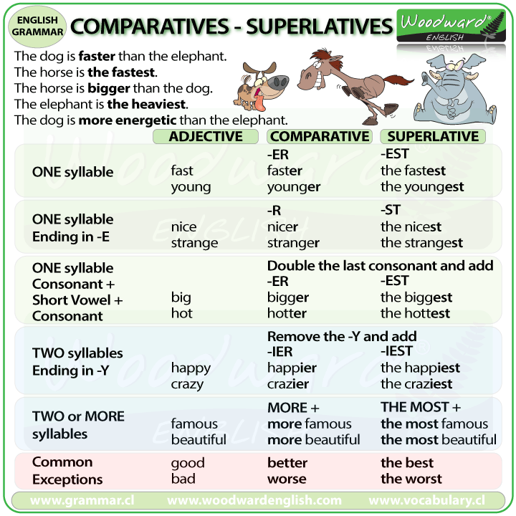

**Be careful!** Some adjectives have irregular comparative and superlative forms.

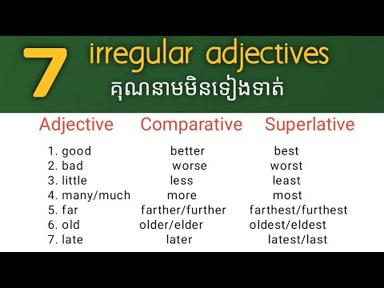

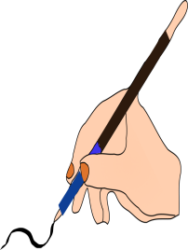**A**. Fill in the table with the correct form of the adjectives.

|  |  |  |  |
| --- | --- | --- | --- |
| 0 | quick | quicker than | the quickest |
| 1 | boring |  |  |
| 2 | good |  |  |
| 3 | little |  |  |
| 4 |  | harder than |  |
| 5 | much / many |  |  |
| 6 | bad |  |  |
| 7 | dangerous |  |  |
| 8 |  | further / farther than |  |
| 9 |  | Cleverer / more clever than |  |
| 10 |  |  | the easiest |
| 11 | hot |  |  |



**B.** Use the Comparative or the Superlative form of the adjectives to complete

the sentences.

0. My baby sister is ……the youngest….. (young) in our family.

1. Bill is ……………….. (bad) player in the team.

2. Paris is ……………. (big) Athens.

3. Deserts are ……….(hot) places in the world.

4. My English – Greek dictionary is ……………. (heavy) book in my house.

5. Your armchair is …………………… (comfortable) mine.

6. I have ……………. (little) money than you.

7. This is ………………. (good) restaurant in the city.

8. A Ferrari is ……………… (fast) a Smart.

9. White meat is ……………… (healthy) red meat.

10. Becky is ………………. (popular) girl in our school.



**C.** Complete the sentences with the correct form of the adjective (Positive, Comparative, Superlative). Don’t forget to add **than**, **of**, **in**, or **the** where necessary.

0. This watch is very ………expensive……... **expensive**

1. Helen is ………………………… girl in class. **noisy**

2. Steve is ………………………… John. **intelligent**

3. Jim is a ………………… tennis player ………… his brother. **good**

4. I think Maths is ……………………… subject at school. **difficult**

5. An elephant is ……………………. a giraffe. **big**

6. This coat costs …………………… money of all. **little**

7. I am ………………………….. my brother. **young**

8. That was …………………….. meal I’ve ever had. **tasty**

9. My Science teacher is very ………………… **clever**

10. She’s got ………………….. money ………….. her sister. **much**

11. The music is very ………………… Turn it down! **loud**

12. Chris is ……………………. student ………… our class. **intelligent**



**D.** Correct the mistakes and rewrite the sentences.

1. Chris is more cleverer than Scott. …………………………………………………………

2. Jane is prettier form Sylvia. …………………………………………………………

3. Chocolate ice cream is the more delicious of all. ………………………………………….

4. She is a very taller woman. ………………………………………………………..

5. The bus is longest than my car. ………………………………………………………..