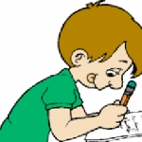 **Class E**

**Unit 7 – GOING BACK IN TIME**

**Lesson 1: Famous people of the past (Pages 86-89)**

1. past = παρελθόν

2. daily life = καθημερινή ζωή

3. experience = εμπειρία

4. change = αλλάζω, αλλαγή

5. historical event = ιστορικό γεγονός

6. famous = διάσημος

7. theatre = θέατρο

8. playwright = θεατρικός συγγραφέας

9. play = θεατρικό έργο

10. research = έρευνα

11. present = παρουσιάζω - presentation = παρουσίαση

12. actor = ο ηθοποιός – actress = η ηθοποιός

13. comedy = κωμωδία

14. tragedy = τραγωδία

15. It is based on… = Είναι βασισμένο σε…

16. birth = γέννηση

17. location = τοποθεσία

18. seat = θέση, κάθισμα

19. row = σειρά (καθισμάτων)

20. shape = σχήμα

21. move = μετακομίζω

22. die = πεθαίνω - death = θάνατος

23. to be born= γεννιέμαι e.g. I **was born** in Patras.

24. religious = θρησκευτικός

25. element = στοιχείο

26. influence = επηρεάζω, επιρροή

27. in honour of… = προς τιμή του…

28. stone = πέτρα, πέτρινο

29. ship owner = ιδιοκτήτης πλοίων, πλοιοκτήτης

30. politician = πολιτικός

31. composer = συνθέτης

32. prepare = ετοιμάζω, προετοιμάζω

**Lesson 2: Past experiences (Pages 90-93)**

1. A picture is a thousand words. = Μια εικόνα είναι χίλιες λέξεις.

2. crime = έγκλημα

3. alibi = άλλοθι

4. scene = σκηνή

5. It takes place = λαμβάνει χώρα, συμβαίνει

6. bank robbery = ληστεία τράπεζας

7. interrogate = ανακρίνω - interrogation = ανάκριση

8. I change my mind = αλλάζω γνώμη

9. agree ≠ disagree = συμφωνώ ≠ διαφωνώ

10. maybe = ίσως

11. for a couple of minutes = για δύο λεπτά

12. have a chat with somebody (sb) = κουβεντιάζω με κάποιον

13. during = κατά την διάρκεια

14. document = έγγραφο

15. silent= σιωπηλός – silence = σιωπή

16. What’s the matter? = Τι συμβαίνει;

17. support = υποστηρίζω

18. innocent= αθώος ≠ guilty = ένοχος

19. portable = φορητός

20. peaceful = ειρηνικός

21. characteristic = χαρακτηριστικό

22. to turn up = εμφανίζομαι

23. to suggest= προτείνω

24. What’s the matter? =Τι συμβαίνει;

25. to rush= ορμώ

26. cashier= ταμίας

27. to hit (hit – hit – hit) = χτυπώ

28. to threaten= απειλώ

**Lesson 3: Alexander the Great (Page 94)**

1. to lead (lead – led – led)= ηγούμαι – leader = ηγέτης

2. murder = φόνος

3. conquer = κατακτώ

4. major= μεγαλύτερος ≠ minor = μικρότερος

5. enemy= εχθρός ≠ friend = φίλος

6. navy = ναυτικό

7. attack (v, n) = επιτίθεμαι, επίθεση

8. destroy= καταστρέφω - destruction = καταστροφή

9. port = λιμάνι

10. battle = μάχη

11. withdraw = αποσύρω

12. troops = στρατεύματα

13. capture = κυριεύω, κατακτώ

14. causeway = ανυψωμένος δρόμος

15. defeat= νικώ (έναν αντίπαλο)

16. to reach= φτάνω

17. guard= φρουρός

18. coast= ακτή

19. land= έδαφος, χώρα



**Simple Past Tense**

In English we use the **Simple Past** tense for

• actions that happened in the past at a definite time

• routines or states in the past that are now finished

e.g. Napoleon **died** in 1821.

I **cleaned** my room yesterday.

Last night we **visited** our grandparents.

He **had** a small boat when he **was** young.

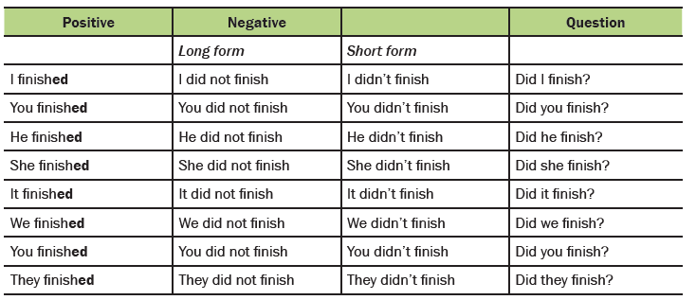

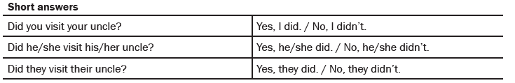

* **Note :** We add **–ed** to form the Past Tense of regular verbs.

**Spelling rules**

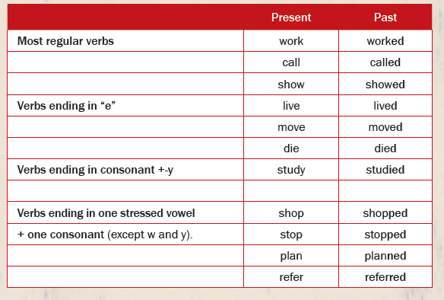

**Key words:** yesterday, then, ago, last night/week/month/year, in 1995…

**Past Simple Tense of the Verb “to be”**

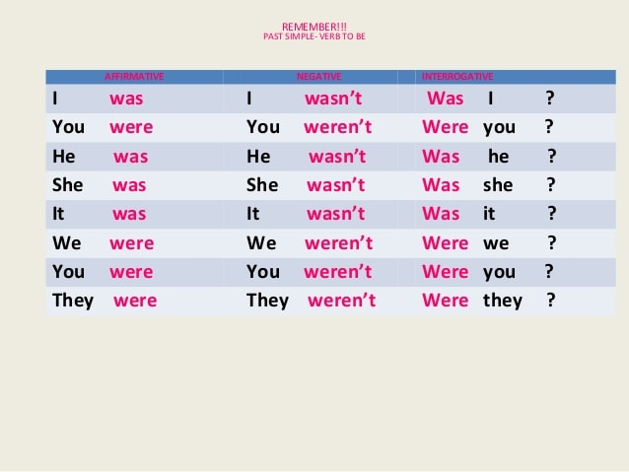

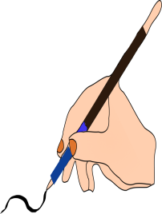

**A.** Put the verbs in brackets in the Simple Past tense.

0. Samantha ……danced……. (dance) all night long at the party on Saturday.

1. We ………………………. (see) a play at the Globe Theatre last year.

2. ..............……………. (John / start) piano lessons two years ago?

3. You …………………………….. (not / write) what the teacher ……….. (say).

4. Mum ………………. (finish) work late last night.

5. My brother …………….. (not / buy) a board game yesterday.

6. Jonathan ………………….. (not / be) happy when the school ………………. (start) in

September.

7. ……………………………………(your grandparents / be) rich when they ………… (be)

young?

8. ……………………………. (the children / wash) their hands before dinner?

9. I …………………. (study) hard before the test.

10. At the end of the play everybody ……………… (clap).



**B**. Ask questions to which the bold part of the sentence is the answer.

0. In the evenings we usually **went to a pub**. →

What did you usually do in the evenings?

1. She pushed **her bike**. →

2. She carried **a bag**. →

3. We waited **in the park**. →

4. The policeman arrested **the thief**. →

**5. We** ate fish. →

6. She watched the match **last night**. →

7. She asked her friend **because she did not know what to do**. →

**8. I** opened the door. →

9. The teacher checked **our homework**. →

**10. Cindy** had a dog. →