 **Class E**

**Unit 8 – ALL ABOUT STORIES**

**Lesson 1: Fairy Tales (Pages 98-101)**

1. fairytale = παραμύθι

2. traditional feast = παραδοσιακή γιορτή

3. Little Red Riding Hood = Κοκκινοσκουφίτσα

4. adventure = περιπέτεια

5. mystery = μυστήριο

6. suitable title = κατάλληλος τίτλος

7. Once upon a time… = Μια φορά κι έναν καιρό…

8. handsome = όμορφος (για άντρες) – beautiful ( για γυναίκες) ≠ ugly= άσχημος -η -ο

9. prince= πρίγκιπας - princess = πριγκίπισσα

10. kingdom = βασίλειο

11. quality = ποιότητα / αρετή

12. agree= συμφωνώ ≠ disagree= διαφωνώ

13. sensitive = ευαίσθητος

14. important= σημαντικός - importance = σημασία

15. to come across = συναντώ τυχαία

16. whether = if = Αν

17. lonely = μόνος, μοναχικός

18. storm = καταιγίδα, θύελλά

19. lighting = αστραπή

20. thunder = κεραυνός

21. dreadful = τρομαχτικός, απαίσιος

22. servant = υπηρέτης

23. young= νέος-α –ο ≠ old= γέρος, γριά

24. queen= βασίλισσα – king= βασιλιάς

25. to marry= παντρεύομαι

26. easy= εύκολος ≠ difficult= δύσκολος

27. to look for= ψάχνω

28. terrible= τρομερός

29. to flash= αστράφτω

30. to pour down= πέφτει βροχή

31. suddenly= ξαφνικά

32. to be scared to death= πεθαίνω από τον φόβο μου

33. to hide= κρύβω, κρύβομαι (hide – hid – hidden)

34. awful= απαίσιος –η –ο

35. to shiver= τρέμω, τουρτουρίζω

36. inside= μέσα ≠ outside= έξω

37. to fall in love= ερωτεύομαι

38. to prepare= προετοιμάζω

39. tiny= μικροσκοπικό

40.bottom= βάση, το κάτω μέρος ≠ top= κορυφή, το πάνω μέρος

41. mattress= στρώμα

42.thick= παχύς –ιά –ύ ≠ thin= λεπτός –ή -ό

43.duvet= πάπλωμα

44. delicate= λεπτεπίλεπτος, ευαίσθητος

**Lesson 2: What an experience! (Pages 102-105)**

1. I was scared to death = πέθανα από τον φόβο μου

2. nasty experience = κακή, απαίσια εμπειρία

3. What do you mean? = Τι εννοείς;

4. seem = φαίνομαι

5. It seems that… = Φαίνεται ότι…

6. raise my hand = σηκώνω το χέρι μου

7. attack = επιτίθεμαι, επίθεση

8. scary = τρομαχτικός

9. still = ακίνητος

10. on the way home = στο δρόμο για το σπίτι

11. cousin = ξάδελφος, ξαδέλφη

12. to play a trick **on** sb = κάνω φάρσα σε κάποιον

13. convertible car = ανοιχτό αυτοκίνητο (χωρίς οροφή)

14. bush = θάμνος

15. terrify = τρομοκρατώ

16. gunshot = πυροβολισμός

17.during= κατά τη διάρκεια, στη διάρκεια

18. to scare somebody to death = to scare the daylight out of somebody = φοβίζω

κάποιον πολύ

19. whole= ολόκληρος

20. splendid= υπέροχος

**Lesson 3: A traditional story (Pages 106-108)**

1. customs = έθιμα

2. discover= ανακαλύπτω – discovery = ανακάλυψη

3. attend the mass= παρακολουθώ τη θεία λειτουργία

4. countryside= εξοχή

5. roast the lamb = ψήνω το αρνί

6. priest = ιερέας, παπάς

7. fast = νηστεία

8. at least = τουλάχιστον

9. mention = αναφέρω

10. get a tan = μαυρίζω (στον ήλιο)

11. vacation = διακοπές

12. community = κοινότητα

13. The Last Supper = Ο Μυστικός Δείπνος

14. betray= προδίδω - betrayal= προδοσία

15. The Judgement = Η Κρίση

16. The Crucifixion = Η Σταύρωση

17. The Resurrection = Η Ανάσταση

18. The Holy Week = Μεγάλη Εβδομάδα

19. iceberg = παγόβουνο

20. the electricity went off = κόπηκε το ρεύμα

21.to find out = ανακαλύπτω

22. to work out = γυμνάζομαι

23. final examination = τελικές εξετάσεις

24. couple = ζευγάρι

25. fisherman= ψαράς



**Past Continuous Tense – Actions in progress**

**Form: was / were + -ing** e.g. She was running / They were studying

We use the **Past Continuous** tense to

* talk about an action that was in progress at a specific point in the past

e.g. **At 8 o’clock last night father was watching a news programme.**

* talk about events or actions which were in progress for some time in the past

e.g. We **were dancing** all night long.

* talk about two or more actions which were in progress at the same time in the past

e.g. Sue **was washing** the car while Mark **was watering** the flowers.

* Talk about an action that was in progress and was interrupted by another. For the action that was in progress we use the **Past Continuous** while for the one that interrupted it we use the **Past Simple** tense.

e.g. **As**Nick **was speaking**, the lights **went out** /Mary **was listening** to music **when** I **gave** her a call.

* create the atmosphere and set the background of a story.

e.g. All small creatures were happy in the forest. The birds **were singing**, the rabbits

**were playing** and the wild ducks **were swimming** in the lake.

**Key Words:** while (καθώς, ενώ), as (καθώς), when (όταν).

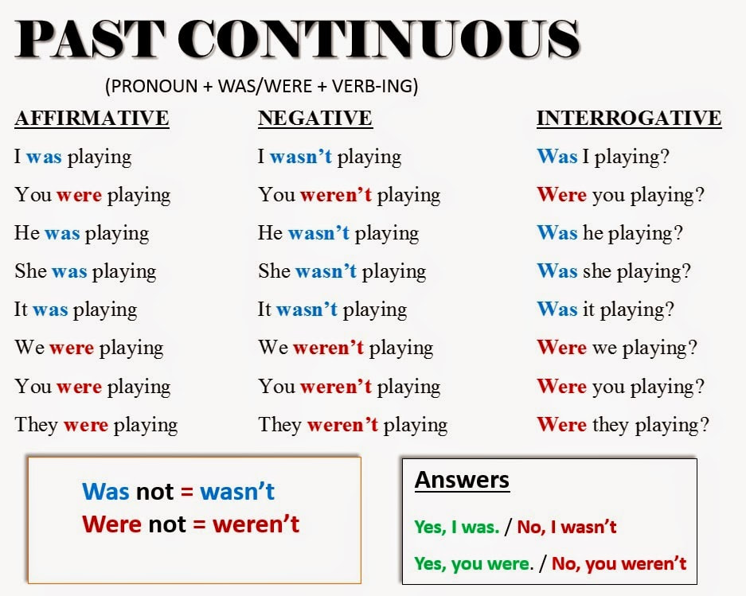

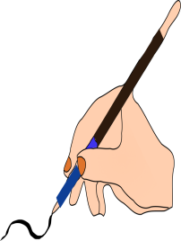

**A.** Complete the sentences with the correct form of the verbs in brackets (**Past Simple** or **Past Continuous**)

1. They were all at school. While Mary (study) ………………………………….. maths in

the lab her friend, Sheila, (have) ………………………………….. a music class and

the boys (work) ………………………………………. on a project.

2. When we (come) ………………………………….. closer we (can) ………………………

read the words on the poster.

3. As they (walk) …………………………………….. home a bike (stop) …………………...

next to them.

4. Grandma (tell) ……………………………..her grandchildren stories when their parents

(arrive) …………………………………… home yesterday.

5. It was a stormy night. The wind (blow) ……………………………………. and the

thunderstorm (rage) ………………………………………. Jack was scared to death.

6. While you (listen) ………………………… to music, the teacher …………..……………. (explain) the lesson.

7. As I (walk)……………………….. down the street, I ……………………………… (meet)

an old friend from school.

8. We (sleep) ………………………………… when the bomb (explode)…………………....

9. While he (watch) ……………………… the news, his girlfriend (appear) ………………..

10. I (begin) ………………………… to enjoy my job when my boss ………………………

(increase) my wages.

11. When Stephen …………..................... (visit) Rome, he …………………………. (buy)

many souvenirs for me.

12. While they (climb) ……………………………………... the mountain, the photographer

.……………………………….. (take) photos.

13. While Sarah (get out) …………………………. of the car, she ………..…… (drop) her

handbag.

14. Mr. Harper ……………………………………… (find) a fly in his soup while he (have)

…………………………………………… lunch at the canteen.

15. When I …….………………… (win) the lottery, I ……………………… (buy) my wife a

new car.