 **Class ST’**

**UNIT 1 – OUR MULTICULTURAL CLASS**

**LESSON 1: Meeting the newcomers (Page 1)**

1. Plain = πεδιάδα

2. Peninsula = χερσόνησος

3. Mountain = βουνό

4. Mountainous = ορεινός

5. Map = χάρτης

6. Landforms = γεωμορφές

**7.** Border = συνορεύω, σύνορο

8. Accident = ατύχημα

9. Cause = προκαλώ e.g. Don’t **cause** any trouble in class!

10. Environmental problem = περιβαλλοντικό πρόβλημα

11. South =Νότος

12. North) = Βορράς

13. East = Ανατολή

14. West = Δύση

15. Origin = καταγωγή

16. Original πρωτότυπο, αυθεντικό e.g This is the **original** painting!

**Pages 2-3**

1. Between = ανάμεσα

2. Flow = ρέω

3. Split = χωρίζω, διαχωρίζω

4. Part = μέρος, κομμάτι e.g. This is a small **part** of the picture.

5. Along = κατά μήκος

6. Outdoors ≠ Indoors = έξω, στην ύπαιθρο ≠ μέσα, εντός σπιτιού

7. Nuclear power plant = Εργοστάσιο πυρηνικής ενέργειας

8. Drinking water supplies = αποθέματα πόσιμου νερού

9. Despite / In spite of = παρά, ανεξάρτητα από…. e.g. They went out in spite of /

despite the rain.

10. Outgoing = εξωστρεφής, ανοιχτόκαρδος

11. Brave ≠ coward, timid = γενναίος ≠ δειλός

12. Ancient = αρχαίος

13. Share = μοιράζομαι e.g Can you **share** your pizza with me?

14. Dry ≠ wet = στεγνός ≠ υγρός

15. Temperature = θερμοκρασία

16. Temperature rise ≠ temperature drop = αύξηση ≠ πτώση θερμοκρασίας

17. It rains heavily = βρέχει πάρα πολύ

18. Natural disaster = φυσική καταστροφή

19. Earthquake = σεισμός

20. Popular ≠ unpopular = δημοφιλής ≠ μη δημοφιλής

21. Nun = καλόγρια

22. Monk = καλόγερος

23. Humanitarian = φιλάνθρωπος, ανθρωπιστής

24. Such as = όπως

25. However = Ωστόσο, Κι όμως

26. Miss = χάνω, μου λείπει

27. Golden Fleece = Χρυσόμαλλο Δέρας

28. Mild = ήπιος, γλυκός (για το κλίμα)

29. Vine = κλήμα, αμπέλι e.g. My grandfather grows **vines**.

30. Below ≠ above = κάτω από ≠ πάνω από

31. Copper = χαλκός

32. Coal mine= ανθρακωρυχείο

33. Oil well = πετρελαιοπηγή

34. Imitate = μιμούμαι

35. Imitation = μίμηση e.g. Babies learn through **imitation.**

36. Terrain = έδαφος

37. Weather = καιρός

**LESSON 2: At the school lab (Pages 6-9)**

1. School subject = μάθημα

2. School lab = σχολικό εργαστήριο

3. Geography = Γεωγραφία

4. Physical Education (P.E) = Γυμναστική

5. Chemistry = Χημεία

6. Music = Μουσική

7. History = Ιστορία

8. Language = Γλώσσα e.g. Andrew speaks two **languages**!

9. Maths = Μαθηματικά

10. Environmental Studies = Μελέτη Περιβάλλοντος

11. Religious Education = Θρησκευτικά

12. Art = Τεχνικά e.g. My favourite subject is **Art**!

13. Search for = look for = ψάχνω

14. Copy – paste = αντιγραφή - επικόλληση

15. Molecular structure = μοριακή δομή

**LESSON 3: A Geography Project (Page 10)**

1. Take part in = παίρνω μέρος σε, συμμετέχω

2. Official = επίσημος

3. Include = περιλαμβάνω e.g. The price **includes** bed and breakfast.

4. Channel = κανάλι

5. Connect– connection = συνδέω - σύνδεση

6. Separate– separation = χωρίζω - χωρισμός

7. Mostly κυρίως e.g. I am **mostly** interested in History.

8. Race = φυλή

9. Caribbean = Καραϊβική

10. Exciting = συναρπαστικός

11. Landscape = τοπίο e.g. The **landscape** is amazing!



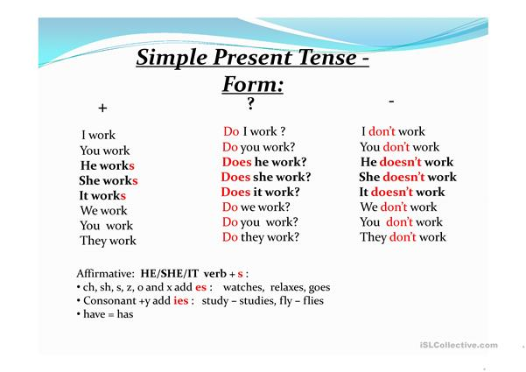

**Present Simple Tense Use**

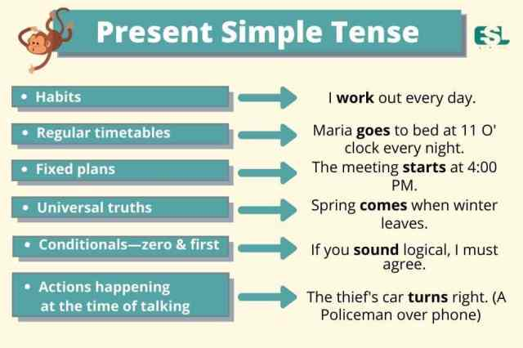

We often use the **Adverbs of Frequency** to show How Often we do something. We put the Adverbs of Frequency before the main verb but after the verb “to be”.

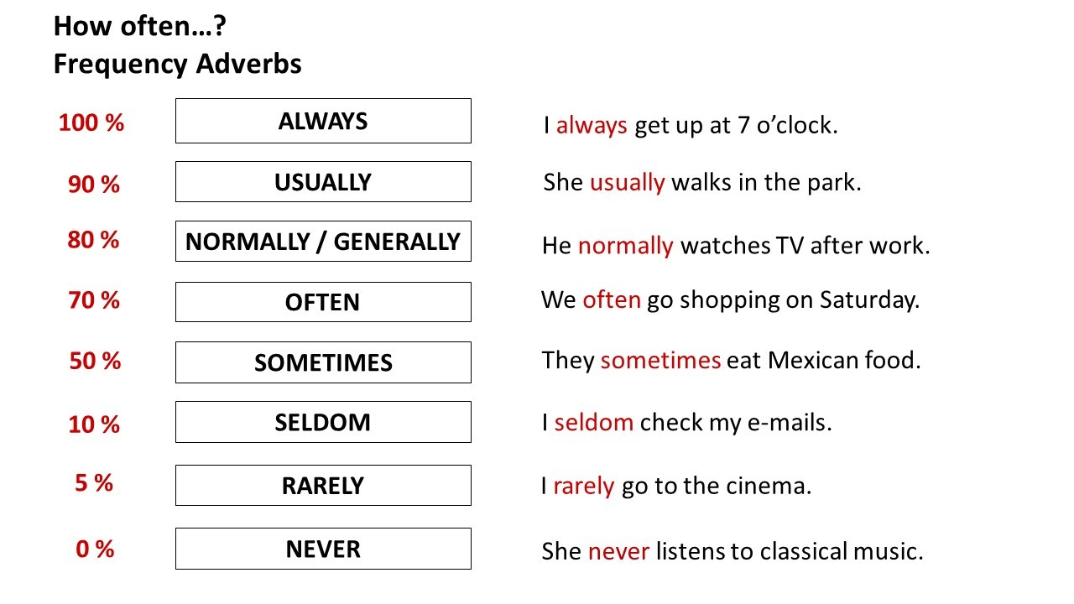

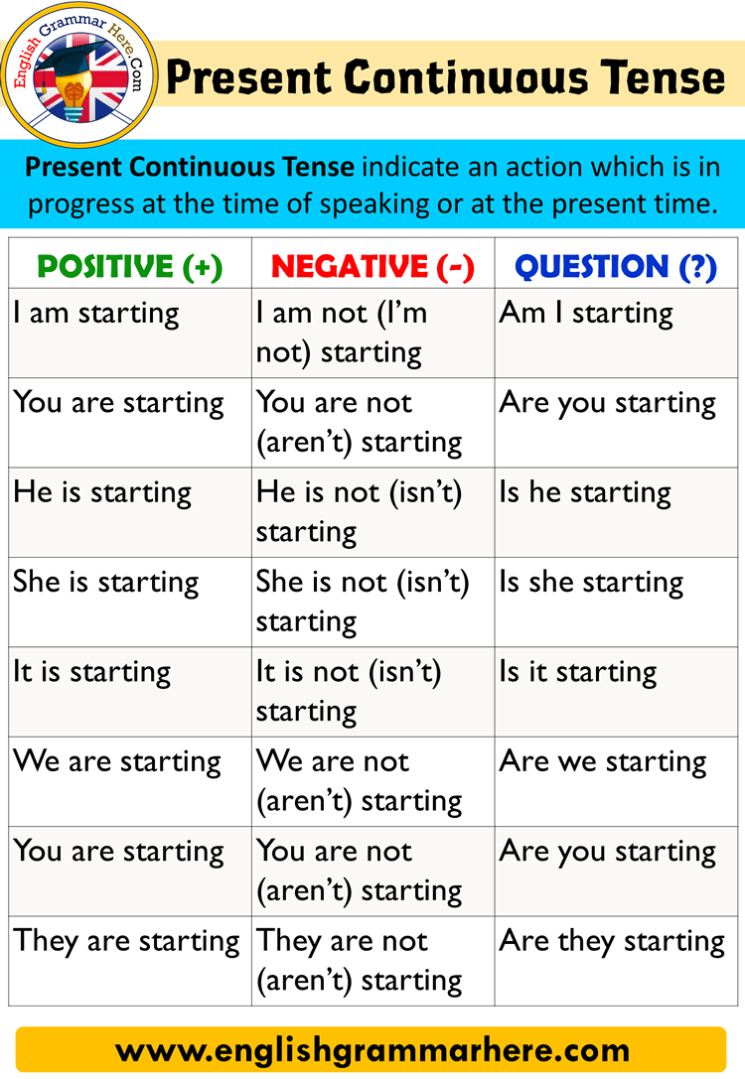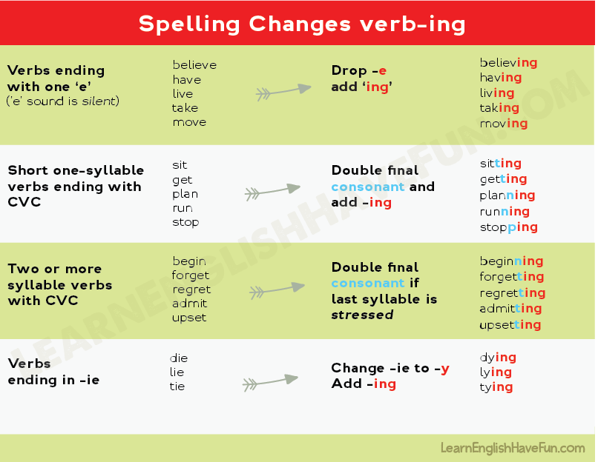

**Present Simple vs Present Continuous**

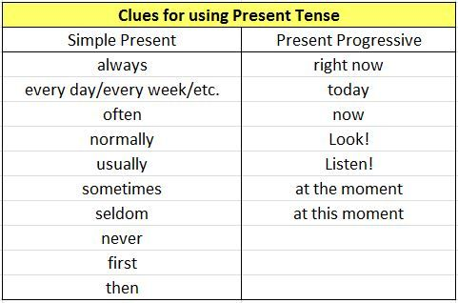

**Non-continuous Verbs**

Non-continuous verbs are not usually used in the continuous form. Some non-continuous verbs are:

* **feeling**: *hate, like, love, prefer, want, wish*
* **senses**: *appear, hear, see, seem, sound, look, smell, taste, feel*
* **communication**: *agree, disagree, mean, promise*
* **thinking**: *believe, imagine, know, mean, realize, recognize, remember, understand*
* **other states**: *be, belong, need, owe, own*

## C:\Users\Dimitra\AppData\Local\Microsoft\Windows\INetCache\IE\N13C86DB\Machovka-Write[1].png A. Choose the correct verb form.

1 - I **have / am having** a great time on this holiday.

2 - She's Italian- she **comes / is coming** from Pisa.

3 - '**Are you enjoying / do you enjoy** your meal?' 'Yes, it's very good.'

4 - This term, I **study / am studying** Latin.

5 - **Do you come / are you coming** to see us next month?

6 - Let me know when you **receive / are receiving** this letter.

8 - Water **boils / is boiling** at a hundred degrees.

10 - I **make / am making** a lot of progress at the moment.

11 - It **worries / is worrying** me a lot at the moment.

12 - I **get / am getting** up at seven o'clock on weekdays.

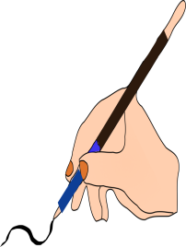 **B.** Fill in the sentences with the correct form of the simple present or the present continuous tense of the verbs in brackets.

1. Right now I ***(watch)*** _____________ a movie. I ***(watch)*** _______ a lot of movies.
2. Rickie ***(be)*** _______ my friend. We ***(like)*** _______ to talk together. Right now we ***(talk)*** ______________ about school.
3. The police officer (***wear***) ________ a badge and a gun to work every day.
4. Jaime usually ***(eat)*** _______ cold cereal for breakfast, but today he ***(eat)*** _______ ________ oatmeal instead.
5. Alison and I ***(study)*** _______ _______ for the exam. We ***(not,*** ***want)*** _______ ______________ to fail it!
6. Jonas ***(sing)*** ________ in the band on Saturdays, and Veda (***play)*** _______ the guitar.
7. My uncle ***(live)*** _______ in Tennessee. I ***(live)*** _______ in North Carolina.
8. My mom ***(cook)*** ______________ dinner tonight. ***(You,*** ***want)*** ____________

_______ to eat with us?

1. Tiffany and Mark ***(travel)*** ______________ to Spain. They will stay in Madrid.
2. We ***(read)*** _______ the newspaper every morning.

** C.** Rewrite the sentences in the correct order

usually - in the morning - reads the newspaper - Tom

***___________________________________________________________***

He -frequently - is - for class - late

***___________________________________________________________***

always –they - happy - are

***___________________________________________________________***

help – she - often - does - her mother?

***___________________________________________________________***

by 11:30 - is - Ann -generally -in bed.

***___________________________________________________________***

occasionally -Molly - the museum - visits.

***___________________________________________________________***

study - you – rarely - for the exam.