** Class ST’**

**UNIT 2 – GOING SHOPPING**

**LESSON 1: At the supermarket (Pages 13-14)**

1. fashion = μόδα

2. pleasure = ικανοποίηση, ευχαρίστηση

3. department store = πολυκατάστημα

4. mall= εμπορικό κέντρο

5. cashier – cashier’s = ταμίας - ταμείο

6. select – selection = επιλέγω - επιλογή

7. tempt – temptation = δελεάζω, βάζω σε πειρασμό - πειρασμός

8. tempting= δελεαστικός

9. cream cake = πάστα

10. dessert = επιδόρπιο

11. taste = γεύση

12. tasty, delicious = γευστικός, νόστιμος

13. pastries = γλυκά, αρτοσκευάσματα

14. prepare – preparation = προετοιμάζομαι - προετοιμασία

15. include = συμπεριλαμβάνω, περιλαμβάνω

16. special occasion = ειδική περίσταση

17. celebration cake = τούρτα

18. baker – bakery = αρτοποιός – αρτοποιείο

19. poultry = πουλερικά

20. train – training = εξασκούμαι – εξάσκηση

21. lamb = αρνάκι

22. ribs = πλευρά

23. pork chops = χοιρινά παϊδάκια

24. steak = μπριζόλα

25. mince = κιμάς

26. greengrocer = μανάβης

27. superb = εξαίσιος, υπέροχος

28. organic products = βιολογικά προϊόντα

29. mushrooms = μανιτάρια

**VOCABULARY (Page: 14)**

1. healthy = υγιεινός e.g. We must eat **healthy** food.

2. variety = ποικιλία

3. sweets = γλυκά

4. price = τιμή

5. can / tin of cider = τενεκεδένιο κουτάκι μηλίτη

6. carton = χάρτινο δοχείο υγρού

7. a dozen of eggs = μια ντουζίνα (12) αυγά

8. packet = πακέτο

9. pound = κιλό

10. a jar of jam = ένα βάζο μαρμελάδα

11. bottle = μπουκάλι

12. flour = αλεύρι e.g. You need **flour** to make a cake!

13. groceries = ψώνια από το supermarket

14. Soft drink = αναψυκτικό

**LESSON 2: At the mall (Pages 18-19)**

1. receipt = απόδειξη

2. bookshop = βιβλιοπωλείο e.g. I love buying books from a **bookshop**!

3. periodical = περιοδικό

4. tax = φόρος

5. change = ρέστα e.g. Here is your **change,** sir!

6. customer = πελάτης

7. sweater = φούτερ μπλούζα

8. track suit = αθλητική φόρμα

9. tie = γραβάτα

10. too big = πολύ μεγάλος e.g. Anna’s skirt is **too big** for her to wear!

11. prepare = ετοιμάζω, προετοιμάζω

12. tray = δίσκος σερβιρίσματος

**VOCABULARY (Pages 20-21)**

1. Look = φαίνομαι

2. Sound = ακούγεται

3. Feel = έχει αφή

4. Smell = έχει μυρωδιά

5. Taste = έχει γεύση

6. Lovely = ωραίος, όμορφος

7. Cute = χαριτωμένος

8. Smart = κομψός

9. Elegant = κομψός

10. Short ≠ long = μακρύς ≠ κοντός

11. Tight ≠ loose = στενός ≠ χαλαρός, φαρδύς

12. Baggy = φαρδύς

13. Pale green = ανοιχτό πράσινο

14. Dark / navy blue = σκούρο / ναυτικό μπλε

15. Cotton = βαμβακερός

16. Woolen / Woollen = μάλλινος

17. Leather = δερμάτινος

18. Denim = τζιν

19. Linen = λινό

20. Silk = μεταξωτός

21. Nylon = νάυλον

22. Polyester = πολυεστέρας

23. Skirt = φούστα

24. Pants = παντελόνι

25. A pair of sneakers / trainers = αθλητικά παπούτσια

**VOCABULARY (Page 23)**

1. Yoghurt = γιαούρτι

2. Fridge = ψυγείο

3. Exciting = συναρπαστικός

4. Nasty = ενοχλητικός, κακός

5. Boring = βαρετός e.g. This film is really **boring**.

6. Old fashioned = παλιομοδίτικος

7. Tidy = τακτοποιώ, συγυρίζω

8. Suit = ταιριάζει (αν κάτι μας πάει)

9. Fit = με χωράει (σαν μέγεθος) e.g. This skirt doesn’t **fit** me. It’s too small.

10. Match = ταιριάζει (το ένα χρώμα ή ρούχο με το άλλο)

11. Size = μέγεθος

12. Perfectly = τέλεια



**Countable and uncountable nouns**

**Countable nouns**

* Countable nouns can be counted using numbers (e.g. two dogs, four horses). They have a singular and a plural form. In the singular form we can use **a** or **an** (e.g.a man, an animal).
* If we want to ask about the quantity of a countable noun, we say "How many?" combined with the plural form of the countable noun (e.g. How many friends have you got?).

**Uncountable nouns**

* Uncountable nouns cannot be counted with numbers. They may be the names for abstract ideas or qualities or physical objects that are too small or too amorphous to be counted (liquids, powders, gases, etc.).
* Uncountable nouns are used with a singular verb. They **do not** have a plural form (e.g. tea, bread, sugar, water, air, rice, love, money, fear, safety, research, beauty, knowledge, advice etc).
* We **cannot** use *a or an* with uncountable nouns.
* To express a quantity of an uncountable noun, we use a word or expression such as “*some, a lot of, much, a bit of, a great deal o*f” or we can use an exact measurement: “*a cup of, a can /tin of, a bag of, 1kg of, 1L of, a bar of, a handful of, a pinch of, an piece of, a slice of etc*.
* If we want to ask about the quantity of an uncountable noun, we ask "How much?" (e.g. Can you give me some information about the meeting?, How much sugar would you like in your tea?).

**Tricky spots**

* Some nouns are countable in other languages but uncountable in English. The most common ones are: *accommodation, advice, baggage, behavior, furniture, information, luggage, news, progress, traffic, travel, trouble, weather, work*
* Be careful with the noun ***hair*** which is normally uncountable in English, so it is not used in the plural. It can be countable only when referring to individual hairs (e.g. She has long blond hair, I washed my hair yesterday, I found a hair in my soup!, My mother has got a few grey hairs already.

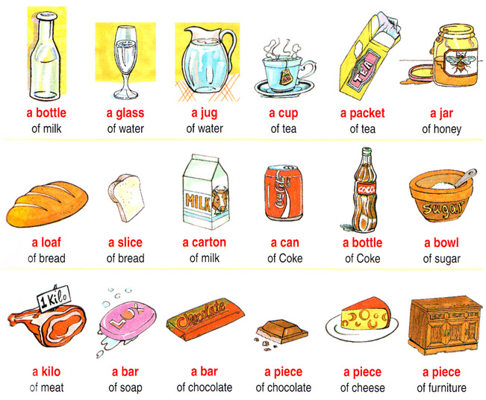

**QUANTIFIERS**

Expressions of quantity tell us *how much* or *how many* of something exists.

This is a summary of the most common expressions of quantity, ordered from ‘*zero quantities*’ to ‘*more than you need or want*’.

|  |  |  |  |
| --- | --- | --- | --- |
| **COUNTABLE** | **SENTENCE** | **UNCOUNTABLE** | **SENTENCE** |
| **not any**  **no** | I do**n’t** have **any** pens.  There are **no** pens that work. | **not any**  **no** | I do**n’t** have **any** money.  I found **no** information on the topic. |
| **few**  **not many** | **Few** shops sell this type of coffee.  **Not many** shops sell this type of coffee. | **little**  **not much** | We have **little** money to spend on the project.  We do**n’t** have **much** money to spend on the project. |
| **a few** | We have **a few** booksto share | **a little** | I like **a little** cheese on pasta. |
| **some: affirm.**  **any: neg. + quest.** | There are **some** bottles of milk in the fridge.  Do you have **any** brothers and sisters?  I haven’t got **any** books to read. | **some: affirm.**  **any: neg. + quest.** | I need **some** fruit to make a fruit salad.  Is there **any** beer in the glasses?  I don’t have **any** money. |
| **many**  **a lot (of)**  **lots (of)**  **plenty of** | **Many** of the houses were burnt in the fire.  There are always **a lot of** cars parked in this street.  Do you have apples? Yes, I have **a lot**.  There were **lots of** people at the concert.  Did you buy any clothes? Yes, **lots**.  There are **plenty of** colours to choose from. | **much**  **a lot of**  **lots of**  **plenty of** | Do you drink **much** coffee?  We had **a lot of** fun at the party.  **Lots of** time is needed to learn a language.  Mesilla has got **plenty of** English novels. |
| **too many** | There are **too many** books to read. | **too much** | Don’t put **too much** sugar in my coffee, please. |

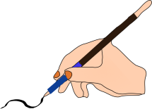 **A.** Complete the sentences with ***a few*** or ***a little*.**

1. I’m going shopping. I need to buy _______ things for tonight’s party.

2. _______people swim in the sea in autumn.

3. Don’t worry. I will wait for you. I’ve got _______ time.

4. There is ____________ snow on the ground. The children can make a snowman.

5. He knows ________people. They can help him find a job.

6. He knows ________people in his new job. He feels so lonely.

7. We need __________ milk and ________ eggs to make a cake.

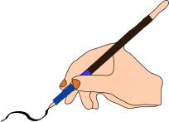 **B.** Circle the right answer: ***a few / few*** or ***a little / little.***

1. I need a little / little money. Can you lend me some?

2. He went out a few / few minutes ago.

3. I have a few / few friends here. We always spend time together.

4. There were a few / few guests at the party. The hosts were unhappy.

5. You don’t have to hurry. There is a little / little traffic at this time of the day.

6. You have a little / little time to finish the test. You must write faster.

7. There are a few / few trees in our garden. We are going to plant some more next

spring.

8. Can I speak to you for a few / few minutes?

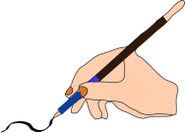 **C.** Correct the mistakes**.**

|  |  |
| --- | --- |
| 1. How many free time do you have?  2. There isn’t a lot of snow in the streets.  3. The doctor gave me any medicine for  my cough.  4. There are a little students in the class.  5. I wanted to buy any fresh eggs, but  there weren't some in the store. | 6. He never gives his kids few money.  7. There isn’t many juice in the glass.  8. Please give me any more coffee.  9. He never makes much mistakes in  spelling.  10. There aren't some good seats left for  the play tonight. |

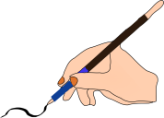 **D.** Complete the sentences with **SOME / ANY / MUCH /MANY /A LOT OF / (A) FEW / (A) LITTLE.** In some sentences several variants are possible.

1. Come here. There is _________dirt on your collar.

2. I love vegetables. I don’t eat __________ meat.

3. I can’t go out tonight. I have _________ homework.

4. I’m sorry, I can’t finish my project. Can you give me _____ more time?

5. It’s not sunny today. There aren’t ________ people at the beach.

6. There aren’t ________ flowers in our garden.

7. I know it’s bad for me. I have only _______ sugar in my tea.

8. Could I have _________ bread with my soup?

9. There isn’t ______ space in my office.

10. They used to be rich, but now they don’t have _______ money.

11. There is only ______ oil in this bottle. Have you got some more?

12. They’ve got a farm, but they haven’t got ________ animals.

13. This isn’t a difficult text. There are only _______ words I don‘t know.

14. You can have as _______ coffee as you like.