** Class ST’**

**UNIT 3 – Imaginary Creatures**

**LESSON 1: Old and modern creatures (Pages 26 - 27)**

1. make up a story = επινοώ μια ιστορία

2. mysterious = μυστηριώδης

3. creature= πλάσμα

4. supernatural powers = υπερφυσικές δυνάμεις

5. ordinary = συνηθισμένος

6. get married = παντρεύομαι

7. fall in love with = ερωτεύομαι

8. flee (fled – fled)= το σκάω, το βάζω στα πόδια

9. savage, fierce= άγριος

10. belly= κοιλιά

11. shipwrecked = ναυαγός

12. keep vigil= μένω ξάγρυπνος e.g. We kept vigil through the night waiting for them to

call

13. underneath = από κάτω

14. cunning = πονηρός

15. fairy = ξωτικό

16. tiny = μικροσκοπικός

17. winged = φτερωτός

18. behave = συμπεριφέρομαι

19. predictable= προβλέψιμος ≠ **un**predictable = απρόβλεπτος

20. delightful= ευχάριστος

21. delicate = ντελικάτος, εύθραυστος

22. be loyal to somebody = είμαι πιστός σε κάποιον

23. nasty = wicked = κακός, μοχθηρός

24. naughty = άτακτος

25. ogre = τέρας, δράκος

26. spit= φτύνω

27. flame= φλόγα

28. be proud of = είμαι περήφανος

29. disgusting = αηδιαστικός

30. witch = μάγισσα

31. knight = ιππότης

32. hideous = φριχτός, απαίσιος

33. bride= νύφη

34. bouquet = μπουκέτο

35. each other = ο ένας με τον άλλο

36. Bring (brought – brought) = φέρνω

37. According to…= σύμφωνα με…

38. good hearted = καλόκαρδος

**Page 29**

1. huge ≠ tiny = τεράστιος ≠ μικροσκοπικός

2. vicious ≠ good-hearted = κακός ≠ καλόκαρδος

3. wicked ≠ good = κακός ≠ καλός

4. horrible≠ lovely = απαίσιος ≠ υπέροχος

5. playful ≠ serious = παιχνιδιάρης ≠ σοβαρός

6. ugly≠ beautiful = άσχημος ≠ όμορφος

7. friendly ≠ **un**friendly = φιλικός ≠ εχθρικός

8. happy ≠ **un**happy = χαρούμενος ≠ λυπημένος

9. kind ≠ **un**kind = καλός, ευγενικός ≠ κακός

10. attractive ≠ **un**attractive = ελκυστικός ≠ μη ελκυστικός

11. predicable ≠ **un**predictable = προβλέψιμος ≠ απρόβλεπτος

12. sensitive ≠ **in**sensitive = ευαίσθητος ≠ αναίσθητος

13. expensive ≠ **in**expensive = ακριβός ≠ φθηνός, cheap

14. active ≠ **in**active = ενεργός ≠ αδρανής

**LESSON 2: Do you believe in ghosts?**

**Page 30**

1. believe in = πιστεύω σε

2. ghost = φάντασμα

3. couple= ζευγάρι

4. carriage = άμαξα

5. seek shelter = αναζητώ καταφύγιο

6. it is getting dark = σκοτεινιάζει

7. silent = σιωπηλός

8. cosy = αναπαυτικός

9. coin= νόμισμα, κέρμα

10. comfortable= άνετος ≠ **un**comfortable = άβολος

11. realize = αντιλαμβάνομαι, συνειδητοποιώ

12. ruins = ερείπια, χαλάσματα

13. pleasant = ευχάριστος ≠ **un**pleasant = δυσάρεστος

14. talkative = ομιλητικός

15. moody = που αλλάζει συχνά διάθεση, κατσούφης



**Comparison of adjectives**

We use the Comparative form of an adjective to compare two things e.g. Tim is taller than his brother. We use the Superlative form to show how one person or thing is different to all the others of its kind e.g. Mary is the tallest girl in our class.

In the Comparative form we add **–er than**in short adjectives and **more + adjective + than**in long adjectives.

In the Superlative form we add **the –est**in short adjectives and **the most + adjective**in

long adjectives.

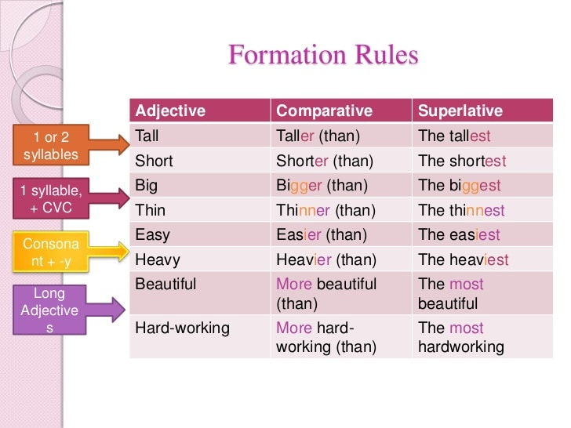

**Irregular adjectives**

|  |  |  |
| --- | --- | --- |
| **Adjective** | **Comparative** | **Superlative** |
| good | better than | the best |
| bad | worse than | the worst |
| far | farther / further than | the farthest / the furthest |
| much / many | more than | the most |
| little | less than | the least |

**Comparisons of adjectives with *as…as and not as / so… as***

We can use the phrases as…as ( = τόσο…όσο) and not as / so ….as ( = όχι τόσο … …όσο) to make comparisons.

|  |  |  |  |  |  |
| --- | --- | --- | --- | --- | --- |
| noun or  pronoun | positive verb | **as** | adjective | **as** | noun or  pronoun |
| Life in the city | is | as | fantastic | as | life in the country |
| noun or  pronoun | negative verb | **as / so** | adjective | **as** | noun or  pronoun |
| Our house | Is not | as / so | luxurious | as | a hotel |

**Forming adverbs**

We use adverbs when we want to answer the question ***HOW***. To form regular adverbs, we add **– ly** to adjectives.

|  |  |  |
| --- | --- | --- |
| Adjective | Adverb | Examples |
| quiet | quiet**ly** | The children are **quiet**.  They are playing  **quietly**. |
| careful | carefully | Tom is a careful driver.  He drives carefully. |
| happ**y** | happ**ily** | That is a **happy** boy.  He is singing **happily**. |

**Irregular adverbs**

|  |  |
| --- | --- |
| **Adjective** | **Adverb** |
| good | well |
| hard | hard |
| fast | fast |
| high | high |
| low | low |
| late | late |
| early | early |
| long | long |
| right | right |
| little | little |
| much /many | much /many |

**Comparison of adverbs**

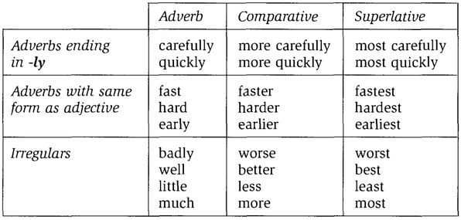

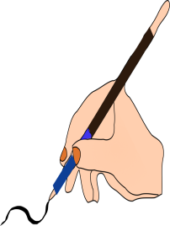**A.** Complete the sentences using the comparative or the superlative form of the adjectives. Add any words that are necessary.

1. America is much ......................................(large) France.
2. David isn’t as ………………………………………………….. (tall) as Bob.
3. Cats aren’t as ……………………………………………….(aggressive) as lions.
4. Do you think she is .........................................(old) I am?
5. I think tulips are ...........................................(beautiful) daffodils.
6. Is it as ......................................(cold) here as in Canada?
7. It is ten miles from .................................................(near) town.
8. It isn't very warm today. It was ..........................(warm) yesterday.
9. It was a very cold day. It was ............................(cold) of the year.
10. It was a very happy day. It was ...........................(happy) day of my life.
11. My father is much .............................................(bad) he was.
12. Shirley is a lot ………………………….………………………………..(intelligent ) Susan.
13. She's a very popular singer. She is .....................................(popular)

singer in our country.

1. Mary's car isn't very big. My car is .....................................(big) hers.
2. Paris is ....................................................(large) city in France.
3. The TGV is ......................................(fast) of all the other trains.
4. The Taylors aren't very nice. The Browns are much ...................(nice).
5. This church is very old. It's .....................................(old) in the town.
6. What is ............................................(long) river in the world?
7. You're not very tall. Your brother is ....................................(tall) you.

** B.** Complete the sentences with the appropriate adjective or adverb from the ones given: **angry, quick, terrible, good, heavy, hard.**

1. Don’t talk! The teacher is getting very ........................

2. I’m ..............sorry, I’m late, but my alarm clock didn’t go off.

3. Your suitcase looks very ........... Let me help you!

4. You are not very ............ at writing English, are you?

5. It’s raining .................at the moment. We can’t go to the park.

6. My mother works...........to make ends meet.

7. Why is that man looking .............. at you?

8. The sinking of the Titanic was a ................. tragedy.

9. She can speak English very .......... Listen to her!

10. If you can play football .......... join the school football club.

**C.** Fill in the correct adverb form (comparative or superlative) of the adjectives in brackets.

1. I speak English (fluent) now than last year. …………………………………….........
2. She smiled (happy) than before………………………………………………….........
3. This girl dances (graceful) of all…………………………………………………..........
4. Could you write (clear)? ..........................................................................................
5. Planes can fly (high) than birds…………………………………………………….......
6. He had an accident last year. Now, he drives (careful) than before…………........

……………………………………………………………………………………...........

1. Jim can run (fast) than John……………………………………………………….......
2. Our team played (bad) of all……………………………………………………….......
3. He worked (hard) than ever before……………………………………………….......