 **Class ST’**

**UNIT 4 – The history of the aeroplane**

**LESSON 1: A day at the museum (Pages 38-39)**

1. receive= λαμβάνω

2. pen friend = φίλος δι’ αλληλογραφίας

3. similar = παρόμοιος

4. flier = ιπτάμενος

5. simulator = προσομοιωτής

6. force = δύναμη, ισχύς

7. flight = πτήση

8. file = φάκελος, αρχείο

9. worksheet = φύλλο εργασίας

10. invent = εφευρίσκω, επινοώ

11. inventor = εφευρέτης

12. invention = εφεύρεση

13. return = επιστρέφω

14. admire = θαυμάζω

15. grow up = μεγαλώνω

16. repair = επισκευάζω

17. fix = φτιάχνω, επισκευάζω

18. classmate = συμμαθητής

19. experiment = πείραμα

20. to last = διαρκώ

21. cover = καλύπτω, σκεπάζω

22. visit = επισκέπτομαι

23. exciting = συναρπαστικό

24. attached file = συνημμένο αρχείο

**THE PARTS OF AN AEROPLANE**

1. aileron = πηδάλιο κλίσης αέρος

2. fuselage = άτρακτος

3. cockpit = πιλοτήριο

4. nose wheel = τροχός

5. landing gear = σύστημα προσγείωσης

6. fin = πτερύγιο

7. rudder = πηδάλιο

8. wing = φτερό

9. tail = ουρά

10. windows = παράθυρα

11. hatch = πόρτα

**LESSON 2: An air pocket (Pages 42-43)**

1. pocket = τσέπη

2. air pocket = κενό αέρος

3. above the ocean = πάνω από τον ωκεανό

4. passenger = επιβάτης

5. pray = προσεύχομαι

6. prayer = προσευχή

7. say my prayers = λέω την προσευχή μου

8. drag = εμπόδιο, φόρτωμα

9. lift = σηκώνω, ανύψωση, ύψωμα

10. thrust = ώθηση

11. gravity = βαρύτητα

12. forward ≠ backward = προς τα εμπρός ≠ προς τα πίσω

13. downward ≠ upward= προς τα κάτω ≠ προς τα πάνω

14. cargo = φορτίο

15. speed = ταχύτητα

16. sound = ήχος

17. goods = αγαθά

18. engine = μηχανή

19. material = υλικό

20. rocket = πύραυλος

21. orbit = τροχιά, βάζω σε τροχιά

22. below = κάτω από

23. in order to… = έτσι ώστε, για να

24. powerful = ισχυρός, δυνατός

25. They are designed = είναι σχεδιασμένα

26. seaplane = υδροπλάνο

27. lightweight = ελαφρύς

28. land = προσγειώνομαι ≠ to take off = απογειώνομαι

**LESSON 3: The fall of Icarus (Pages 46)**

1. field = χωράφι

2. shepherd = βοσκός

3. look after = take care of = φροντίζω

4. sheep (- sheep) = πρόβατο (- πρόβατα)

5. fisherman = ψαράς

6. sweat = ιδρώνω

7. melt = λιώνω

8. wax = κερί

9. coast = ακτή

10. unnoticed = απαρατήρητος

11. drown = πνίγομαι



**Talking about the past**

**Past Simple**

USE

We use the Simple Past tense to talk about an action, a situation or an event,

short or long, that

• happened in the past e.g. I *lived* in that house when I was younger.

• is completely finished e.g. I had spaghetti for lunch

• we say (or understand) the time and/or place it happened e.g. John *rode* his bike to

school on Monday.

* happened one after the other (when we tell a story) e.g. I looked out of the window and saw him standing outside my front door.

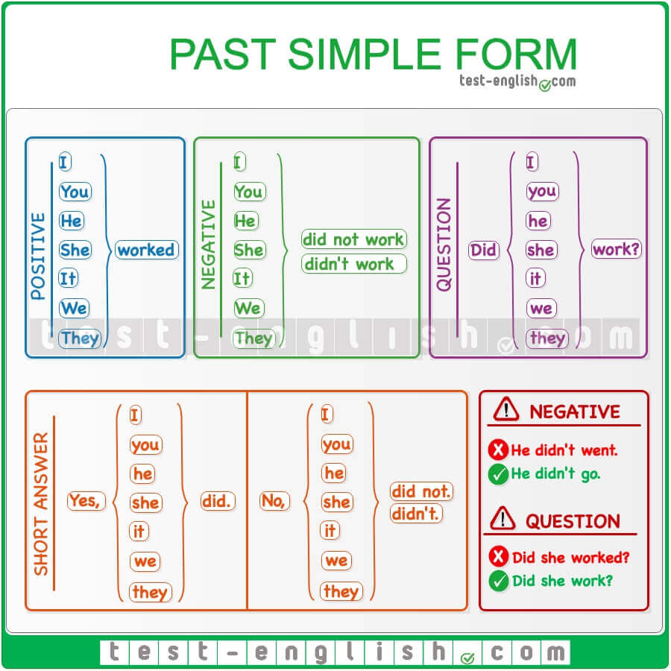

**Past Continuous**

USE

The Past Continuous tense expresses

* an action that was in progress at a particular moment in the past e.g. I was doing my homework at 7 in the evening.
* an action that was in progress when another action happened. In this case for the action that was in progress we use Past Continuous, whereas for the action that interrupted it we use the Past Simple e.g. We were watching a film on TV when our mother called us for dinner.
* two actions that were in progress at the same time e.g. While I was studying, my father was reading a newspaper.

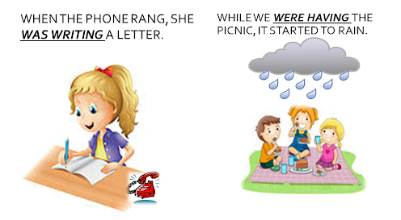

We can join the two ideas with **when** or **while**. We use:

**when +** Simple Past tense e.g. I was watchingTV **when** the telephone ***rang***.

**while +** Past Continuous tense e.g. I saw Peter **while** I was walking to school – **While** I

was watching TV the telephone rang.

**Linking Words**

When we tell a story we use linking words to lead our audience. Some of the linking words we can use to narrate events in a chronological order are**: First, Then, Later, After that, When, While, As, Finally, In the end.**

***As*** the Wright brothers were growing up, they were repairing and fixing things.

***First***, they made kites and sold them to classmates.

***Then***, they opened a bicycle shop and repaired bicycles.

***Later***, they used the money for their first flight experiments.

***Finally***, they flew the first plane in 1903.

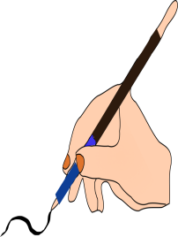**A.** Circle the correct verb form in each of the following sentences.

1. Mary **prepared / was preparing** lunch when they **came / was coming.**
2. Tom was very unlucky. It **rained / was raining** every day during his holidays.
3. Who was that nice girl you **talked / were talking** to when I **walked / was walking** by the pub?
4. Last weekend Susan **fell / was falling** and **broke/ was breaking** her leg.
5. When I **entered / was entering** the cafeteria Mary **had / was having** lunch with Peter.
6. We **drove/ were driving** to Berlin in Robert´s new car.
7. The sun **shone / was shining** brightly when **I got up / was getting up** this morning.
8. Ann finally **told / was telling** us the whole story about Peter.

**B.** Read the following sentences and put the verbs in brackets in either the Past Simple or the Past Continuous. Put any other words in brackets in the correct place.

a) As Sophie ___________(walk) up Regent Street she ___________(meet) an old

friend from college.

b) When ___________(father/arrive) yesterday?

He ___________(arrive) late. The train ___________(be) delayed due to an

accident.

c) Who ___________(you/ speak) to on the phone when I ___________(come) in?

d) Mary ___________(read) in bed when she ___________(hear) a strange noise

downstairs.

e) When Mr. Lawrence ___________(leave) home at 8.30 this morning, the sun

___________(shine) brightly. However, by 10 o´clock it ___________(rain) heavily.

f) Sebastian ___________(arrive) at Susan´s house a little before 11 a.m., but she

___________(not/be) there. She ___________(study) at the library.

g) The fireman ___________(rescue) a 75-year-old woman who ___________(be)

trapped on the second floor of the burning building.

h) ___________(you/do) any shopping yesterday?

i) Yesterday Jane ___________(fall) and ___________(hurt) herself while she

___________(ride) her bicycle.

j) What ___________(Peter / do) when you ___________(knock) on his door?

k) Helen ___________(wear) her mini dress to the party last night.

 **C.** Read the following story about a fire and then put the verbs in the brackets in either the Past Simple or the Past Continuous to complete it.

When I (get up) 1. .…………….. , smoke (come) 2. ………………………. under my bedroom door and I (hear) 3. …………………………. a strange noise. I (look) 4. ….………………. out of the window and firemen (stand) 5. ………………………….. in the garden. I (see) 6. ……………………….. a fire-engine in the street. I (leave) 7. ……………………… my room quickly and (go) 8. …………………………to the children’s room. They (cry) 9. ………………………when I (get) 10. ………………….. there.

When they (see) 11. ………………….. me, they (run) 12. ………………………. to me and we all (jump) 13. ………………………………. out of the window, while the firemen (hold) 14. ……………………………………. a blanket under us. A police car (wait) 15. …………………………………….. for us and it (take) 16. ……………………………. us to hospital. Finally, our house (burn down) 17. ………………………….. , but we (be) 18.

……………………………. all safe.