

**Class ST’**

**UNIT 6 – Me, Myself and my Future Job**

**LESSON 1: Talking about jobs and careers (Pages 61 - 65)**

1. safety rules = κανόνες ασφαλείας

2. working environment = εργασιακό περιβάλλον

3. skill - ability = ικανότητα

4. personal traits = προσωπικά χαρακτηριστικά

5. New Year resolutions = αποφάσεις για τη νέα χρονιά

6. possibility = πιθανότητα

7. permit = επιτρέπω - permission = άδεια

8. advice = συμβουλή

9. predict = προβλέπω - prediction = πρόβλεψη

10. promise = υπόσχομαι, υπόσχεση

11. warn = προειδοποιώ - warning = προειδοποίηση

12. request = ζητάω, αίτημα

13. offer = προσφέρω, προσφορά

14. intend to = σκοπεύω να…/ προτίθεμαι να…– intention = πρόθεση

15. ecologist = οικολόγος

16. jewellery designer = σχεδιαστής κοσμημάτων

17. air traffic controller = ελεγκτής εναέριας κυκλοφορίας

18. hairdresser = κομμωτής -τρια

19. shift = βάρδια

20. communication skill = επικοινωνιακή ικανότητα

21. precious stones = πολύτιμες πέτρες

22. necklace = κολιέ, περιδέραιο

23. earrings = σκουλαρίκια

24. tool = εργαλείο

25. delicate = λεπτό, ντελικάτο

26. require = ζητάω

27. dexterity = δεξιότητα

28. coordinate = συντονίζω, συγχρονίζω - coordination = συγχρονισμός

29. patience = υπομονή – patient = υπομονετικός

30. concentration = συγκέντρωση

31. knowledge = γνώση

32. direct = κατευθύνω – direction = κατεύθυνση

33. flying schedule = πρόγραμμα πτήσης

34. instruct = δίνω οδηγίες – instruction = οδηγία

35. for many different reasons = για πολλούς και διάφορους λόγους

36. vary = ποικίλω – variety = ποικιλία

37. responsible = υπεύθυνος

38. compassionate = συμπονετικός

39. nutrition = διατροφή

40. razor = ξυράφι

41. create = δημιουργώ – creation = δημιουργία – creative = δημιουργικός

42. self- confident = αυτός που έχει αυτοπεποίθηση

43. certain = ορισμένος, βέβαιος

44. independently = ανεξάρτητα

45. lifeguard = ναυαγοσώστης

46. dive = βουτάω

47. well trained = καλά εκπαιδευμένος

48. facilities = εγκαταστάσεις

49. candidate = υποψήφιος

50. repair = επισκευάζω

51. work under pressure = δουλεύω υπό πίεση

52. loads of = πολλά

53. attention = προσοχή

54. detail =λεπτομέρεια

55. artistic = καλλιτεχνικός –η, -ο

56. care for / take care of = φροντίζω

57. stressful = αγχωτικό

58. occupation = επάγγελμα

59. health sciences = επιστήμες υγείας

**LESSON 2: What do they do? (Pages 66-69)**

1. tour guide = ξεναγός

2. meteorologist, weather forecaster = μετεωρολόγος, εκφωνητής δελτίου καιρού

3. threat = απειλώ

4. on-the-spot decision = απόφαση της στιγμής

5. suitcase = βαλίτσα

6. to accomplish a goal = πετυχαίνω έναν στόχο

7. goggles = γυαλιά / μάσκα (δύτη, για τη θάλασσα)

8. aisles = διάδρομοι, πτέρυγες

9. tamper with = πειράζω κάτι, ανακατεύομαι (εκεί που δεν πρέπει)

10. muscles = μύες

11. assist = βοηθώ - assistance = βοήθεια

12. liquid = υγρό

13. grease = γράσο, λιπαντικό

14. challenge = προκαλώ, πρόκληση

15. fascinated = γοητευμένος

16. skyscraper = ουρανοξύστης

17. budget = προϋπολογισμός

18. a wide range/variety of… = μία ευρεία ποικιλία από…

19. exhausted = very tired, εξαντλημένος



**MODALS: can, may, should, will, be going to**

**CAN**

We use **can** to talk about **possibility** (= what is possible), **ability** (= what we are able) or **permission** (= what we are free to do): I can play the piano (ability) - You can’t use the facilities if you aren’t a club member (permission) – Can I go out? (permission – informal).

Note! The use of CAN for permission is informal.

**May**

We use **may** to formally ask / give **permission** for something or to talk about **possibility** e.g. May I leave early today? (permission – formal) - If you’re a police officer, you may work night shifts (possibility).

**Should**

We use **should** to give **advice** to someone e.g. If you’ve got a cold, you should take the day off

**FORM**

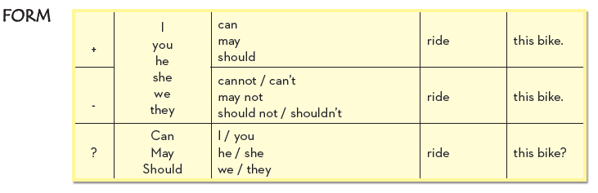

**Simple Future (will / won’t)**

We use the **Simple Future** **tense (will / won’t)** to show **prediction, offer, promise*,* warning,on the spot decision**and **request**.

Examples: There isn’t any milk. I’ll go to the supermarket to get some (on-the-spot

decision)

Will you help me with this maths exercise? (request)

Don’t worry if this box is heavy. I’ll help you carry it (offer)

I will never be late again (promise)

I think Kate will become a teacher because she’s so good with children

(prediction)

If you don’t help me, I will never speak to you again (1st Conditional –

threat)

Note!

* When we have a plan, arrangements or intention to do something in the future, we usually use other tenses or expressions, such as the Present Continuous tenseor begoing to.
* When we use will / won’t for predictions, we make a general prediction not based on evidence.

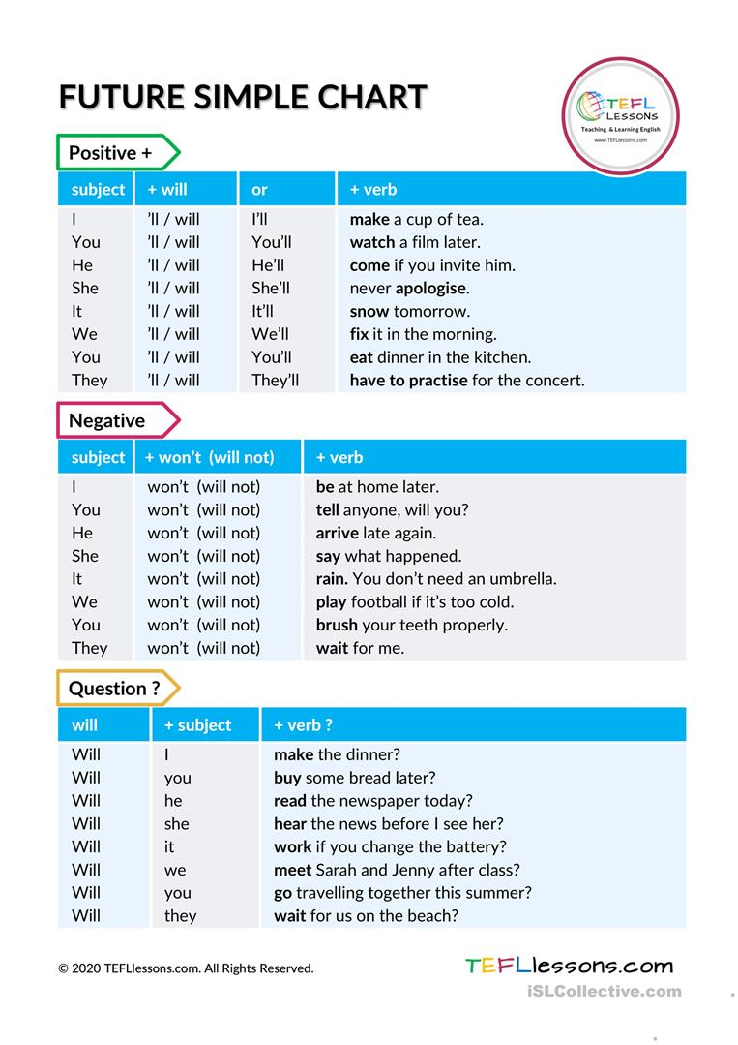



**The Verb Phrase Be going to**

We use **be going to…** to talk about something that we have the **intention** /we have planned to do before the time of speaking. We also use it to make **predictions** based on evidence e.g. When I finish school, I’m going to get a job as a waiter (intention) - Are you going to come to the cinema with us? (plans) – Look at all those black clouds in the sky. It’s going to rain (prediction).

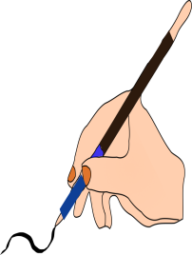

**A.** Match the phrases.

1. Do you like this shirt? A. I’ll help you do the house work.

2. I’m very tired B. we will be late.

3. Be quiet. C. I think you will become a teacher.

4. If you don’t come quickly, D. I love it. Will you buy it for my birthday?

5. Do your homework, E. I will get you a glass of water.

6. I’m thirsty. F. You will wake up your mother.

7. I love children. G. or your teacher will be very angry.



**B.** Match the problems with the correct advice.

1. I’ve got a bad cold. A. You should take a day off work.

2. I want to lose weight. B. You should study hard.

3. I’m tired. C. You should go to the doctor.

4. I’ve got a test tomorrow. D. You should be brave and strong.

5. I want to become a policeman. E. You should ask your mother for help.

6. I’ve got a pain in my tooth. F. You shouldn’t eat sweets.

7. I can’t understand this maths problem. G. You should go to the dentist.



**C.** You **MAY** to talk about what may happen in the following situations.

0. Take your umbrella with you. – (rain) It may rain.

1. Study hard. – (test) ………………………………………………

2. Take some sandwiches with you. – (hungry) …………………………………………..

3. Wear a jacket. – (cold) ………………………………………………

4. Don’t forget your map. – (lose your way) ……………………………………

5. Call her before you leave. – (be there) ………………………………………….