

**Class ST’**

**UNIT 7 – SHARE YOUR EXPERIENCES**

**Page 73**

1. experience = εμπειρία

2. questionnaire = ερωτηματολόγιο

3. extract = απόσπασμα (από εφημερίδα, περιοδικό κτλ)

4. champion = πρωταθλητής

5. championship = πρωτάθλημα

6. world record = παγκόσμιο ρεκόρ

7. record holder = κάτοχος ρεκόρ

8. protect= προστατεύω – protection = προστασία

9. activity = δραστηριότητα

10. car accident = αυτοκινητιστικό ατύχημα

11. electricity blackout = διακοπή ηλεκτρικού ρεύματος

12. shake hands with= κάνω χειραψία με…

**LESSON 1: Famous Record Holders (Pages 74 - 77)**

1. article = άρθρο

2. nickname = υποκοριστικό, παρατσούκλι

3. torpedo = τορπίλλη

4. distance = απόσταση

5. dominate= κυριαρχώ – domination = κυριαρχία

6. event = αγώνισμα, άθλημα/ γεγονός

7. relay team = ομάδα σκυταλοδρομίας

8. exceptional = εξαιρετικός, υπέροχος

9. in total = συνολικά

10. so far = μέχρι τώρα

11. besides + gerund (-ing) = εκτός **e.g. Besides** be**ing** rich, he is also famous.

12. Phantom = φαντομάς, φάντασμα

13. entertain= διασκεδάζω - entertainment = διασκέδαση

14. produce= παράγω – production = παραγωγή

15. compare = συγκρίνω

16. originally = αρχικά

17. audience = ακροατήριο, κοινό

18. break a record = σπάω ένα ρεκόρ

19. review = κριτική

20. performance = παράσταση

21. completely= τελείως

22. success= επιτυχία – successful= πετυχημένος

**SWIMMING STYLES**

23. freestyle = ελεύθερο

24. relay race = σκυταλοδρομία

25. backstroke = ύπτιο

26. breaststroke = πρόσθιο

27. butterfly = πεταλούδα

28. retire = αποσύρομαι – retirement= απόσυρση, συνταξιοδότηση

29. achieve= κατορθώνω – achievement = κατόρθωμα

30. soap opera = σαπουνόπερα

31. magazine cover = εξώφυλλο περιοδικού

32. to be injured = τραυματίζομαι

33. the longest running show= η παράσταση που παίζεται για περισσότερο χρόνο

34. packed= γεμάτο κόσμο

35.composer= συνθέτης

**LESSON 2: Top Stories on the Radio (Pages 78 - 81)**

1. usual= συνηθισμένος ≠ unusual= ασυνήθιστος

2. suitable= κατάλληλος ≠ unsuitable= ακατάλληλος

3. contest = διαγωνισμός

4. take part in = συμμετέχω

5. skewer = σουβλάκι

6. ferret = νυφίτσα

7. beat somebody (sb) = νικώ κάποιον

8. author = συγγραφέας

9. scientist = επιστήμονας

10. information (μόνο ενικός) = πληροφορία, πληροφορίες

**LESSON 3: Going for the Gold (Pages 82 - 84)**

1. ramp= ράμπα

2. bill = λογαριασμός

3. salt = αλάτι – salty = αλμυρός

4. destination = προορισμός

5. sanctuary = ναός, ιερό, άδυτο

6. spirit = πνεύμα

7. inhabit = κατοικώ - inhabitant = κάτοικος

8. vet = κτηνίατρος



**Present Perfect Simple**

We use the **Present Perfect Simple** tense to talk about **past activities**, which we are not interested in **when** they happened. We only want to know **if they happened**

e.g. I **have seen** ET.

He ***has lived*** in Paris.

***Have*** you ***visited*** Rome?

They ***have*** never ***broken*** a world record.

**NOTE:** If we are interested in **when** an action happened we use the **Simple Past**

Tense e.g. Ian Thorpe ***won*** the 400 m freestyle in 2004 Athens Olympics.

**FORM**

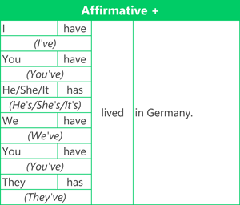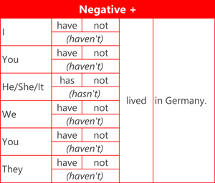

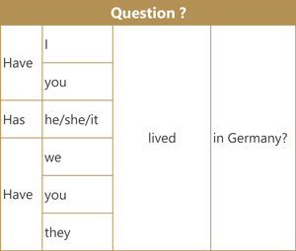

**Key Words:** for, since, just, already, yet, recently, ever, never, this week/month/year

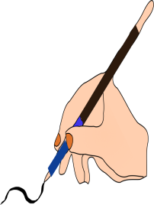

**A.** Fill in the gaps with the **Present Perfect** or the **Past Simple** of the verbs in brackets.

1. I _______went_______ (go) to my first football match when I was six.
2. My sister ____________________ (never / see) a film at the cinema.
3. In 2005 my brother _________________ (meet) five players from the Real Madrid team.
4. Where ___________you ___________ (live) when you where younger?
5. I ___________________ (have) an argument with my girlfriend at the weekend.
6. They ___________________ (study) English yet.
7. I ___________________ (go) on a cruise holiday last summer.
8. My Dad ___________________ (not / smoke) since 2002.
9. How long ____________you___________ (know) Jeremy?
10. __________she__________ (find) her way to the newsagents yesterday?
11. I _______________________ (be) a Harry Potter fan since I was ten.
12. Doug ___________________ (lose) his mobile phone.
13. Mary ____________________ (already / buy) her books for school.
14. Sandra ____________________ (just / call) to say hello.
15. I _____________________ (be born) in 1990.
16. When ____________ your sister ______________ (start) school?
17. This week I _________________ (see) two good films so far.
18. That’s the best concert I___________________ (ever / be) to.
19. Patricia ________________ (see) Chris last week.
20. ___________the butcher _____________(sell) all the sausages?
21. I _________(fall) and __________(break) my arm this morning.
22. Where ___________ you ___________ (be) all day?
23. Alice ____________________ (not / answer) my letter, yet. Perhaps she’s busy.
24. ___________you __________ (ever / win) the lottery?
25. How much money _____________________ (spend) on clothes last weekend?

**PRESENT PERFECT CONTINUOUS**

We use the **Present Perfect Continuous** tense:

* to talk about an **action** that started in the past and stopped recently. There is usually a result **now**.
* I'm tired [now] because I**'ve been running**.
* Why is the grass wet [now]? **Has** it **been raining**?
* You don't understand [now] because you **have**n't **been listening**.
* to talk about an **action** that started in the past and is continuing **now**. This is often used with **for** or **since**.
* I **have been reading for** 2 hours. (I am still reading now.)
* We**'ve been studying since** 9 o'clock. (We're still studying now.)
* How long **have** you **been learning** English? (You are still learning now.)

**FOR or SINCE + Present Perfect Continuous**

We often use **for** and **since** with perfect tenses.

* **For + Period of time** : We use **for** to talk about a **period** of time (three hours, two months, one decadeetc.) e.g. I have been studying **for** three hours / Tara hasn't been feeling well **for** the last two weeks.
* **Since + Point in time:** We use **since** to talk about a **point** in past time (9 o'clock, 1st January, Monday etc.) e.g. I have been watching TV **since** 7pm / Tara has been living with us **since** March.

**Form**

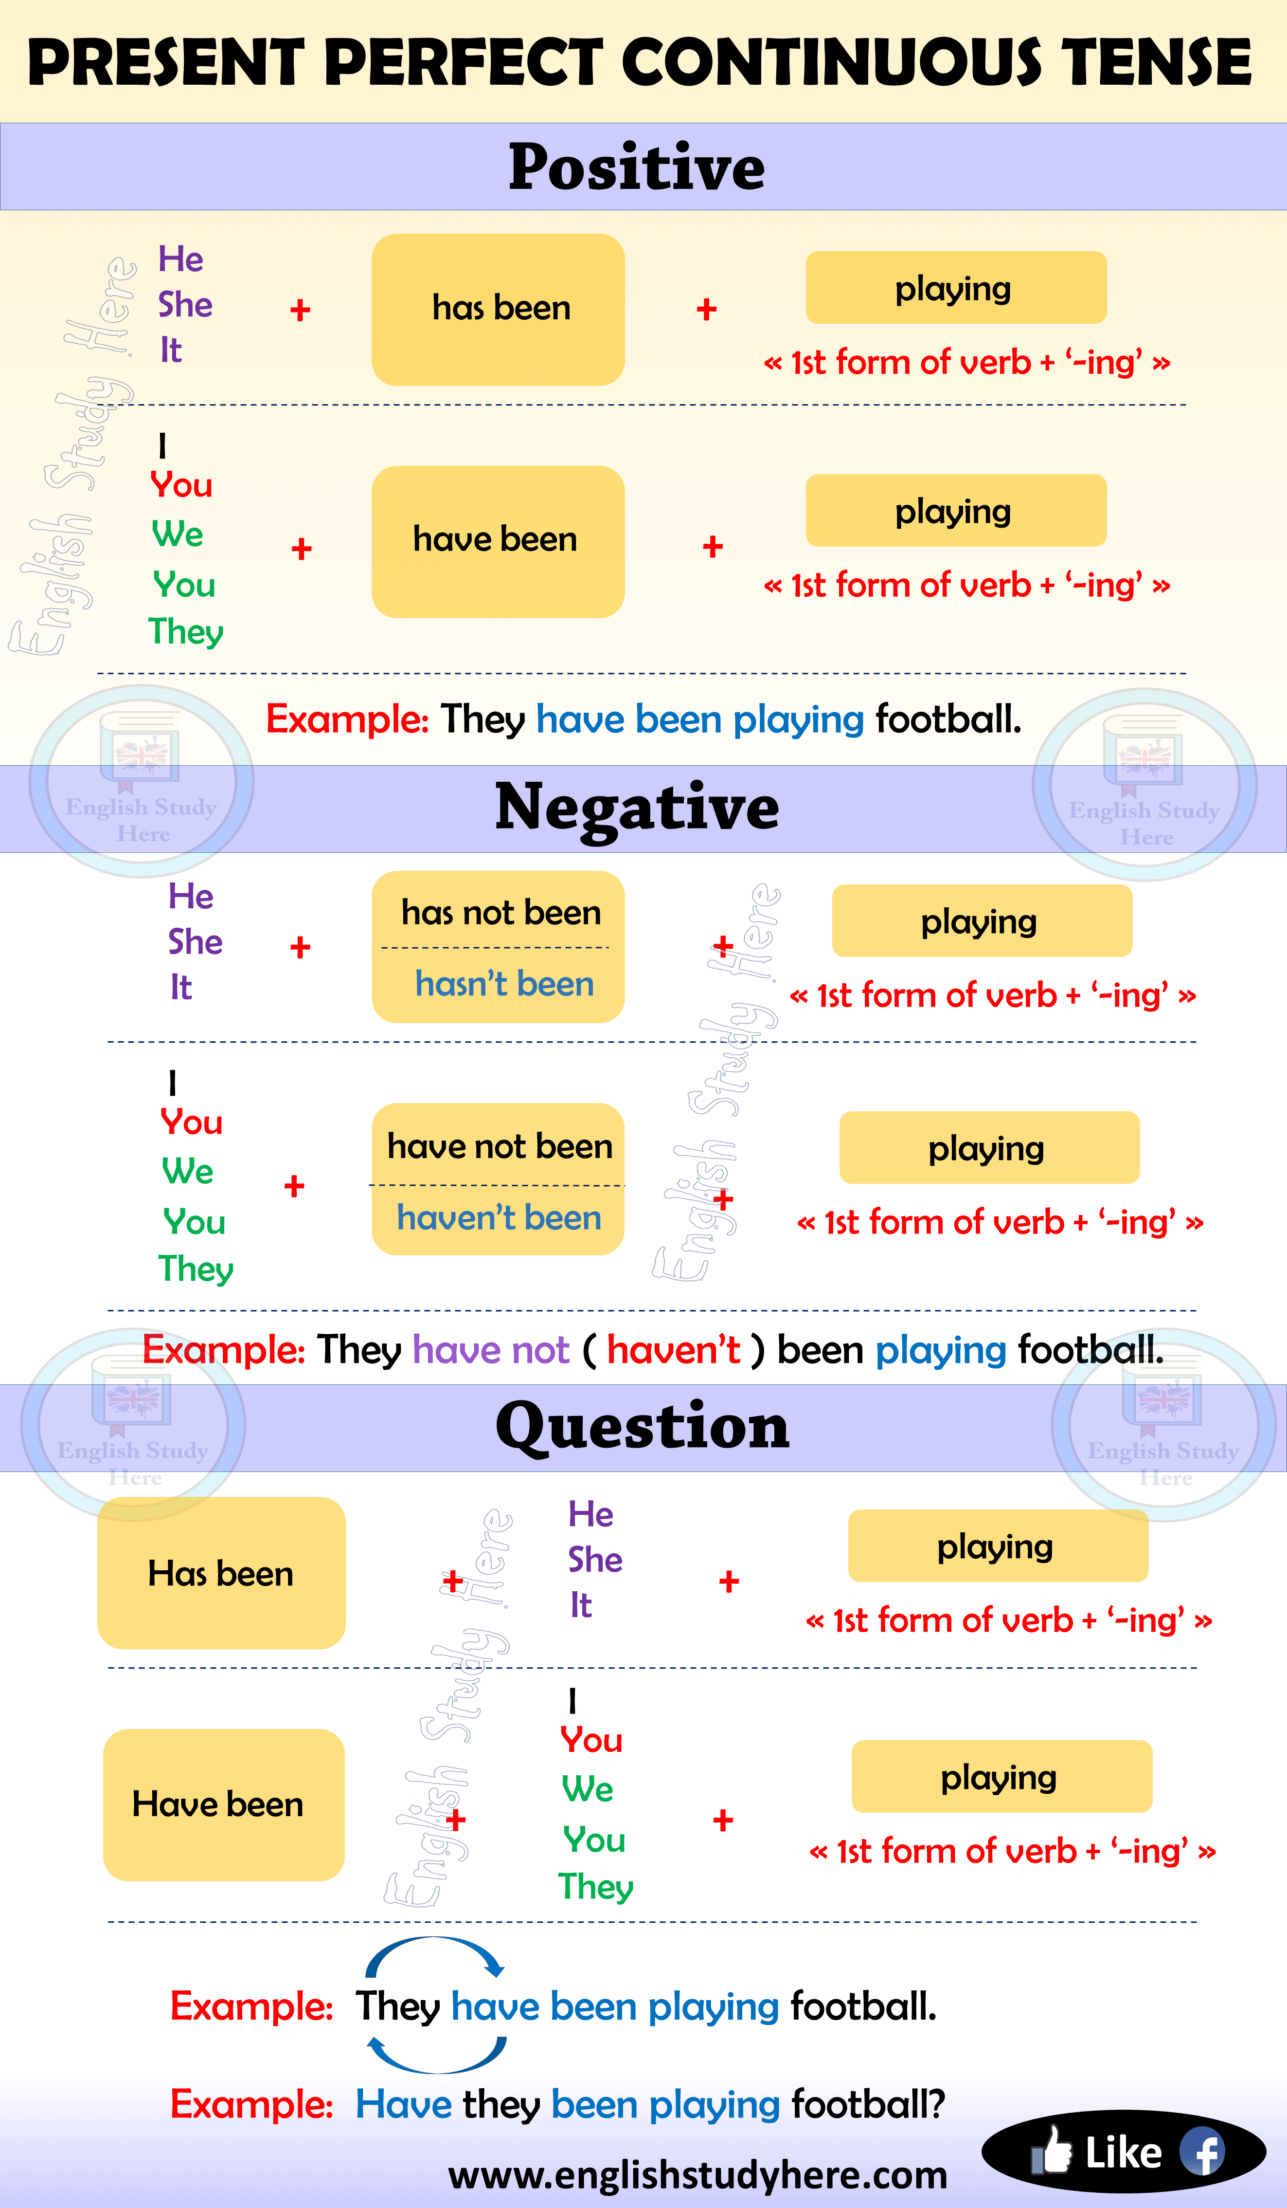



**B.** Put the verbs in the **Present Perfect Simple** or the **Present Perfect**

**Continuous.**

0. - Where is John?

- He is not here right now. He …has gone to the supermarket…………….

1. – What’s the matter? ………………………….. (you / cry)?

- No, I ……………………………. (wash) my hair and I think some shampoo

…………………………. (get) into my eye.

2. – Why are you so late?

- I …………………………………. (repair) my car!

- Really! …………………………… (you / fix) everything?

3. – You look happy!

- Yes, I …………………………………….. (listen) to that CD you gave me.

- Do you like it?

- Yes, it’s great. I ………………………………. (listen) to it four times already.

4. – I ………………………………… (not / feel) very well the last few weeks.

- ……………………………………… (you / see) a doctor?

- Yes, he thinks I ……………………………………. (work) very hard lately.

5. – I’m really sorry I was late. How long ……………………………….. (you / wait)?

- Don’t worry. I ............................... (just / arrive).