My family Tree

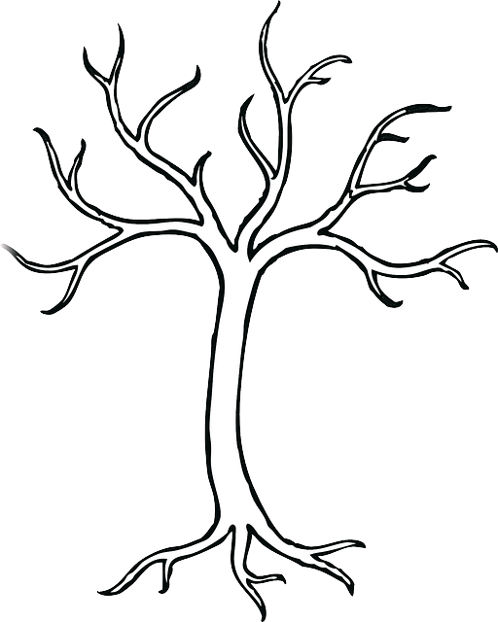

|  |  |
| --- | --- |
| Mother | Mother |
| Father | Father | Grandfather | Grandfather |
| Grandmother | Grandmother | Me | Brother |
| Brother | Brother | Brother | Sister |
| Sister | Sister | Sister | Pet |