The two friendly ghosts

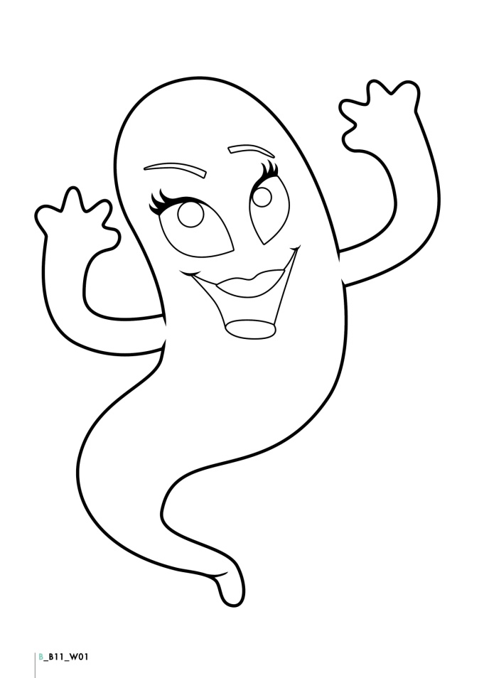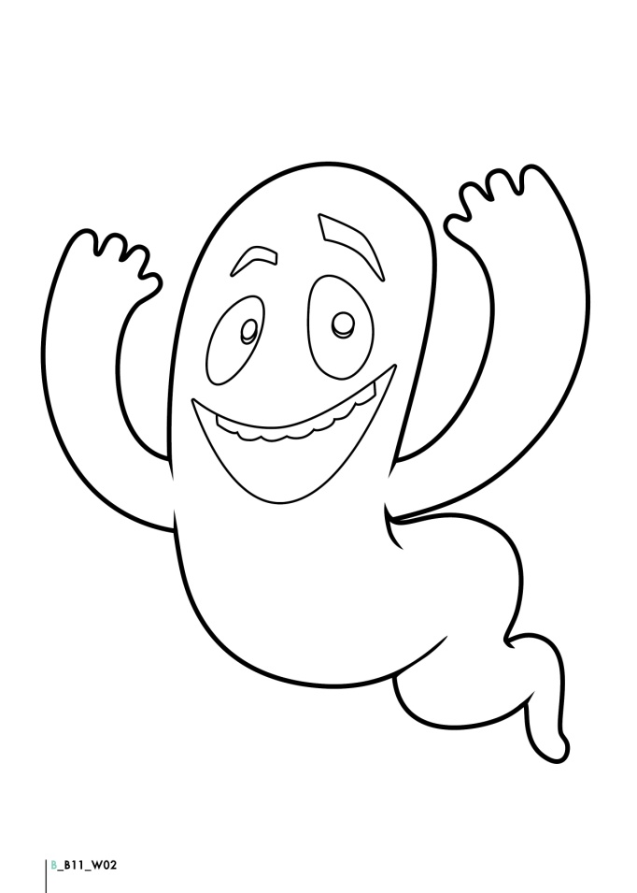

Once upon a time there were 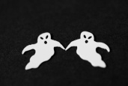 . They were brother and sister. Their names were Michael and Christie. They were very friendly and they liked to make friends.

The two friendly ghosts had 2 big 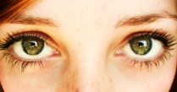,

a  and 2 , but they did not have 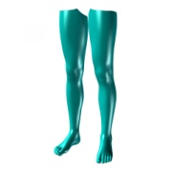. In their free time they liked to play tricks on people but they were not scary at all. They were very cute!

The two little ghosts lived in a haunted 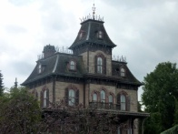 and when they were naughty they liked to hide in a tall  in their secret 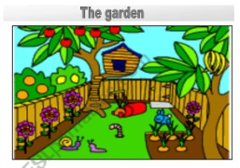.

The 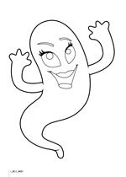 lived in a cotton-candy pink. In her bedroom there was a pink 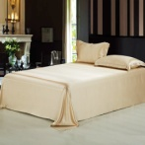, a pale pink 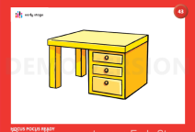 with a swivel 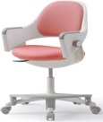, a wonderful 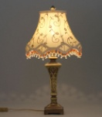 on the desk, a pink 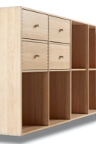 and a toy box. Her favourite toy was a pink teddy bear with a baby bottle.

The 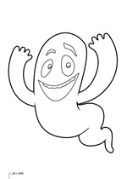lived in a  bedroom. In his bedroom there was a bed with a red mattress and red sheets. There was a lamp and a  on his desk. There was a bookshelf with lots of books full of magic spells in them.

There was also a toy box with lots of toys - 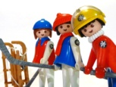 , 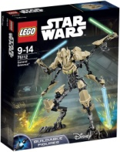, teddy bears and race  .

The two little ghosts could pass through 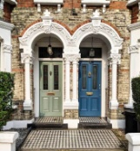 and 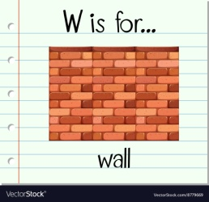. They could travel to space and make funny faces. They could  high, 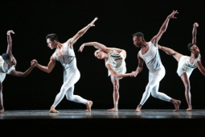 and fly up in the sky. They could use their magic wands, colour, 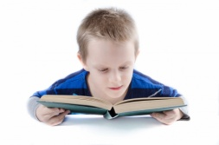 and read people’s minds!!!

At parties they ate , skeleton candies, invisible 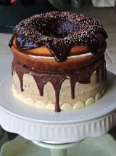 and scary . They drank hot 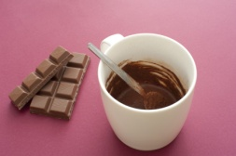, energy drinks,  with eyeball-shaped ice cubes in it!

One day as they were flying around dancing the “Hokey Pokey”, they made all the things in the house float in the air!!!!!

THE END