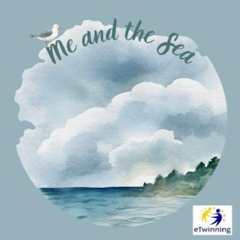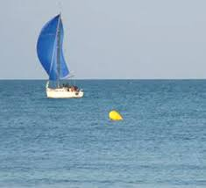

IDIOMS RELATED TO THE SEA
Complete the following sentences with an appropriate idiom from the table below.
like a fish out of the water a whale of a time the world is your oyster
The coast is clear a drop in the ocean make waves smooth sailing packed like sardines fishy fishing for compliments dead in the water
plenty of other fish in the sea keep our head above the water oceans apart as deep as the ocean cried an ocean all at sea in deep water
smooth sailing between the devil and the deep blue sea
boil the ocean rock the boat

- Please, behave yourself. Try not to …make waves….. your first week at the new school!
- The dancer forgot the choreography and was left ……all at sea…. on the stage! He didn’t know what to do!
- At first my son didn’t want to go to the camp, but now he got there he is having a whale of a time!
- The little girl ……cried an ocean….. when she lost her new toy.
- I feel so uncomfortable doing this! I mean, I feel ……like a fish out of the water…
- I don’t think they will agree. Their views are …oceans apart…
- You just graduated from university. Now …the world is your oyster…. You can make your dreams come true!
- When my boyfriend left me, my friends told me not to be sad because there are………………plenty of other fish in the sea…….. and they were right!
- Remember! Your parents’ love for you is …as deep as the ocean…
- I can tell by the look on your face that there is something …fishy… going on here!
- We could barely move in the train. We were …packed like sardines..
- The rumour is out now. All his efforts to keep his secret safe are now…. .…dead in the water……………
- The cost of living is so high I do not know how we can .……keep our head above the water……………………………….
- She can either stay here alone or follow him into the unknown. She doesn’t know what to do! She’s caught …between the devil and the deep blue sea…..
- I know she will not help me so I will not try to convince her. You see, I can’t ...…..boil the ocean.......
- The money we give to charity to help the poor people in Africa is just …a drop in the ocean…. They need far more than that!
- She always talks bad about herself, but I think she is just ….……fishing for compliments……………….
- Little Johnny broke his mother’s cell phone. He’s going to be …………in deep water…. once his mother finds out what he did!
- You can come out now. ……The coast is clear!………
- At first Zumba dancing was difficult, but after we learnt the basic moves it was ……smooth sailing… from there!
- She is sure her modern teaching methods will …rock the boat... in the rather conservative school community, but she is willing to give it a try!

