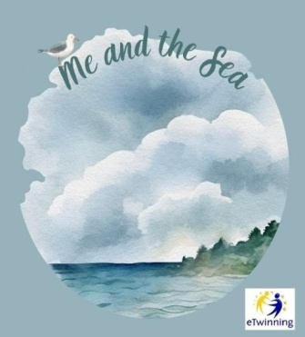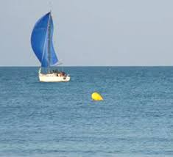
IDIOMS RELATED TO THE SEA
Complete the following sentences with an appropriate idiom from the table below.
like a fish out of the water a whale of a time the world is your oyster
The coast is clear a drop in the ocean make waves smooth sailing packed like sardines fishy fishing for compliments dead in the water
plenty of other fish in the sea keep our head above the water oceans apart as deep as the ocean cried an ocean all at sea in deep water
smooth sailing between the devil and the deep blue sea
boil the ocean rock the boat

- Please, behave yourself. Try not to ………………………….. your first week at the new school!
- The dancer forgot the choreography and was left ………………………. on the stage! He didn’t know what to do!
- At first my son didn’t want to go to the camp, but now he got there he is having ………………..
- The little girl ………………………….. when she lost her new toy.
- I feel so uncomfortable doing this! I mean, I feel ……………………………………
- I don’t think they will agree. Their views are …………………………………………
- You just graduated from university. Now …………………………………………. You can make your dreams come true!
- When my boyfriend left me, my friends told me not to be sad because there are……………… ………………………………………….. and they were right!
- Remember! Your parents’ love for you is ……………………………………………
- I can tell by the look on your face that there is something ………………………… going on here!
- We could barely move in the train. We were ………………………………………..
- The rumour is out now. All his efforts to keep his secret safe are now .……………………………………………………………………………………………
- The cost of living is so high I do not know how we can .…………………………………………………………………………………………….
- She can either stay here alone or follow him into the unknown. She doesn’t know what to do! She’s caught ……………………………………………………………………………………………..
- I know she will not help me so I will not try to convince her. You see, I can’t ...…..…………..…………........................................................................................
- The money we give to charity to help the poor people in Africa is just ………………………………………………………. They need far more than that!
- She always talks bad about herself, but I think she is just …………………………………………………………………………………………….
- Little Johnny broke his mother’s cell phone. He’s going to be ………………………………………………. once his mother finds out what he did!
- You can come out now. ………………………………………………………………
- At first Zumba dancing was difficult, but after we learnt the basic moves it was ……………………………………………………………… from there!
- She is sure her modern teaching methods will ……………………………………... in the rather conservative school community, but she is willing to give it a try!

