**ΦΥΣΙΚΗ Γ’ ΛΥΚΕΙΟΥ**

**ΘΕΤΙΚΟΥ ΠΡΟΣΑΝΑΤΟΛΙΣΜΟΥ**

[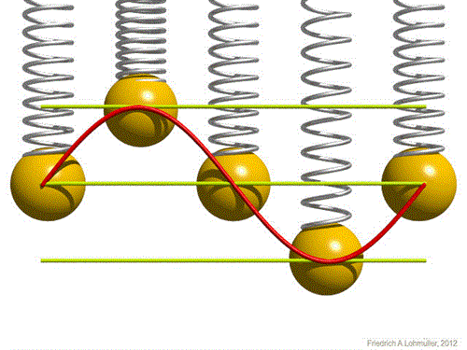](https://www.google.gr/url?sa=i&rct=j&q=&esrc=s&source=images&cd=&cad=rja&uact=8&ved=2ahUKEwiAr7nWi-veAhVQXBoKHc7JDlkQjRx6BAgBEAU&url=http%3A%2F%2Ffysicakasta.blogspot.com%2F2017%2F08%2F2017.html&psig=AOvVaw35Ek-Y3bIMoHpKOweyp0dN&ust=1543082280572306)