Greek City Times στο Instagram

100,000 Banned Books Were Formed Into a '𝗣𝗮𝗿𝘁𝗵𝗲𝗻𝗼𝗻 𝗼𝗳 𝗕𝗼𝗼𝗸𝘀' 🏛️📚
Argentinian artist Marta Minujín's monumental replica of the Greek Parthenon created with 100,000 copies of banned books, symbolises resistance to political repression and the dangers of suppressing free speech.
The artist had created a full-scale replica of one of the world’s most famous structures, the Parthenon in Athens, constructed entirely from censored books.
𝗧𝗵𝗲 𝘀𝘆𝗺𝗯𝗼𝗹𝗶𝘀𝗺 𝗶𝘀 𝘀𝘁𝗿𝗶𝗸𝗶𝗻𝗴, 𝗮𝘀 𝘁𝗵𝗲 𝗣𝗮𝗿𝘁𝗵𝗲𝗻𝗼𝗻 𝗶𝘀 𝘁𝗵𝗲 𝘃𝗲𝗿𝘆 𝗮𝗻𝘁𝗶𝘁𝗵𝗲𝘀𝗶𝘀 𝗼𝗳 𝗽𝗼𝗹𝗶𝘁𝗶𝗰𝗮𝗹 𝗿𝗲𝗽𝗿𝗲𝘀𝘀𝗶𝗼𝗻. 𝗜𝗻𝗱𝗲𝗲𝗱, 𝘁𝗵𝗲 𝗮𝗿𝘁𝗶𝘀𝘁 𝘄𝗲𝗻𝘁 𝗼𝗻 𝘁𝗼 𝗮𝗱𝗱 𝗶𝗻 𝗮 𝘀𝘁𝗮𝘁𝗲𝗺𝗲𝗻𝘁 𝘁𝗵𝗮𝘁 𝘁𝗵𝗲 𝗼𝗿𝗶𝗴𝗶𝗻𝗮𝗹 𝗣𝗮𝗿𝘁𝗵𝗲𝗻𝗼𝗻 𝗶𝘀 "𝘁𝗵𝗲 𝗮𝗲𝘀𝘁𝗵𝗲𝘁𝗶𝗰 𝗮𝗻𝗱 𝗽𝗼𝗹𝗶𝘁𝗶𝗰𝗮𝗹 𝗶𝗱𝗲𝗮𝗹𝘀 𝗼𝗳 𝘁𝗵𝗲 𝘄𝗼𝗿𝗹𝗱’𝘀 𝗳𝗶𝗿𝘀𝘁 𝗱𝗲𝗺𝗼𝗰𝗿𝗮𝗰𝘆."
The temporary exhibition in 2017 was held in the same location where the German Nazis burned hundreds of thousands of censored books in the 1930s and 1940s, that were written by authors who were of Jewish descent, or had pacifist or Communist sympathies
#Parthenon #Replica #Greece #Democracy #WomensArt

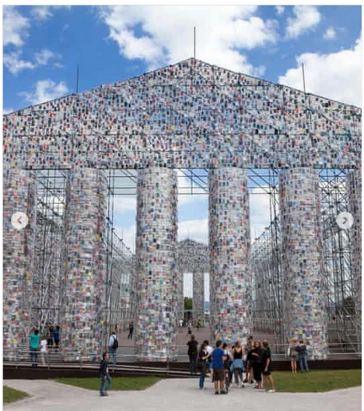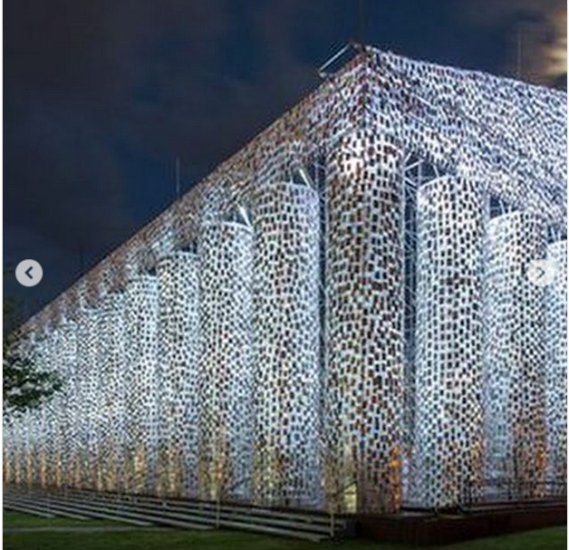

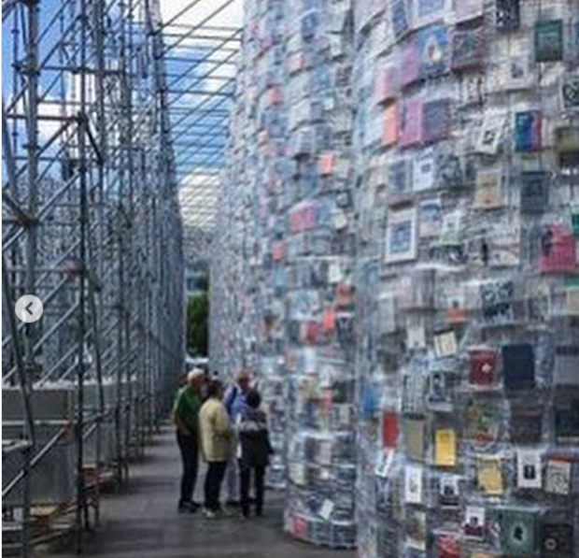

Comments on the Post:
🙌

👏👏😍

✝️🔥

❤️❤️❤️

Incredible

Excellent!!!

Burn it again lol

fabulous🔥🔥🔥

This isn't exactly accurate, as the Parthenon was built with the money of the Delian League, which Athens took by force, therefore suppressing its allies opinion on the management of said money. Athens destroyed entire cities and deserted islands (like Mylos) if they dared to go against it's will. Romanticizing that era is not uncommon though.

1) Leave your own comment on the above post. Remember to use language (verbal or other) that does not offend or provoke when you share your thoughts on the information you read in the post.

