3 Put each verb in brackets into an appropriate verb form.

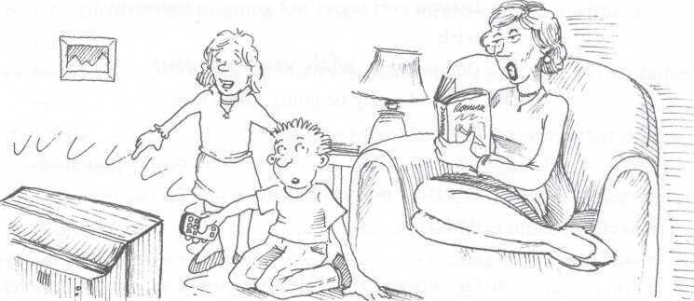

- I'd rather you  (not/watch) television while I'm reading.
- It's high time you ………………………(start) working seriously.
- I wish I ………………………..(spend) more time swimming last summer.
- Helen is bossy. She acts as if she (own) the place.
- I wish you……………………… (not/keep) coming late to class.
- Suppose a complete stranger …………………..(leave) you a lot of money in their will!
- I wish I……………………. (go) to your party after all.
- I'd rather you…………………… (sit) next to Susan, please.
  - The government demanded that the ambassador …………………(be) recalled.
- You are lucky going to Italy. I wish I ………………….(go) with you.

4 Correct the error(s) in each sentence.
- I wish I bought that old house.
- I'd rather you don't eat all the bread
- It's time I go
- I wish I own a motorbike
- I wish we are not leaving in the morning
- Sue would rather reading than watching television.

- Come what comes, I'll be on your side
- I hope it would stop raining
- I'd prefer if you didn't wait
- I wish I didn't listen to you before

