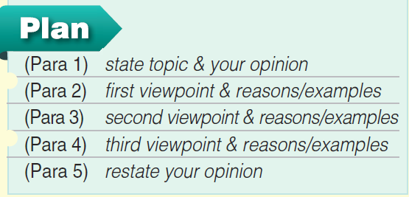
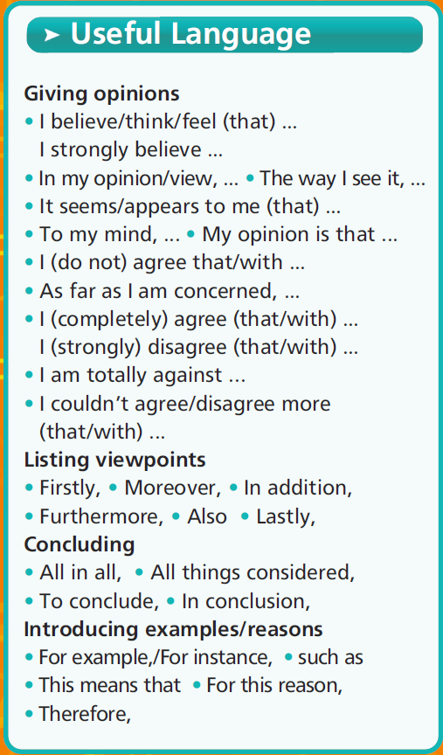
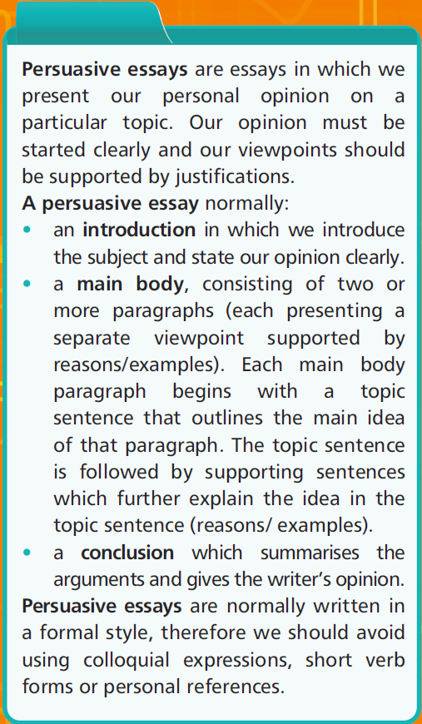
Guidelines to writing an opinion/persuasive essay
General Tips

Persuasive organizer
Topic A : Protecting animals and plants from extinction.
Topic B: Using mobile phones by students in schools
Or topic C: ………………………………………………………………

Viewpoint 1 Viewpoint 2 Viewpoint 3

………………………………………… ………………………………………….. ……………………………………………
………………………………………… ………………………………………….. ……………………………………………
………………………………………… ………………………………………….. …………………………………………..
………………………………………… ………………………………………….. ……………………………………………
…………………………………………. ………………………………………….. ……………………………………………

Supporting Arguments Supporting Arguments Supporting Arguments
&Reasons/Examples & Reasons/Examples reasons /Examples

…………………………………………. ………………………………………….. …………………………………………..
…………………………………………. ..…………………………………………. …………………………………………..
…………………………………………. ………………………………………….. …………………………………………..

Summary of points: …………………………………………………………………………………………………………….

- Write an opinion essay. (120-180 words)

……………………………………………………………………………………………............................................................................................................................................................................................................................................................................................................................................................................................................................................................................……………………………………………………………………………………………......................................................................................................................................................................................................................................................................................................................................................................................................................................................................
…………………………………………………………………………………………….........................................................................................................................................................................................................................................................................................................................................................................................................................................................................
……………………………………………………………………………………………...........................................................................................................................................................................................................................................................................................................................................................

……………………………………………………………………………………………............................................................................................................................................................................................................................................................................................................................................................................................................................................................................……………………………………………………………………………………………......................................................................................................................................................................................................................................................................................................................................................................................................................................................................
…………………………………………………………………………………………….........................................................................................................................................................................................................................................................................................................................................................................................................................................................................
.........................................................................................................................................................................................................................................................................................................................................

