**Unit 5: “Closer Look at Animals on Factory Farms” SB (p. 56)**

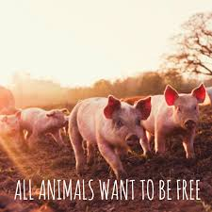

**GLOSSARY**

**Task:** Use an online dictionary to provide the definition of the following vocabulary items (Group work/Breakout sessions).

|  |  |
| --- | --- |
| **polling** |  |
| **raised** |  |
| **abuse** |  |
| **cruelty** |  |
| **majority** |  |
| **efficiency** |  |
| **trumps** |  |
| **welfare** |  |
| **animals are paying the price** |  |
| **operation** |  |
| **profit** |  |
| **at the expense of** |  |
| **slaughters** |  |
| **federal** |  |
| **animal protection laws** |  |
| **raising public awareness** |  |
| **plight** |  |
| **adoption of better prices** |  |
| **breed** |  |
| **hyper production** |  |
| **high-egg volume** |  |
| **brought on** |  |
| **genetic manipulation** |  |