**Harrods**

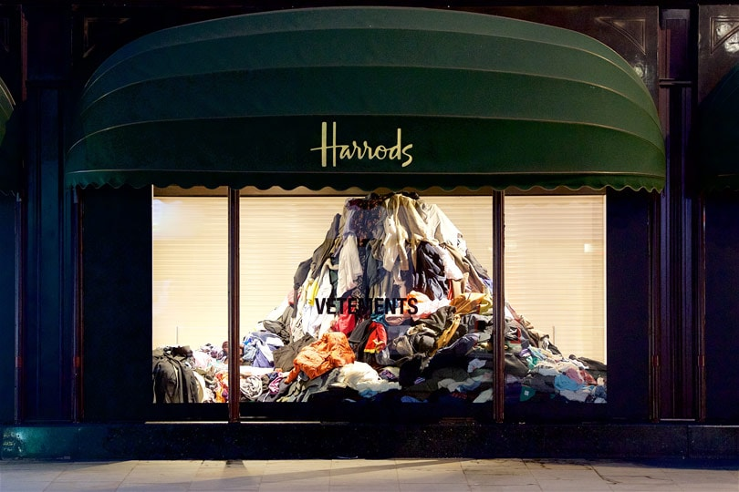

The eye-catching window installation mirrors that of the **Vetements** takeover at New York department store **Saks** last July, where old clothes have become part of the display to highlight **excess clothing** and **waste**.

**Love your Clothes**

* An introduction to **Love Your Clothes (7:31)**

<https://www.youtube.com/watch?v=YsorohqI0DI>