**Story-telling Techniques**:

Supplementary Material for Αγγλικά 1_Γενικού Λυκείου

Unit 3_Writing Activity

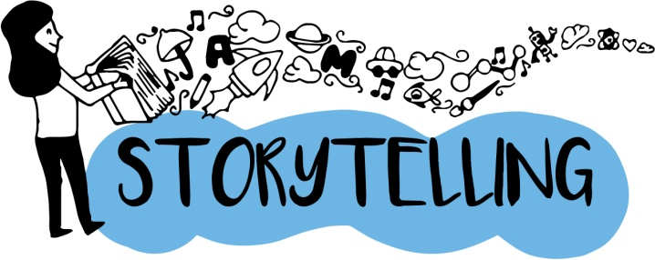

<http://digitalstorytellingclass.pbworks.com/f/Digital+Storytelling+A+Powerful.pdf>

<http://opencourses.uoa.gr/modules/document/file.php/ENL10/Instructional%20Package/PDFs/Unit3a_Digital_storytelling.pdf>

<https://www.samhsa.gov/sites/default/files/programs_campaigns/brss_tacs/samhsa-storytelling-guide.pdf>

<https://www.khanacademy.org/partner-content/pixar/storytelling>

<https://www.ted.com/talks/joe_sabia_the_technology_of_storytelling>

<https://www.ted.com/playlists/62/how_to_tell_a_story>

<https://www.ted.com/talks/andrew_stanton_the_clues_to_a_great_story>

<https://www.ted.com/topics/storytelling>

<https://www.oxfordowl.co.uk/storyteller-videos>

<http://blog.storyandheart.com/blog/2015/1/5/9-best-storytelling-blogs-to-read>

<https://storymaps.arcgis.com/en/>

<https://lifehacker.com/5965703/the-science-of-storytelling-why-telling-a-story-is-the-most-powerful-way-to-activate-our-brains>

<https://www.rockefellerfoundation.org/blog/digital-storytelling-social-impact/>

<https://www.educatorstechnology.com/2012/06/list-of-best-free-digital-storytelling.html>

<http://www.makerspaceforeducation.com/digital-storytelling.html>

<https://globaldigitalcitizen.org/a-list-of-the-best-free-digital-storytelling-tools-for-teachers>

<https://www.slideshare.net/cliotech/digital-storytelling-with-movie-maker>

<http://www.teachhub.com/technology-classroom-best-storytelling-tools>