Teacher Appreciation Week: They wanted respect.

It only took a corona virus pandemic and worldwide economic collapse

Erin Richards, Arika Herron and MJ Slaby USA TODAY
Published 12:16 PM EDT May 4, 2020
https://eu.usatoday.com/story/news/education/2020/05/04/teacher-appreciation-week-2020-coronavirus-virtual/3066238001/
https://www.youtube.com/watch?v=-tGWXN6ROzY
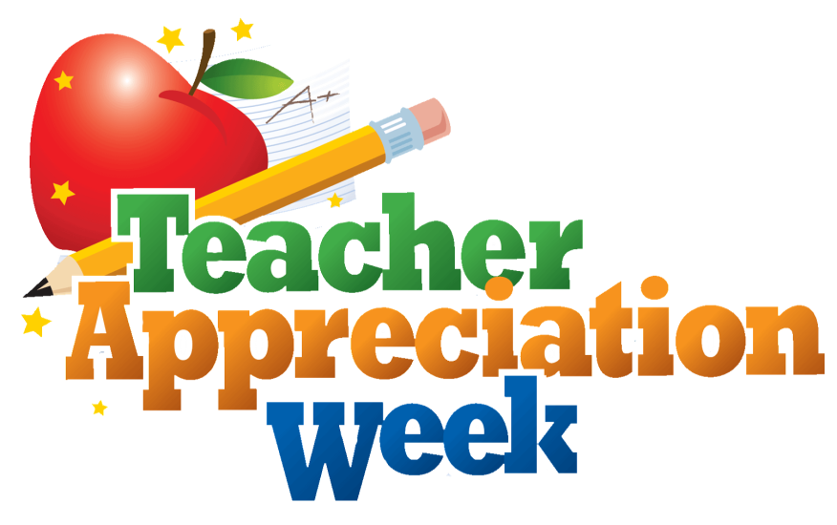
- Remember when you didn't think about teachers much all day?
- Well, what about now? Has anything changed concerning the way you feel about school, teachers, your education and maybe your future?
- Read the news story using the above link for more ideas. Do you find anything strange or difficult to believe? Briefly explain.
- Write an entry in your diary related to the topic ‘Teacher Appreciation Week’ (e.g. Is there someone you would like to ‘Thank’ in any way for what they have offered you over the years? Perhaps a favourite Teacher?)
- Hint: you can watch the video using the above link for more ideas!

#stay safe#stay tuned#keep well

Originator: Evangelia Karagiannidou
(E.F.L. State School Teacher, M.Ed. TESOL)
Anavryta Model Lyceum
Distance Learning Material
Contact Session 5, Class: A’, B’
Week: 04-08/05/2020

