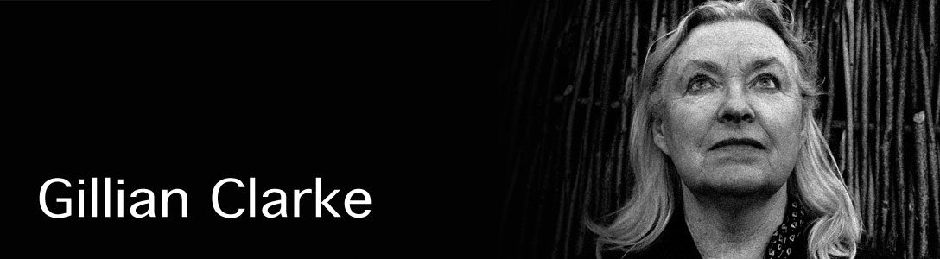

National Poet of Wales 2008-2016
Gillian Clarke was born in Cardiff and lives in Ceredigion. Her work has been on the GCSE and A Level exam syllabus for over thirty years, and she performs her poetry regularly for student audiences at Poetry Live, and in several European cities. Awarded the Queen’s Gold medal for Poetry in 2010, the Wilfred Owen Award in 2012. Prose works include a writer’s journal, At the Source. She has written radio and theatre drama, and translated poetry and prose from Welsh. The Gathering/Yr Helfa, commissioned by the National Theatre of Wales, was performed on Snowdon in September, 2014. Picador published her Selected Poems in 2016. Her tenth collection of poems, Zoology, was published by Carcanet in 2017. Her version of the book-long 7th century Welsh poem, Y Gododdin, is to be published by Faber in 2019.

Cold Knap Lake
https://learnenglishteens.britishcouncil.org.cn/uk-now/literature-uk/cold-knap-lake
Cold Knap Lake is a poem by Gillian Clarke, a poet from Wales. The poem is based on a real memory from her childhood.
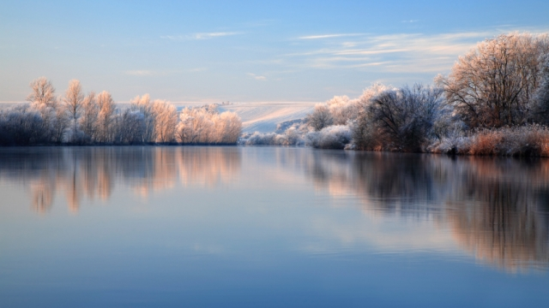
https://soundcloud.com/user-186386944/sets/15-poems
- Writing Skills Practice: “Was I really there…?”
Write a poem, prose poem or piece of prose based on a retrieved memory.
Originator: Evangelia Karagiannidou
(E.F.L. State School Teacher, M.Ed. TESOL)
Anavryta Model Lyceum
Distance Learning Material
Contact Session 3, Class B’
22/04/2020
World Earth Day 2020_UNESCO

