"The Sound Of Silence"
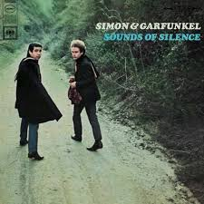

Hello, darkness, my old friend
I've come to talk with you again
Because a vision softly creeping
Left its seeds while I was sleeping
And the vision that was planted in my brain
Still remains
Within the sound of silence
In restless dreams I walked alone
Narrow streets of cobblestone
'Neath the halo of a streetlamp
I turned my collar to the cold and damp
When my eyes were stabbed by the flash of a neon light
That split the night
And touched the sound of silence
And in the naked light I saw
Ten thousand people, maybe more
People talking without speaking
People hearing without listening
People writing songs that voices never share
No one dared
Disturb the sound of silence
"Fools," said I, "You do not know
Silence like a cancer grows
Hear my words that I might teach you
Take my arms that I might reach you."
But my words like silent raindrops fell
And echoed in the wells of silence
And the people bowed and prayed
To the neon god they made
And the sign flashed out its warning
In the words that it was forming
And the sign said, "The words of the prophets
Are written on the subway walls
And tenement halls
And whispered in the sounds of silence."
https://www.azlyrics.com/lyrics/simongarfunkel/thesoundofsilence.html
https://www.youtube.com/watch?v=8FB9GYkIT3E
https://www.youtube.com/watch?v=NAEppFUWLfc

Analysis:
1st verse: self
2nd verse: society
3rd verse: technology
4th verse: friendship
5th verse: religion

- Task: Choose one of the above topics depicted in the song and make an acrostic poem (e.g. you can refer to an experience, feeling, thought, belief, fear, expectation, dream, etc.).

Here’s an example:
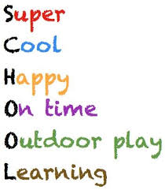

Originator: Evangelia Karagiannidou
(E.F.L. State School Teacher, M.Ed. TESOL)
Anavryta Model Lyceum
Distance Learning Material
Contact Session 4, Class B’
29/04/2020

