Covid-19: Normal life back next winter, says vaccine creator

https://www.bbc.com/news/health-54949799

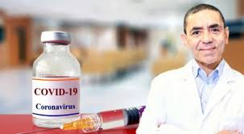

https://images.app.goo.gl/9apnHV6fkM4RJfAMA

“The impact of a new Covid vaccine will kick in significantly over summer and life should be back to normal by next winter, one of its creators has said.”
- Grammar/ Use of English: Direct/ Indirect Speech (Review, Reinforcement) https://www.perfect-english-grammar.com/reported-speech.html
https://dictionary.cambridge.org/grammar/british-grammar/reported-speech_2

- Supplementary Material/ Course book (p.p. 28, 29)
- Language Skills Development (Reading/Writing)
- Digital Literacy Skills/ Online Media

TASK: Write a brief report (approx. 100-150 words) for your school e-newspaper based on the online BBC news article on Prof. Ugur Sahin, co-founder of BioNTech regarding the recent COVID-19 pandemic and the possibility of an effective vaccine.

Distance Learning / Virtual Classroom: A reported speech breakout room activity, where pairs of students role-play an interview between a journalist and a scientist to practice reported speech.

Originator: Evangelia Karagiannidou
(E.F.L. State School Teacher, M.Ed. TESOL)
Anavryta Model Lyceum
Distance Learning Material
Topic: “The COVID-19 pandemic”

English 2, Unit 2 (Supplementary Material)
November 2020

