“A WORLD IN CRISIS… REFUGEES”
[English 2, Unit 2, p.p. 30-31]
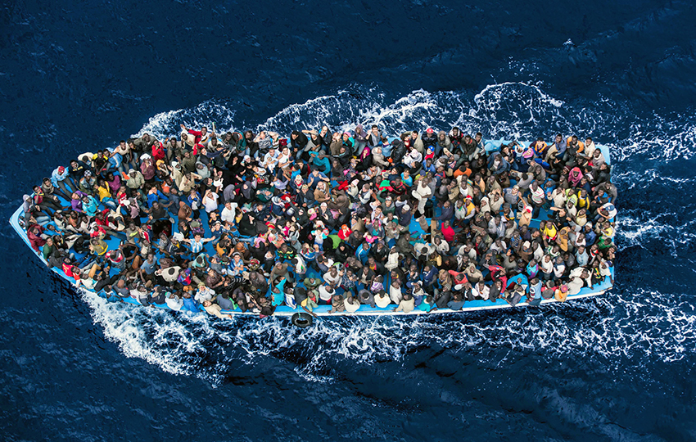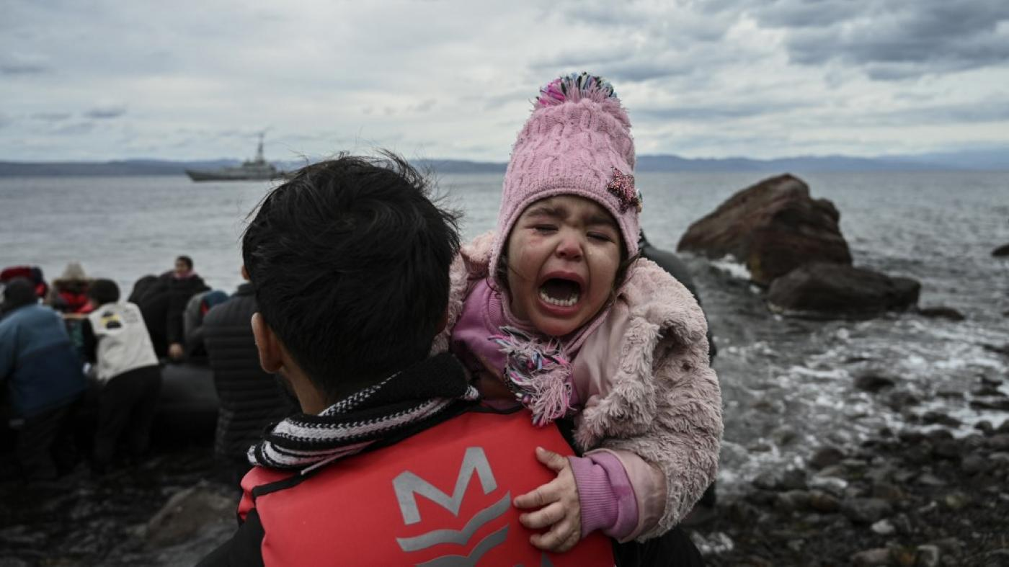
https://images.app.goo.gl/68oZCUF4FJgsuMjSA https://images.app.goo.gl/b2uzJ6gVx35K6jmL6

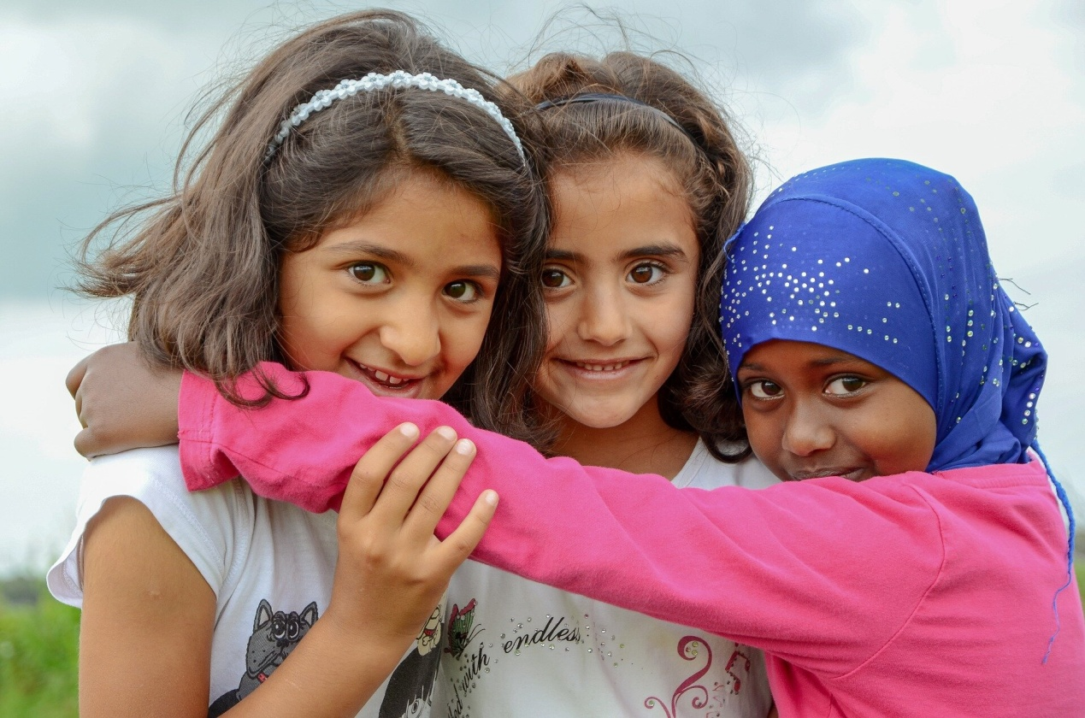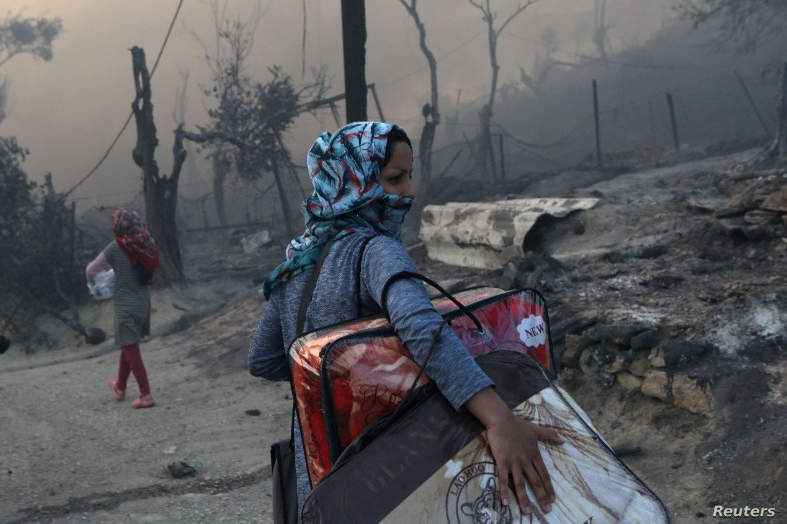
https://images.app.goo.gl/R6JKuhvfx2fsvX5v5 https://images.app.goo.gl/T9FczXwHo3gkdoMZ8
- TASK:
- Choose ONE of the above photos showing refugees to make up a story related to the photo (breakout room activity/ Distance Learning Material). You can use key words from the table below for your story.

(2) Write a letter to the international community to sensitize people about the rights of refugees.
exploitation | danger | life jacket | trafficking | smuggling | dinghy | pain | suffer
army | asylum | borders | contract | detention | centre | education | fear
deportation | family | reunion | chance | parents | passport | persecution | poverty
protection | return | smuggler | labour | visa

Originator: Evangelia Karagiannidou
(E.F.L. State School Teacher, M.Ed. TESOL)
Anavryta Model Lyceum
Distance Learning Material
Topic: “The Refugee Crisis”

English 2, Unit 2 (Adapted/ Supplementary Material)
November 2020

