ΠΗΝΕΛΟΠΗ ΜΠΑΛΑΟΥΡΑ Α3

Homework

Jack Phillips, a 25-year-old senior wireless operator, also proved to be one of the many heroes during the sinking of the RMS Titanic. On the evening of April 14, 1912, Phillips was working through a backlog of personal messages from the passengers and crew. However, he and Harold Bride, a junior wireless officer, did pass on several messages about iceberg warnings to Captain Edward Smith.

As the RMS Titanic hit an iceberg at 11:40 PM, Phillips continued to work in the wireless room. When Bride came to take over from Phillips, Captain Smith entered and ordered Phillips to send out a distress signal, calling for assistance from nearby ships and providing the liner’s estimated position.

Both wireless officers worked tirelessly until 2:00 AM sending distress signals. Then Captain Smith informed them that they had done their duty and ordered them to abandon ship. While Bride took the opportunity to throw flotation devices into the water to help others, Phillips remained at his post in the wireless room sending distress signals until the final minute of the liner’s sinking. Although Phillips managed to climb onto the upturned Lifeboat B, he sadly passed away and slipped into the water. Thankfully, Harold Bride survived the event. He died in 1956.

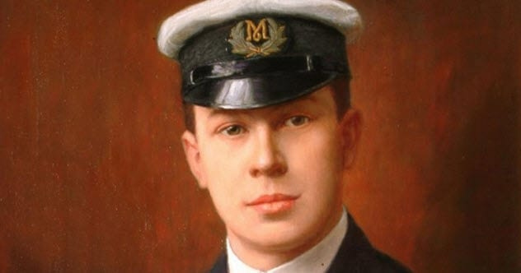

When Nigerian-born Godwin Ajala first arrived in the United States, he was forced to endure various poorly paid jobs until he secured a permanent position as an access control officer at the World Trade Center. His role required him to walk various floors and ride the elevators at the two towers to secure the building and provide assistance for small emergencies. When he wasn’t working at the towers, he was preparing to take the New York State bar exam.

When the planes hit the World Trade Center, 33-year-old Ajala selflessly helped thousands of people to evacuate the towers. He reportedly held the door open for people as they fled the building, and he guided others out of the towers to safety. Sadly, he later succumbed to exhaustion and fell into a coma, passing away the following Sunday.

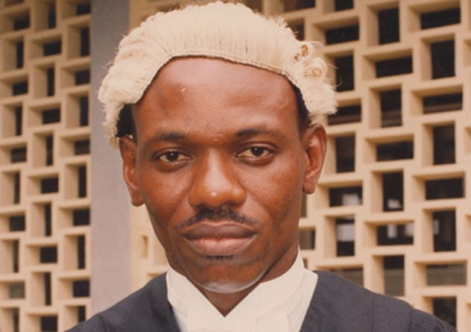

Many stories have emerged of truly brave individuals who selflessly risked their lives to save others during the Holocaust. One story that is impossible to forget is that of Maximilian Kolbe, a Polish priest who was sent to Auschwitz concentration camp in 1941.

The Nazis slowly starved prisoners at the death camp as they each received small rations that couldn’t sustain a child. Every prisoner received a cup of imitation coffee each morning and weak soup and half a loaf of bread following work. With everyone struggling to secure a place to receive their ration of food, Father Maximilian Kolbe would stand aside to allow others to eat, which meant there was often limited food left for him.

There was also a rule in Auschwitz that 10 men would be killed if one attempted to escape from the concentration camp. A man from Kolbe’s bunker escaped in July 1941, so 10 men were selected to be starved to death.

As Franciszek Gajowniczek, one of the chosen prisoners, cried in anguish, Kolbe stepped forward to the commandant and said, “I am a Catholic priest. Let me take his place. I am old. He has a wife and children.” The commandant accepted his request, and the priest took Gajowniczek’s place.

After two weeks of hunger and thirst, Kolbe was the only person in the group who was fully conscious. He raised his left arm to Bock, an executioner, who injected the priest with a fatal dose of carbolic acid on August 14, 1941.

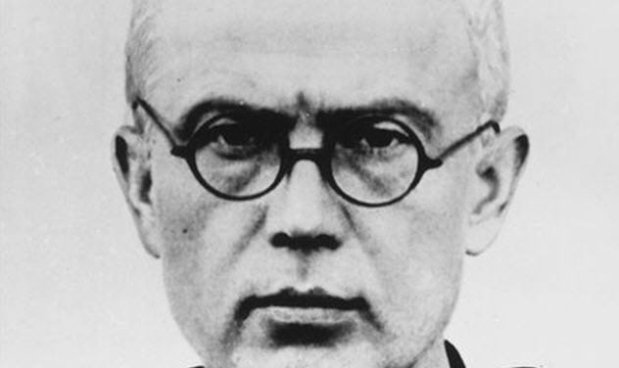

Frank Foley wouldn’t be most people’s idea of a typical British spy or hero. After all, he was reportedly small and a little potbellied. He also wore round glasses, so he appeared almost the opposite of James Bond. Yet, according to Sir Alex Younger, the current head of MI6, Foley was “a consummately effective intelligence officer.”

After Kristallnacht and before the outbreak of World War II, he went undercover as a passport control officer for the British embassy in Berlin. As he was fully aware of the poor treatment the Jews received from the Nazis, Foley decided to take action by forging passports and altering visas to help Jewish people escape Hitler’s rule.

Although he lacked diplomatic immunity, Foley even entered various Nazi concentration camps to issue travel documents and visas. Due to his heroic actions, he is believed to have rescued more than 10,000 men, women, and children in Nazi Germany.

