**ΠΗΝΕΛΟΠΗ ΜΠΑΛΑΟΥΡΑ Α3**

As the saying goes, “Adversity does not build character, it reveals it.” In times of great misfortune and even catastrophe, there are often only a few people who have the strength and courage to go above and beyond to help others survive.

Many tragedies have led to stories of great self-sacrifice as people have shown immense bravery to save the lives of others.

For instance, Rick Rescorla, a former British military officer, served as head of security for Morgan Stanley in the World Trade Center’s South Tower. The 1993 terrorist attack on the complex left a big impression on Rescorla, who had already highlighted the security weaknesses prior to the 1993 bombing. Confident that the World Trade Center would experience something similar in the future, Rescorla regularly made employees at the bank embark on escape drills, which saved their lives during the September 11, 2001, attacks. On 9/11, Rescorla also led people down the stairs to safety while singing Cornish songs to boost morale. What’s more, he reportedly returned to the 10th floor of the South Tower to help others evacuate the building. Although Rescorla was one of more than 2,600 people who sadly died when the towers collapsed, his heroic actions are believed to have saved the lives of more than 2,500 employees.

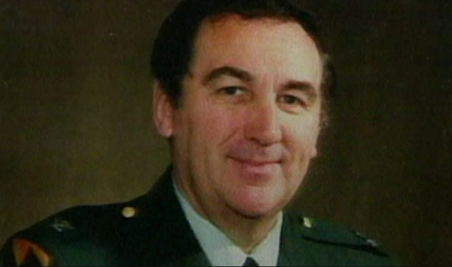

Another example is:

Benjamin Keefe Clark didn’t serve as a police officer or firefighter on September 11, 2001. He was working as a chef, prepping meals for those at the Fiduciary Trust Company on the 96th floor offices in the South Tower. When the plane hit the building, he didn’t try to escape the disaster himself. Instead, he took the steps to guide others to safety. Reportedly, the former Marine ensured that everyone in his department as well as in all the 96th floor offices evacuated the building immediately. Following the tragic event, a Fiduciary official credited Benjamin with saving hundreds of lives. For example, once they reached the 78th floor, he reportedly assisted a woman in a wheelchair. Despite his undeniable heroism, he didn’t survive the tragic event.

