ANIMAL RIGHTS

Από: ΣΙΔΕΡΗ ΑΓΓΕΛΙΝΑ

Τμήμα: Α3

Ημερομηνία: 18/12/2020

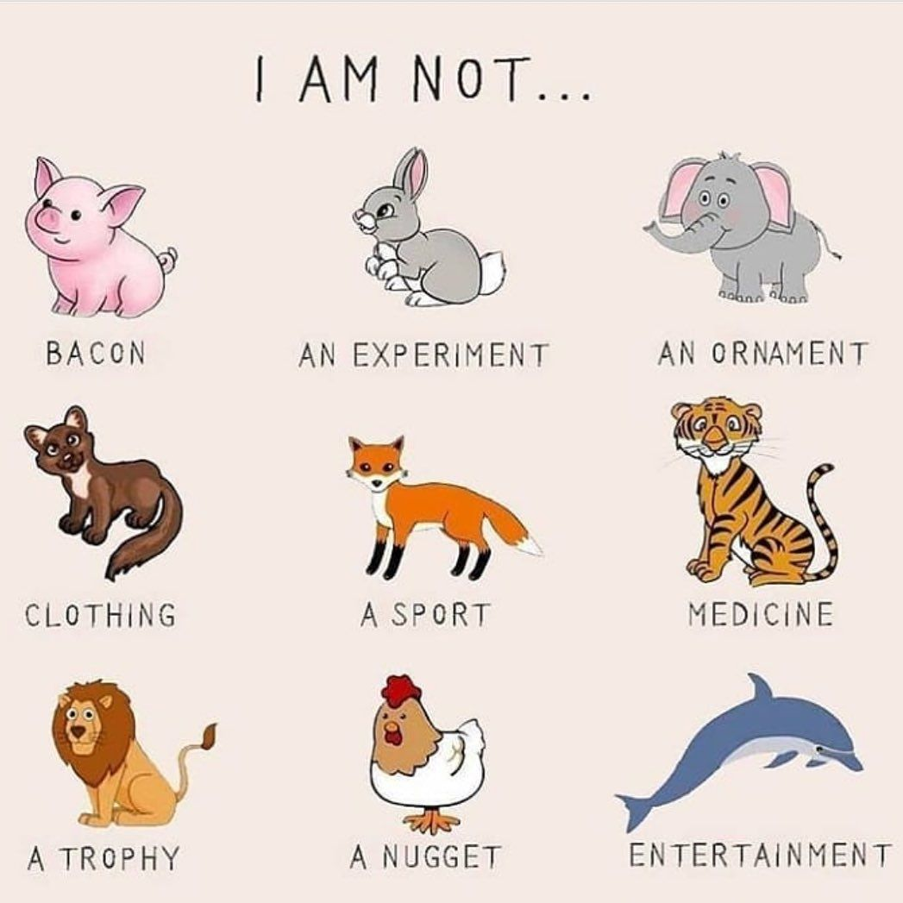

WHAT IS THE POINT IN SAVING ENDANGERED SPECIES?

In 1981, mountain gorillas were at rock-bottom. Confined to a small mountain range in central Africa, with humans encroaching on their habitat bringing poaching and civil war, [their population was estimated at just 254](http://dx.doi.org/10.1017/S0030605300018524). They would all have fitted into a single Boeing 747. Today things look a little better. A survey in 2012 reported that [the population was up to 880](http://www.theguardian.com/environment/2012/nov/13/mountain-gorilla-population-rises). That is a big improvement, but it's still only two Boeing 747s of mountain gorillas. They remain [critically endangered](http://www.iucnredlist.org/details/full/39999/0). We hear similar tales of woe all the time, from all around the world. Whether it's tigers, pandas, California condors or coral reefs, much of the world's wildlife is under threat. It's initially upsetting, and eventually just numbing. Is it worth worrying about it all? Sure, it will be sad if there aren't any more cute pandas on the planet, but it's not like we depend on them. Besides, surely, it's more important to take care of humans – who, let's face it, have their own problems to worry about – than to spend millions of dollars preserving animals. What, in short, is the point of conservation? Species go extinct all the time anyway. As well as individual species dying out, there have been five mass extinctions that obliterated swathes of species. The most recent one, 65 million years ago, took out the dinosaurs. If extinction is a natural process that goes on even in the absence of humans, why should we stop it? One answer is that species are now going extinct far faster than they used to. A recent study estimated that [the extinction rate has increased a hundredfold over the last century](http://dx.doi.org/10.1126/sciadv.1400253), and we seem to be to blame. But beyond that, there's a simple reason to save species: because we want to. Many of us love the natural world. We think animals are cute, majestic, or just plain fascinating. We love walking in the dappled sunlight of an old forest, or scuba-diving over a coral reef. Who doesn't think mountain gorillas are awesome? Nature is beautiful, and that aesthetic value is a reason to keep it, just as we preserve artistic masterpieces like the Mona Lisa. The first problem with this argument is that it spells doom for all those animals and plants that people are less fond of: the ugly, the smelly and the just plain obscure. If we don't find them appealing, they're out. More fundamentally, it comes from a position of luxury and privilege. It's all very well for a moneyed person in the western world to want to preserve tigers because they're nice to look at, but that doesn't cut much ice with a villager in rural India whose family is in danger from one. So, the fact that some of us find nature beautiful, by itself, won't do. There needs to be a more practical reason to keep species around. The big leap forward came in the 1990s, when biologists started outlining all the ways animals and plants benefit us just by being there. These benefits, which most of us take for granted, are called "ecosystem services". Some of these services are obvious. For instance, there are plants and animals that we eat. Meanwhile, photosynthetic plankton in the sea, and green plants, provide us with the oxygen we breathe. These are quite direct, but sometimes the services provided can be more subtle. Pollinating insects like bumblebees are an obvious example. Many of our crop plants rely on these insects to produce seeds, and would not survive – let alone provide us with food – without them. This is why the decline in pollinating insects has provoked so much concern. Take the idea that nature is beautiful and we should preserve it for its aesthetics and wonder. Our pleasure at the beauty of nature can now be thought of as an ecosystem service. Nature provides us with beauty. You may well ask how we can put a price on that. How do you objectively measure beauty? Well, you can't, but that doesn't stop us deciding what it's worth. We do it all the time with paintings, music and other forms of art. If we value something and are prepared to pay to have it, then it has value. To do the same thing with nature, we just need a system that allows us to pay to experience it.

WHAT CAN WE DO TO PROTECT ENDANGERED SPECIES?

1. Learn about endangered species in your area. Teach your friends and family about the wonderful wildlife, birds, fish and plants that live near you. The first step to protecting endangered species is learning about how interesting and important they are. Our natural world provides us with many indispensable services including clean air and water, food and medicinal sources, commercial, aesthetic and recreational benefits.

 2. Visit a national wildlife refuge, park or other open space. These protected lands provide habitat to many native wildlife, birds, fish and plants. Scientists tell us the best way to protect endangered species is to protect the places where they live. Get involved by volunteering at your local nature center or wildlife refuge. Go wildlife or bird watching in nearby parks. Wildlife related recreation creates millions of jobs and supports local businesses.

 3. Make your home wildlife friendly. Secure garbage in shelters or cans with locking lids, feed pets indoors and lock pet doors at night to avoid attracting wild animals into your home. Reduce your use of water in your home and garden so that animals that live in or near water can have a better chance of survival. Disinfect bird baths often to avoid disease transmission. Place decals on windows to deter bird collisions. Millions of birds die every year because of collisions with windows. You can help reduce the number of collisions simply by placing decals on the windows in your home and office.

 4. Native plants provide food and shelter for native wildlife. Attracting native insects like bees and butterflies can help pollinate your plants. The spread of non-native species has greatly impacted native populations around the world. Invasive species compete with native species for resources and habitat. They can even prey on native species directly, forcing native species towards extinction.

5. Herbicides and pesticides may keep yards looking nice but they are in fact hazardous pollutants that affect wildlife at many levels. Many herbicides and pesticides take a long time to degrade and build up in the soils or throughout the food chain. Predators such as hawks, owls and coyotes can be harmed if they eat poisoned animals. Some groups of animals such as amphibians are particularly vulnerable to these chemical pollutants and suffer greatly as a result of the high levels of herbicides and pesticides in their habitat.

 6. Slow down when driving. Many animals live in developed areas and this means they must navigate a landscape full of human hazards. One of the biggest obstacles to wildlife living in developed areas is roads. Roads divide habitat and present a constant hazard to any animal attempting to cross from one side to the other. So, when you’re out and about, slow down and keep an eye out for wildlife.

 7. Recycle and buy sustainable products. Buy recycled paper, sustainable products like bamboo and Forest Stewardship Council wood products to protect forest species. Never buy furniture made from wood from rainforests. Recycle your cell phones, because a mineral used in cell phones and other electronics is mined in gorilla habitat. Minimize your use of palm oil because forests where tigers live are being cut down to plant palm plantations.

 8. Never purchase products made from threatened or endangered species. Overseas trips can be exciting and fun, and everyone wants a souvenir. But sometimes the souvenirs are made from species nearing extinction. Avoid supporting the market in illegal wildlife including: tortoise-shell, ivory, coral. Also, be careful of products including fur from tigers, polar bears, sea otters and other endangered wildlife, crocodile skin, live monkeys or apes, most live birds including parrots, macaws, cockatoos and finches, some live snakes, turtles and lizards, some orchids, cacti and cycads, medicinal products made from rhinos, tiger or Asiatic black bear.

9. Harassing wildlife is cruel and illegal. Shooting, trapping, or forcing a threatened or endangered animal into captivity is also illegal and can lead to their extinction. Don’t participate in this activity, and report it as soon as you see it to your local state or federal wildlife enforcement office.

10. Protect wildlife habitat. Perhaps the greatest threat that faces many species is the widespread destruction of habitat. Scientists tell us the best way to protect endangered species is to protect the special places where they live. Wildlife must have places to find food, shelter and raise their young. Logging, oil and gas drilling, over-grazing and development all result habitat destruction. Endangered species habitat should be protected and these impacts minimized.

By protecting habitat, entire communities of animals and plants can be protected together. Parks, wildlife refuges, and other open space should be protected near your community. Open space also provides us with great places to visit and enjoy. Support wildlife habitat and open space protection in your community. When you are buying a house, consider your impact on wildlife habitat.

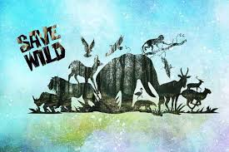

WHY ARE SCIENTISTS SO CONCERNED ABOUT SPECIES UNDER EXTINCTION?

Should you care that an obscure [flower](http://www.mnn.com/your-home/organic-farming-gardening/stories/us-plucks-tiny-daisy-from-brink-of-extinction) that only grows in a very limited area, serves no obvious purpose, and is unlikely to ever be in an arrangement in anyone’s home is facing possible extinction? The U.S. Fish and Wildlife Service recently proposed that just such a flower be protected under the [Endangered Species Act](http://www.mnn.com/earth-matters/translating-uncle-sam/stories/endangered-species-where-are-they-now) and that the 786 acres in 13 counties in Georgia and Alabama where it is found be designated as “critical habitat.” The plant is the Georgia rockcress (*Arabis Georgiana),* a 3-foot-tall flower that grows only on steep river bluffs with exposed rock outcroppings beneath hardwood trees where it gets a mix of sun and shade. It was first identified as needing federal protection in 1975. Almost 40 years later, the 18 surviving populations are threatened by development, logging, quarrying, camping, invasive species and hydropower dams. What about the more than 750 imperiled plants and animals across the country that the Center for Biological Diversity in Tucson, Ariz., a national, nonprofit conservation organization with more than 625,000 members dedicated to the protection of endangered species and wild places, and the federal Fish and Wildlife Service are seeking to protect? Should you care about them? Noah Greenwald, the center’s endangered species program director who is based in Portland, Ore., thinks you should care a lot. “This is not just about one plant in Georgia and Alabama,” he said.

An extinction crisis  
“Many scientists around the globe say we are in an extinction crisis,” he continued. “They say we are experiencing a greatly accelerated rate of extinction that has become 1,000 to 10,000 times the historical rate of extinction.” In fact, according to the center, the extinction crisis is the world’s sixth mass extinction of plants and animals and the worst loss of species since the dinosaurs died off 65 million years ago. The fear among scientists, Greenwald said, is that by 2050, 30 to 50 percent of all the species on the planet could be headed toward extinction. People should care about extinction of seemingly obscure plants and animals, even if they do not live, work or play in the habitats where the threatened species live, he said, for the same reason that the coal miner should be concerned that the canary is lying motionless on the bottom of the cage. Just as the canary is a sign of trouble with the air in the mine, the loss of species indicates impending problems for the health of the planet. When we lose species out of ecosystems, we start losing the services those ecosystems provide. The functionality of ecosystems goes down.

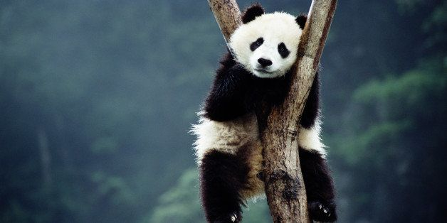

ΒΙΒΛΙΟΓΡΑΦΙΑ:

[*https://www.google.com/search?q=animal+rights&source=lnms&tbm=isch&sa=X&ved=2ahUKEwjkrZ2n19XtAhWRHOwKHU0mDvoQ_AUoAXoECBEQAw#imgrc=-aLrXRXMc9J14M](https://www.google.com/search?q=animal+rights&source=lnms&tbm=isch&sa=X&ved=2ahUKEwjkrZ2n19XtAhWRHOwKHU0mDvoQ_AUoAXoECBEQAw#imgrc=-aLrXRXMc9J14M)

*<http://www.bbc.com/earth/story/20150715-why-save-an-endangered-species>

*<https://www.endangered.org/10-easy-things-you-can-do-to-save-endangered-species/>

*<https://www.google.com/search?q=what+can+we+do+to+protect+endangered+species&biw=1536&bih=698&tbm=isch&source=lnms&sa=X&ved=0ahUKEwjok8XE3dXtAhXIlIsKHfloDmgQ_AUIECgC#imgrc=8tfHVX9OMyF47M>

*<https://www.huffpost.com/entry/extinction-crisis-should-you-care_n_4109243?guccounter=1&guce_referrer=aHR0cHM6Ly93d3cuZ29vZ2xlLmNvbS8&guce_referrer_sig=AQAAAJZ3tN2bH7KJHYYp9VZNLS5IVB2I3-PdTLfKxyurhfvzl1W1dotPDrc_GaTpHk4lSrTpOCY52_rZj36IE0y6im7lPfK-XojHPy02BahG7Bt7WOiuEbtMySXm4_etE_XkEywMBpaLD2eY9dNL-hsfEML4zkuXJIxMHt82Z8HCxCSV>

*<https://www.google.com/search?q=why+scientist+are+concerned+about+species+under+extinction&source=lnms&tbm=isch&sa=X&ved=2ahUKEwivnJej49XtAhVksYsKHWs-CBcQ_AUoAnoECBAQBA&biw=1536&bih=698#imgrc=2FjGHPzvHMf_bM>

~~THANK YOU~~