*Pablo Picasso*

*The Old Guitarist*

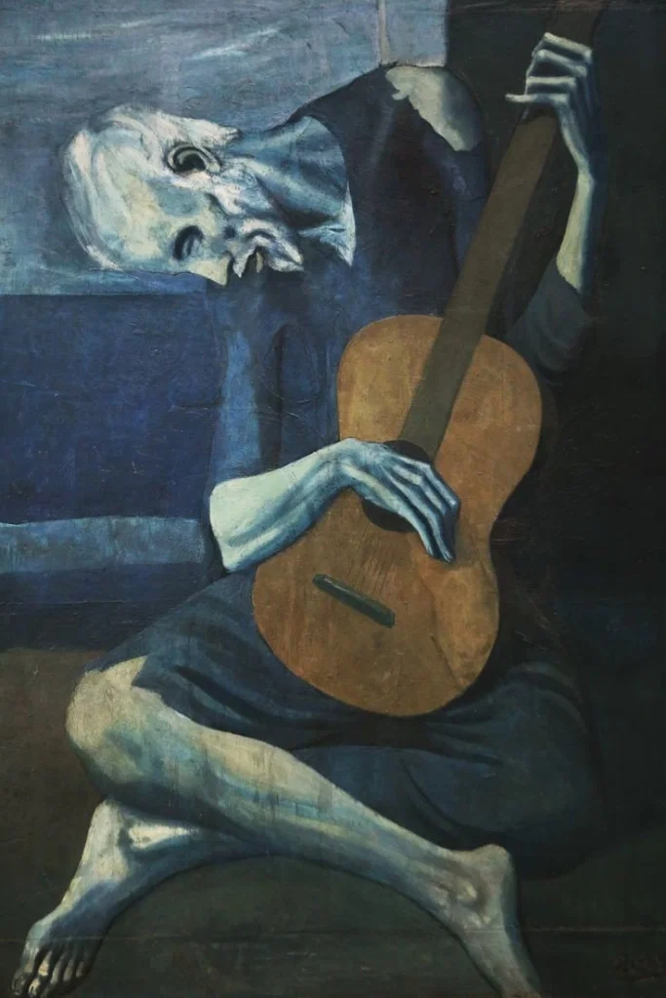

"The Old Guitarist" is an oil painting by Pablo Picasso created in late 1903 and early 1904. It features an elderly musician, a blind, poor man dressed in rags, hugging his guitar while playing music in the streets of Barcelona in Spain.

Picasso's paintings of this period are characterized by the color blue and symbolize an emotionally charged period of his life. Some of his most famous works depicting acrobats, harlequins, prostitutes, beggars and artists.

The dominance of blue shades creates flat, two-dimensional forms that divide the guitarist into levels. In addition, the overall muted blue palette creates a general tone of melancholy and highlights the tragic and sad theme. The use of oil paint on the sign causes a darker and more theatrical mood. The colors are combined together without reducing the brightness, creating an even more cohesive dramatic composition.

The guitarist looks weak and seems to be close to death, suggesting little comfort to the world and emphasizing the misery of his condition.

The large, brown guitar is the only major color change found in the work, the dull brown, in contrast to the blue background, becomes the center of attention.

The guitar represents the only hope for survival.

Some art historians believe that the colors of the painting show the solitary life of an artist and the financial dissatisfaction they face.

Αrt isolates artists from the world.

And yet, despite the isolation, the guitarist depends on the rest of society to live.

All these feelings reflect the situation of Picasso at that time and his critique of the state of society.