# Claude Monet: The Father of Impressionism

Claude Monet, born in Paris in 1840, is widely recognized as the founder of the Impressionist movement, which forever changed the course of art history. Through his groundbreaking techniques and dedication to capturing the beauty of light and nature, Monet created a legacy that continues to inspire artists and admirers today.

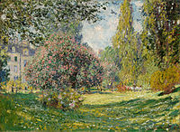

Το πάρκο Monceau, 1876, Νέα Υόρκη, Μητροπολιτικό Μουσείο

Monet’s early life shaped his passion for art. Though he was born in Paris, he spent much of his childhood in Le Havre, where he developed an appreciation for the natural world.

** His painting *Impression, Sunrise (1872) would later define the Impressionist movement, a term initially used by critics to mock his work. However, the movement became a revolution, emphasizing light, color, and atmosphere over rigid detail.*

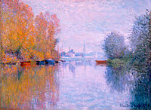

*Φθινόπωρο στον Σηκουάνα, Argenteuil, 1873, Ατλάντα, High Museum of Art*

**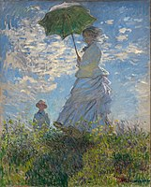***One of Monet’s defining features was his commitment to painting outdoors, or en plein air. He believed that capturing the natural light and changing seasons brought life and authenticity to his work. This dedication is evident in his most famous series, Water Lillies, painted in his garden at Giverny. The garden, which Monet carefully designed, featured a Japanese bridge and a lily pond, both recurring themes in his work.*

**

**

*Η Madame Monet και ο γιος της ή Γυναίκα με ομπρέλλα, 1875, Ουάσινγκτον, National Gallery of Art*

*Monet’s contributions to art extended far beyond his lifetime. He died in 1926 at the age of 86, but his work continues to influence modern artists. By focusing on fleeting moments and the play of light on everyday scenes, he introduced a new way of seeing the world.*

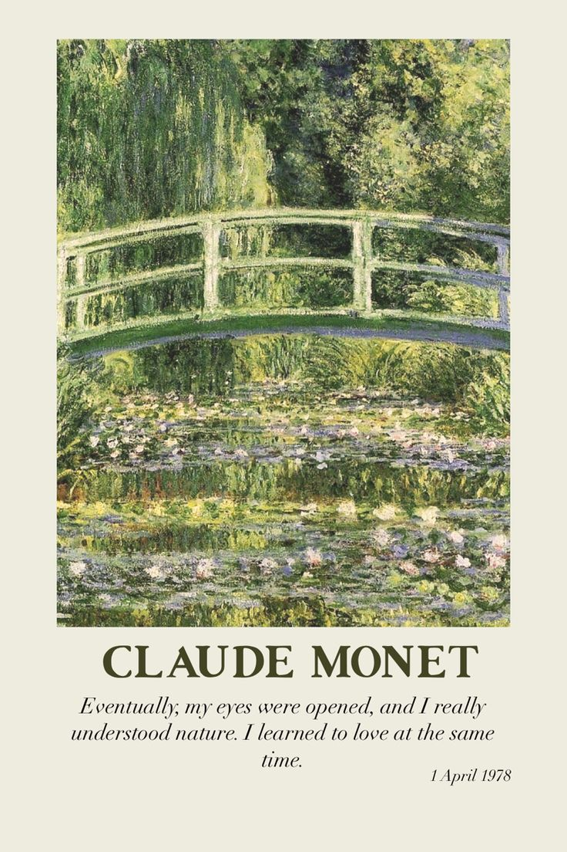

*In conclusion, Claude Monet’s legacy as the father of Impressionism is undeniable. His revolutionary approach to art, love for nature, and iconic works like Water Lillies and Impression, Sunrise ensure his place in history as one of the greatest artists of all time.*

**Marialena**

**Katsikokeri**

**B2**